The Version of Record of this article is published in Environmental Research Elsevier and is available online at https://doi.org/10.1016/j.envres.2026.124263. This preprint has not undergone any post-submission improvements or corrections.

Supplementary Materials
Magnetic association of microplastics in urban road dust: Size distribution and ecological risk

Sylwia Dytłow^{1*} Małgorzata Kida² Sabina Ziembowicz²

¹ Institute of Geophysics, Polish Academy of Sciences, Księcia Janusza 64, 01-452 Warsaw, Poland

² Department of Chemistry and Environmental Engineering; Faculty of Civil and Environmental Engineering and Architecture; Rzeszów University of Technology, 35-959 Rzeszów, Ave Powstańców Warszawy 6, Poland; Telephone number: +48 17 7432407;

Sylwia Dytłow ORCID 0000-0001-6968-6491

Małgorzata Kida ORCID 0000-0003-1744-4014 (e-mail: mkida@prz.edu.pl)

Sabina Ziembowicz ORCID 0000-0002-8032-5168 (e-mail: s.ziembowicz@prz.edu.pl)

*E-mail address of the corresponding Author (S.Dytłow): skdytlow@igf.edu.pl

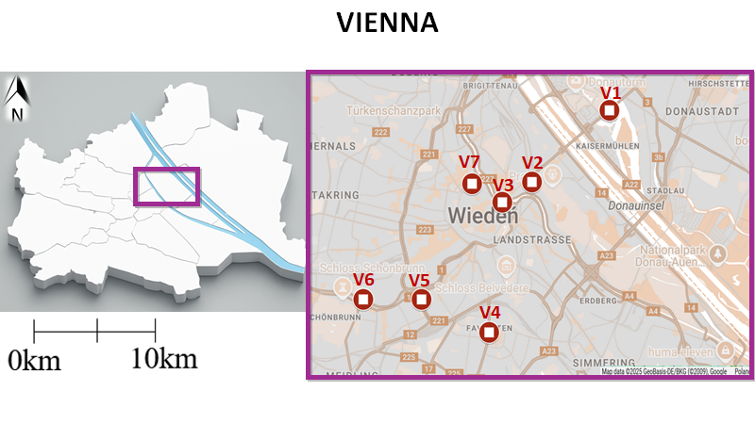
Figure S1. Location of road dust sampling sites (V1–V7) in Vienna, Austria. The inset shows the city's position, while the main map highlights the seven urban sampling points within central and southern districts.

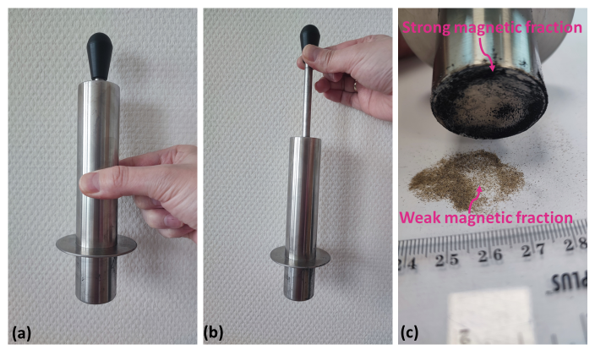

Figure S2. A manual magnetic separator used for fraction separation.
(a) Magnetic field activated (lever pushed inward).
(b) Magnetic field deactivated (lever pulled upward). (c) Application of the separator to the sample surface.

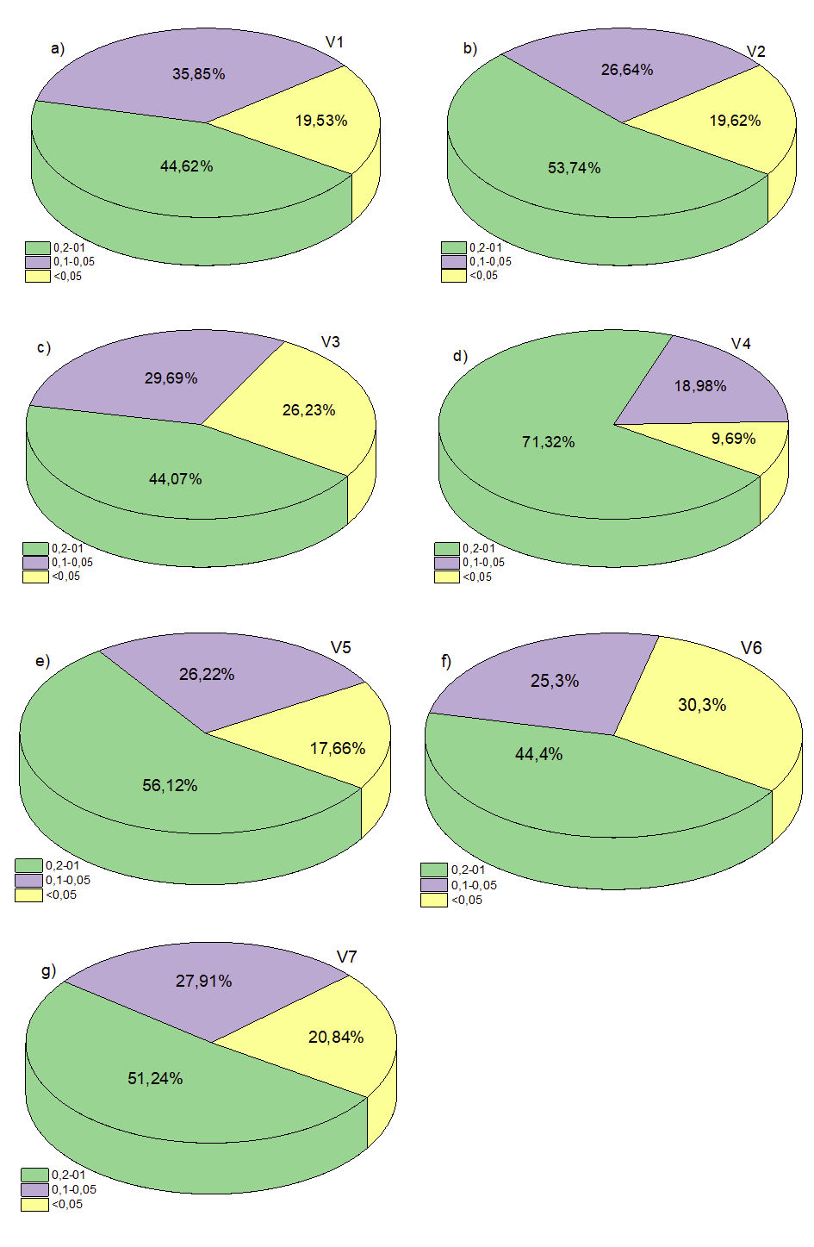

Figure S3. Size fraction distribution of bulk road dust samples collected from seven locations (V1–V7). The pie charts illustrate the mass percentage contribution of three particle size fractions—0.2–0.1 mm (green), 0.1–0.05 mm (purple), and <0.05 mm (yellow)—to the total sample weight at each site.

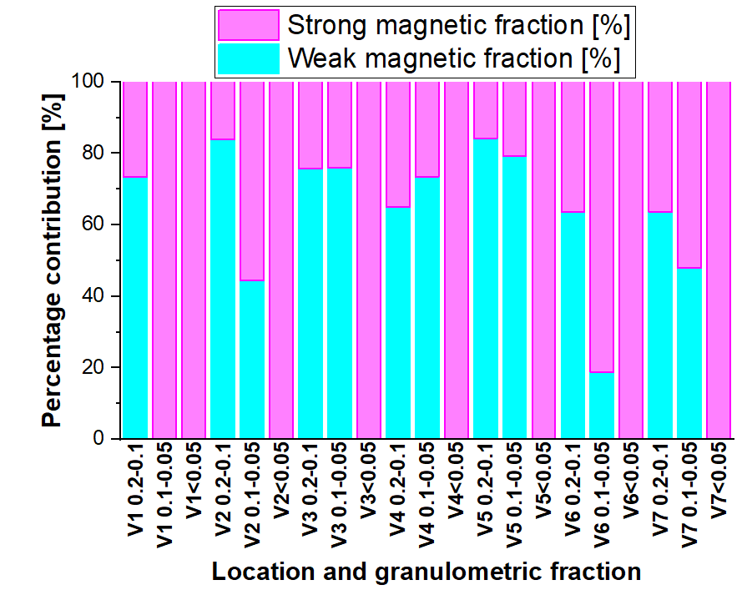

Figure S4. Contribution of strong and weak magnetic fractions in different grain sizes across sampling sites.

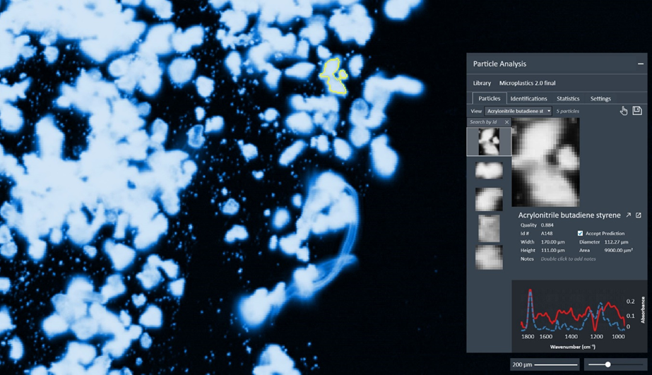
Figure S5. Acrylonitrile butadiene styrene.

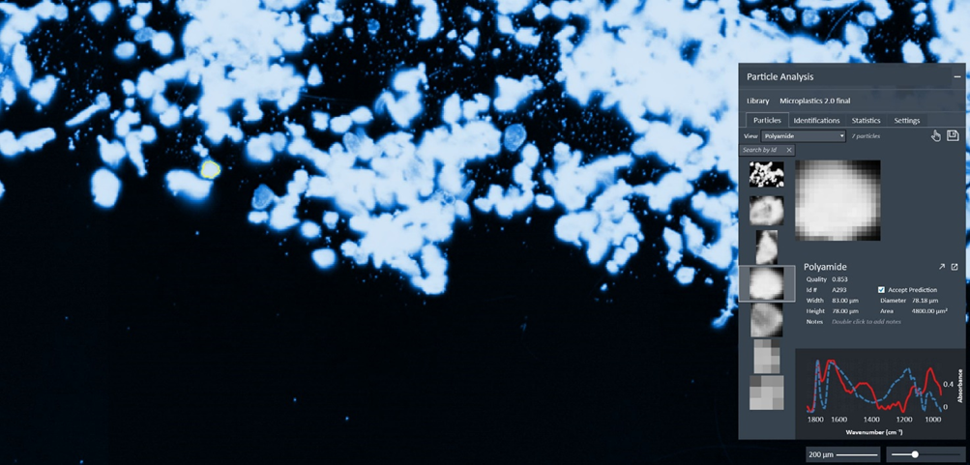Figure S6. Polyamide.

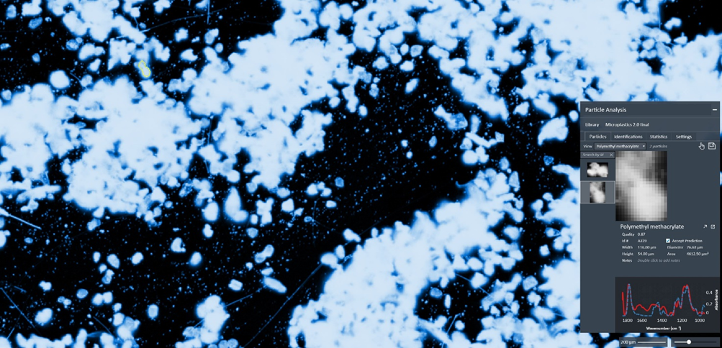Figure S7. Polymethyl methacrylate.

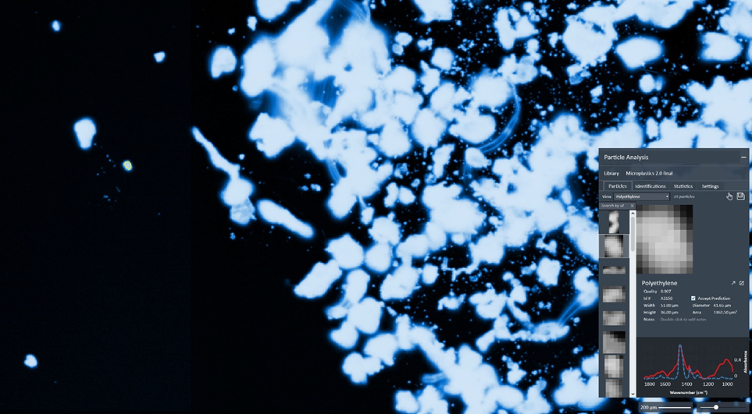Figure S8. Polyethylene.

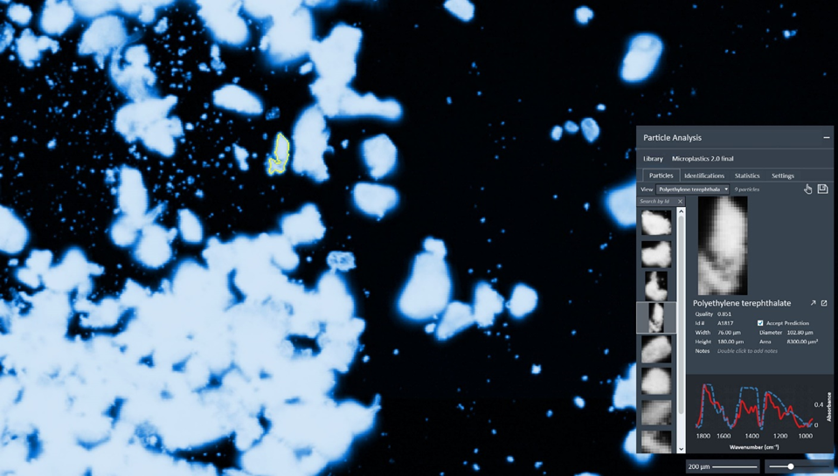Figure S9. Polyethylene terephthalate.

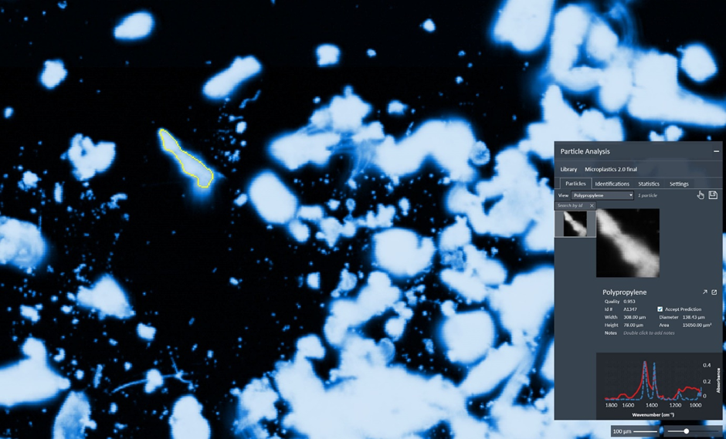Figure S10. Polypropylene.

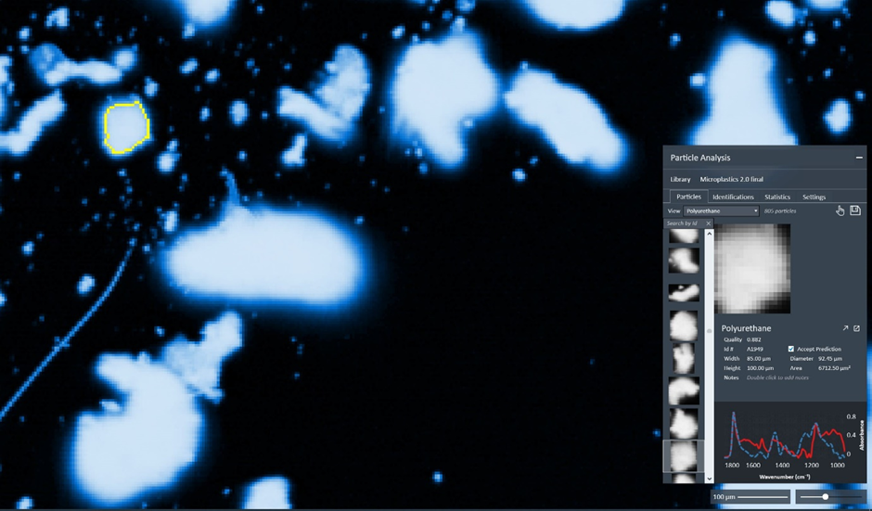Figure S11. Polyurethane.

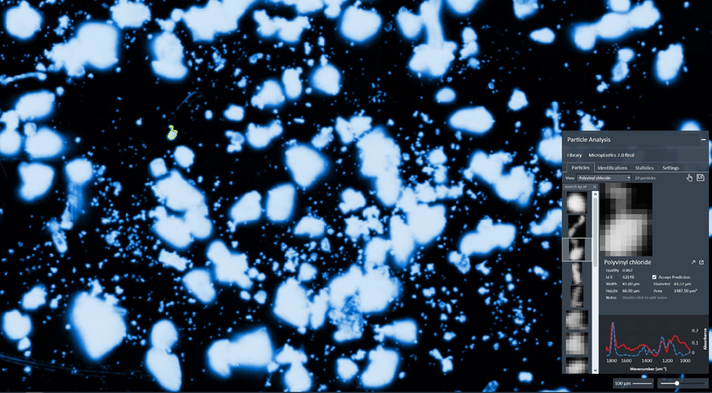Figure S12. Polyvinyl chloride.

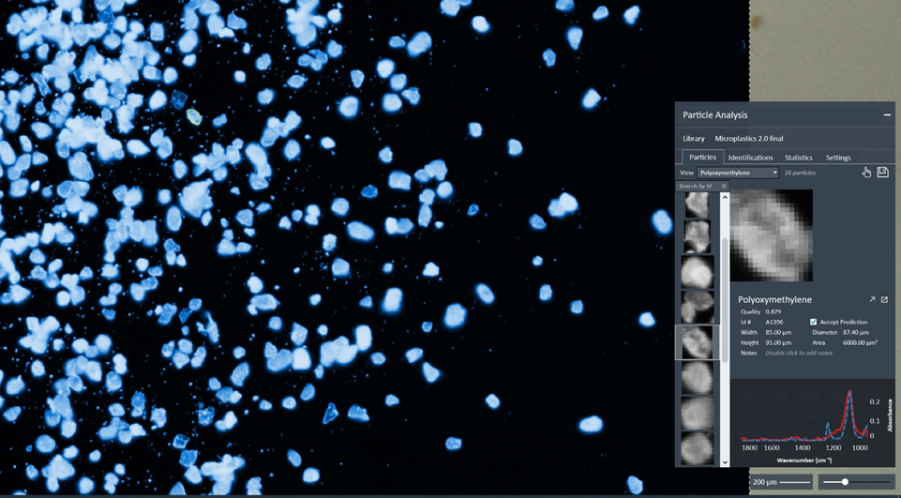Figure S13. Polyoxymethylene.

Sample ID | Coordinates | Description of sampling site | Traffic intensity approx. vehicles/day | Site type
V1 | 48°14′09.53″ N, 16°25′24.10″ E | The site is located on Wagramer Straße in the Donaustadt (22nd) district of Vienna and is characterized by a mix of modern office buildings, residential complexes, and green urban spaces. Wagramer Straße serves as a major local thoroughfare, connecting the Donau City area with other parts of Vienna and facilitating access to the U1 metro line. The street runs alongside these commercial and residential developments, and recent urban redesigns have introduced wide cycle lanes, pedestrian paths, and landscaped areas, which help to organize traffic and create a more pedestrian-friendly environment. Traffic levels are generally moderate to moderately high, especially during peak commuting hours, but the improved infrastructure eases congestion and supports smoother vehicle, bicycle, and pedestrian flows. | 9600 | urban commercial/residential mixed-use site.
V2 | 48°13′01.02″ N, 16°23′29.00″ E | The site is located on Franzensbrückenstraße, immediately adjacent to Praterstern in Leopoldstadt (2nd district), Vienna, at the junction leading from the square to surrounding streets and the Wiener Prater park. The area is a mixed-use urban environment with residential buildings, commercial establishments, and services, benefiting from the nearby major transport hub that includes metro lines U1 and U2, regional trains, trams, and buses. Traffic levels are moderate to high for vehicles, especially during peak hours, while pedestrian and cyclist flows are also significant due to the station, shops, and park access. Overall, the site functions as a dynamic urban edge zone, combining strong transport connectivity with nearby green spaces, creating a balanced environment for mobility, commerce, and recreation. | 9400 | mixed-use urban site adjacent to major transport hub
V3 | 48°12′41.94″ N, 16°22′44.33″ E | The site is located on Franz-Josefs-Kai, at Schwedenplatz in the 1st district of Vienna, along the right bank of the canal (Donaukanal). Franz-Josefs-Kai is a historic quay-street roughly 1.3 km long, forming part of the old ring road around Vienna’s old town. The stretch at Schwedenplatz serves as a major urban artery and transport junction, with easy access to multiple transit lines — including metro lines (U1, U4), trams, buses, and water-based transport along the canal. The surroundings feature a mixed-use urban environment: residential and historic buildings (many reflecting the “Gründerzeit” style), restaurants/cafés, small shops, and riverside amenities — typical of a central-city quay. Due to the proximity of Schwedenplatz and major transport infrastructure, pedestrian and public-transport traffic is high, while vehicular traffic along the quay is also significant, especially as the street is part of a main city ring/artery (the national route B227). Overall, the site functions as a high-access, mixed-use urban core quay, combining history, residential/commercial use, and strong multimodal connectivity — offering convenient access to inner-city amenities, waterways, and public transport while retaining a canal-side, central-city character. | 43400 | mixed-use urban site adjacent to major transport and canal
V4 | 48°10′38.21″ N, 16°22′24.74″ E | The site is located at the intersection of Laxenburger Straße and Erlachgasse in the Favoriten district (10th district) of Vienna, at the junction of a main arterial road and a smaller residential street. The area is a mixed-use urban environment, with residential buildings, small shops, and local services along Erlachgasse, while Laxenburger Straße carries heavier vehicle traffic as a main thoroughfare. Traffic levels are moderate to high, particularly during commuting hours, with pedestrian and cyclist flows present along sidewalks and local lanes. Overall, the site functions as a residential edge along a major arterial street, combining accessibility to public transport and local amenities with a predominantly urban, low- to mid-rise built environment. | 20200 | Residential-arterial edge
V5 | 48°11′09.71″ N, 16°20′42.50″ E | The site is located at the intersection of Bräuhausgasse and Margaretenstraße in the Margareten district (5th district) of Vienna, at the junction of a smaller residential street and a main urban arterial. The surrounding area is a mixed-use urban environment, with historic residential buildings, small shops, and local services. Traffic levels are moderate, with vehicles primarily using Margaretenstraße as a main thoroughfare and pedestrians present along both streets accessing shops and residences. As a short-term sampling site, this location provides a representative urban edge environment, combining exposure to vehicular, pedestrian, and local neighborhood flows while remaining accessible and safe for monitoring activities. | 50200 | Residential-arterial intersection
V6 | 48°11′09.78″ N, 16°19′14.77″ E | The site is located at the main approach area to Schönbrunn Palace in the 13th district of Vienna, near the junction of the main access road to the palace and Winckelmannstraße. The surroundings combine historical and cultural heritage (the palace and its park), mixed-use urban fringe typified by low- to mid-rise residential and service buildings, and transit-related infrastructure. Given that Schönbrunn is a major tourist destination with a public transport stop nearby (metro U4 station “Schönbrunn”, tram/bus lines) - the location experiences variable traffic and pedestrian flows: elevated pedestrian and tourist footfall, periodic vehicle traffic (visitors arriving by car or bus), and a mix of local residential mobility. As a short-term sampling site, this location offers a heritage-edge / urban fringe tourism-interface type: it reflects a blend of residential neighbourhood dynamics, visitor/tourist flows, and access traffic — useful for monitoring elements like ambient noise, air quality, mixed mobility impacts, or urban environment stress in a zone balancing cultural heritage and daily urban life. | 15000 | Urban arterial / tourist-edge intersection
V7 | 48°12′59.51″ N, 16°21′58.32″ E | The site is located at the intersection of Schlickplatz and Maria-Theresien-Straße in Vienna, in an urban mixed-use area that combines residential buildings, small shops, and local services. Maria-Theresien-Straße functions as a main arterial street, carrying moderate to high vehicle traffic, while Schlickplatz is a smaller street feeding into it, with pedestrians accessing nearby businesses and residences. Traffic patterns include vehicles on the arterial, pedestrians along sidewalks, and local neighborhood flows, making this a representative point for urban monitoring. As a short-term sampling site, it captures the dynamics of a residential-arterial edge, balancing accessibility with exposure to both vehicular and pedestrian activity. | 18500 | urban roadside / residential-arterial intersection
Table S1. Details of sampling sites: ID, coordinates, description, traffic intensity, and site type.

 | Grain size 0.2-0.1 mm |  | Grain size 0.1-0.05 mm |  | Grain size < 0.05 mm
Name of sampling site | Strong magnetic [%] | Weak magnetic [%] | Strong magnetic [%] | Weak magnetic [%] | Strong magnetic [%] | Weak magnetic [%]
V1 | 26,6 | 73,4 | 100 | 0 | 100 | 0
V2 | 16 | 84 | 55,5 | 44,5 | 100 | 0
V3 | 24,3 | 75,7 | 24,1 | 75,9 | 100 | 0
V4 | 35,1 | 64,9 | 26,5 | 73,5 | 100 | 0
V5 | 15,8 | 84,2 | 20,8 | 79,2 | 100 | 0
V6 | 36,5 | 63,5 | 18,7 | 81,3 | 100 | 0
V7 | 63,7 | 36,3 | 48 | 52 | 100 | 0

Table S2. Contribution of strong and weak magnetic fractions in different grain sizes across sampling sites.

 | Grain size 0.2-0.1 mm |  |  | Grain size 0.1-0.05 mm |  |  | Grain size  < 0.05 mm
Name of sampling site | Bulk  sample  Χfd [%] | Strong magnetic  Χfd [%] | Weak  Magnetic Χfd [%] | Bulk  sample  Χfd [%] | Strong magnetic Χfd [%] | Weak  magnetic  Χfd [%] | Strong magnetic  Χfd [%]
V1 | 6,2 | 5,5 | 8,4 | 6,4 | 6,4 | 9,6 | 6,3
V2 | 4,3 | 6,5 | 7,1 | 5,2 | 4,7 | 8,5 | 6,3
V3 | 5,0 | 4,6 | 8,4 | 4,8 | 4,4 | 9,1 | 6,5
V4 | 2,5 | 2,9 | 9,3 | 3,2 | 3,7 | 7,3 | 5,5
V5 | 3,6 | 4,6 | 7,1 | 5,2 | 5,8 | 10,5 | 5,2
V6 | 5,6 | 6,8 | 9,0 | 6,2 | 5,0 | 7,7 | 6,4
V7 | 2,0 | 3,6 | 7,7 | 3,8 | 4,5 | 7,3 | 4,1
Min. | 2,0 | 0,0 | 7,1 | 3,2 | 3,7 | 10,5 | 4,1
Max. | 6,2 | 6,8 | 9,3 | 6,4 | 6,4 | 8,8 | 6,5
Mean | 4,2 | 4,3 | 8,1 | 5,0 | 4,9 | 1,2 | 5,8
SD | 1,6 | 2,4 | 0,8 | 1,2 | 0,9 | 9,6 | 0,9
Table S3. Frequency-dependent magnetic susceptibility (χfd%) of road dust samples collected at different sampling sites (V1–V7) for three grain-size fractions.

Sample and fraction | Ms 10⁻³ [A*m³/kg] | Mrs 10⁻³ [A*m³/kg] | Hc [mT] | Hcr [mT] | Mrs/Ms [-] | Hcr/Hc [-]
0.2-0.1 mm | Strongm magnetic fraction
V1 | 248,82 | 17,24 | 3,50 | 17,50 | 0,07 | 5,00
V2 | 451,26 | 36,88 | 7,50 | 35,00 | 0,08 | 4,67
V3 | 705,46 | 54,42 | 3,50 | 16,00 | 0,08 | 4,57
V4 | 1548,92 | 94,08 | 6,50 | 30,00 | 0,06 | 4,62
V5 | 1359,06 | 48,88 | 1,00 | 3,00 | 0,04 | 3,00
V6 | 102,72 | 4,68 | 6,00 | 32,00 | 0,05 | 5,33
V7 | 439,45 | 6,29 | 1,00 | 3,00 | 0,01 | 3,00
0.1-0.05 mm | Strong magnetic fraction
V1 | 247,22 | 13,58 | 3,00 | 15,00 | 0,05 | 5,00
V2 | 577,36 | 18,48 | 1,00 | 5,00 | 0,03 | 5,00
V3 | 1477,20 | 104,38 | 5,50 | 25,00 | 0,07 | 4,55
V4 | 2487,38 | 141,98 | 5,50 | 29,00 | 0,06 | 5,27
V5 | 524,67 | 40,45 | 6,00 | 26,00 | 0,08 | 4,33
V6 | 283,56 | 15,26 | 3,00 | 18,00 | 0,05 | 6,00
V7 | 413,82 | 23,20 | 3,50 | 22,50 | 0,06 | 6,43
<0.05 mm | Strong magnetic fraction
V1 | 193,36 | 10,96 | 3,00 | 18,00 | 0,06 | 6,00
V2 | 274,56 | 24,38 | 6,50 | 33,00 | 0,09 | 5,08
V3 | 218,70 | 14,22 | 5,50 | 34,00 | 0,07 | 6,18
V4 | 256,96 | 19,72 | 4,50 | 20,00 | 0,08 | 4,44
V5 | 333,26 | 27,56 | 4,50 | 24,00 | 0,08 | 5,33
V6 | 301,42 | 21,78 | 5,50 | 32,00 | 0,07 | 5,82
V7 | 434,32 | 30,06 | 4,50 | 26,50 | 0,07 | 5,89
0.2-0.1 mm | Weak magnetic fraction
V1 | 8,86 | 0,28 | 2,50 | 31,00 | 0,03 | 12,40
V2 | 10,80 | 1,00 | 8,50 | 38,00 | 0,09 | 4,47
V3 | 11,22 | 0,78 | 5,50 | 36,00 | 0,07 | 6,55
V4 | 3,89 | 0,14 | 3,00 | 33,00 | 0,04 | 11,00
V5 | 5,49 | 0,35 | 5,00 | 35,00 | 0,06 | 7,00
V6 | 8,21 | 0,18 | 1,50 | 7,00 | 0,02 | 4,67
V7 | 15,32 | 1,54 | 8,70 | 43,00 | 0,10 | 4,94
0.1-0.005 mm | Weak magnetic fraction
V1 | the weak magnetic subfraction was not obtained because 100 percent of the material was recovered as the strongly magnetic fraction
V2 | 14,34 | 1,26 | 8,50 | 42,00 | 0,09 | 4,94
V3 | 16,46 | 1,02 | 5,50 | 32,00 | 0,06 | 5,82
V4 | 7,05 | 0,27 | 3,00 | 28,00 | 0,04 | 9,33
V5 | 14,34 | 1,26 | 8,50 | 30,00 | 0,09 | 3,53
V6 | 10,58 | 0,23 | 1,00 | 7,00 | 0,02 | 7,00
V7 | 35,20 | 1,50 | 3,00 | 18,00 | 0,04 | 6,00
<0.05 mm | Weak magnetic
 | For all locations V1-V7 the weak magnetic subfraction for fraction <0.005 mm was not obtained because 100 percent of the material was recovered as the strongly magnetic fraction
Table S4. The parameters of the hysteresis loop and remanent coercivity values for magnetic and weak magnetic fractions of road dust across different grain size ranges.

Width (µm) | Height (µm) | Diameter (µm) | Aspect Ratio | Area (µm²) | Perimeter (µm) | Eccentricity | Circularity | Solidity | Identification
170 | 111 | 112.27 | 1.53 | 9900 | 669.41 | 0.60 | 0.28 | 0.69 | Acrylonitrile butadiene styrene
83 | 78 | 78.18 | 1.06 | 4800 | 271.42 | 0.66 | 0.82 | 0.94 | Polyamide
116 | 54 | 76.63 | 2.14 | 4612.5 | 310.92 | 0.48 | 0.60 | 0.88 | Polymethyl methacrylate
51 | 36 | 41.65 | 1.44 | 1362.5 | 147.78 | 0.58 | 0.78 | 0.93 | Polyethylene
28 | 64 | 41.27 | 0.44 | 1337.5 | 161.92 | 0.87 | 0.64 | 0.92 | Polyethylene terephthalate
308 | 78 | 138.43 | 3.95 | 15050 | 732.55 | 0.34 | 0.35 | 0.80 | Polypropylene
85 | 100 | 92.45 | 0.85 | 6712.5 | 324.35 | 0.69 | 0.80 | 0.95 | Polyurethane
41 | 66 | 43.52 | 0.63 | 1487.5 | 200.21 | 0.67 | 0.47 | 0.73 | Polyvinyl chloride
85 | 95 | 87.40 | 0.89 | 6000 | 307.28 | 0.56 | 0.70 | 0.96 | Polyoxymethylene

Table S5. The characteristics of the selected particles.

 | MPs | PE | PET | PMMA | POM | PP | PU | PVC | ABS | PA | χlf | χfd% | χARM | MPLI | Ms | Mrs | Hc | Hcr | T
MPs | 1,00
PE | 0,08 | 1,00
PET | -0,06 | 0,06 | 1,00
PMMA | -0,04 | -0,06 | -0,03 | 1,00
POM | 0,52 | -0,06 | 0,02 | -0,11 | 1,00
PP | 0,21 | 0,10 | 0,03 | -0,10 | 0,01 | 1,00
PU | 0,57* | 0,07 | 0,10 | -0,06 | 0,22 | -0,19 | 1,00
PVC | 0,50 | 0,03 | -0,02 | -0,12 | 0,12 | 0,03 | 0,27 | 1,00
ABS | 0,19 | -0,08 | -0,07 | -0,09 | 0,05 | 0,82* | -0,19 | -0,15 | 1,00
PA | 0,06 | -0,07 | -0,06 | -0,08 | -0,10 | 0,87* | -0,23 | -0,13 | 0,95* | 1,00
χlf | 0,54* | 0,33 | -0,13 | -0,24 | 0,44 | 0,06 | 0,26 | 0,24 | 0,11 | 0,03 | 1,00
χfd% | -0,24 | -0,15 | 0,10 | 0,14 | -0,03 | -0,10 | -0,25 | -0,06 | -0,14 | -0,14 | -0,70* | 1,00
χARM | 0,47 | 0,36 | -0,13 | -0,24 | 0,37 | 0,01 | 0,26 | 0,22 | 0,13 | 0,04 | 0,97* | -0,71* | 1,00
MPLI | 0,95* | 0,16 | 0,03 | 0,07 | 0,46 | 0,28 | 0,67* | 0,52 | 0,23 | 0,14 | 0,48 | -0,26 | 0,44 | 1,00
Ms | 0,49 | 0,36 | -0,13 | -0,21 | 0,44 | -0,01 | 0,28 | 0,21 | 0,03 | -0,03 | 0,97* | -0,68* | 0,96* | 0,45 | 1,00
Mrs | 0,51 | 0,37 | -0,13 | -0,20 | 0,51 | 0,00 | 0,19 | 0,29 | 0,04 | -0,04 | 0,95* | -0,55* | 0,91* | 0,45 | 0,95* | 1,00
Hc | 0,28 | 0,19 | -0,17 | 0,39 | 0,10 | -0,04 | 0,00 | 0,32 | -0,06 | -0,10 | 0,09 | 0,13 | 0,07 | 0,29 | 0,09 | 0,23 | 1,00
Hcr | -0,06 | -0,22 | 0,02 | 0,17 | -0,08 | -0,05 | -0,07 | 0,25 | -0,17 | -0,09 | -0,45 | 0,53 | -0,48 | -0,05 | -0,40 | -0,30 | 0,54* | 1,00
T | 0,15 | 0,01 | -0,24 | 0,17 | 0,18 | -0,01 | -0,05 | 0,04 | -0,03 | -0,12 | 0,18 | -0,26 | 0,14 | 0,11 | 0,18 | 0,21 | 0,10 | -0,19 | 1,00

*p value <0.001
Table S6. Pearson correlation matrix between microplastic types, pollution indices, and magnetic parameters (N = 34). Values represent Pearson correlation coefficients (r). Asterisks (*) indicate statistical significance at the p<0.001 level. Abbreviations: MPs – total microplastics; PE – polyethylene; PET – polyethylene terephthalate; PMMA – poly(methyl methacrylate); POM – polyoxymethylene; PP – polypropylene; PU – polyurethane; PVC – polyvinyl chloride; ABS – acrylonitrile butadiene styrene; PA – polyamide; χlf​ – mass specific magnetic susceptibility; χfd%​ – frequency dependent magnetic susceptibility; χARM​ – anhysteretic remanent magnetization; MPLI – Microplastic Pollution Load Index; Ms​ – saturation magnetization; Mrs​ – saturation remanence; Hc​ – coercivity; Hcr​ – remanent coercivity; T – traffic intensity.

