The Version of Record of this article is published in Journal of Hazardous Materials Elsevier, and is available online at https://doi.org/10.1016/j.jhazmat.2026.141944. This version has not undergone any post-acceptance improvements or corrections.

An Integrated Methodological Framework for the Characterization of Fine Urban Road Dust (<50 μm): Magnetic, Mineralogical, and Thermal Analyses
Sylwia Dytłow
Institute of Geophysics, Polish Academy of Sciences, Księcia Janusza 64, 01-452 Warsaw, Poland
ORCID 0000-0001-6968-6491
skdytlow@igf.edu.pl

Małgorzata Lempart-Drozd
Institute of Geological Sciences, Polish Academy of Sciences, Research Centre in Krakow, Senacka St. No. 1, PL-31002, Poland
ORCID 0000–0001-7394–5951
ndlempar@cyf-kr.edu.pl
*E-mail address of the corresponding Author: skdytlow@igf.edu.pl

Highlights
- IR and TG-MS signatures define the anthropogenic organic loading in dust.
- Magnetic susceptibility is a rapid proxy for total organic carbon and organic matter.
- Magnetite-associated aggregates concentrate hazardous organic pollutants.
- TG-MS qualitatively and quantitatively characterized road dust components.
- Identifying geogenic and anthropogenic dust requires integrated physicochemical analysis.
Keywords
Road dust; XRD; TG-MS; Magnetic susceptibility; Organic matter
Abstract
Urban road dust (<50 µm) is a primary reservoir for hazardous materials, but its geogenic matrix often masks anthropogenic pollutants. This study introduces an integrated framework combining magnetic susceptibility (χ), XRD, TG-MS, FTIR, and SEM to characterize road dust from Vienna. Results reveal a matrix dominated by geogenic quartz (25-45%) and carbonates (20-50%); however, quartz acts as a diamagnetic diluent, whereas technogenic magnetite governs the magnetic behavior (χ up to 374.8×10⁻⁸ m³kg⁻¹). Although trace iron (hydr-) oxide phases are below the XRD detection limits, thermomagnetic κ(T) curves and FTIR results identify stable single-domain magnetite. A key finding is the powerful performance of χ as a comprehensive proxy for carbonaceous pollutants, which is strongly correlated with Total Carbon (r=0.71), Total Organic Carbon (r=0.78), and Organic Matter (r=0.76). Crucially, analysis of magnetic extracts revealed that they are significantly enriched in hazardous anthropogenic components compared to the geogenic background. TG-MS and FTIR analyses of these extracts successfully identified concentrated signatures of bitumen, tire wear, and fuel residues via aliphatic C-H groups (2924, 2853cm⁻¹) and specific pyrolytic mass fragments (e.g, m/z 77, 78, 91, 105). This integrated approach effectively distinguishes harmless geogenic minerals from technogenic materials hazardous to the environment and human health. A novel application of TG-MS analysis enables quantitative and qualitative characterization of road dust components and is a promising tool for further investigation. Using χ as a rapid, nondestructive prescreening tool allows for high-resolution monitoring of pollution hotspots and public health risks associated with inhalable, magnetite-linked organic contaminants, providing a reliable strategy for urban air quality management.
Environmental implication
The integration of magnetic, mineralogical, and thermal methods provides a sophisticated diagnostic tool for urban environmental management. By combining magnetic susceptibility (χ) with TG-QMS and FTIR, it is possible to bypass the detection limits of traditional XRD and precisely distinguish geogenic backgrounds from hazardous anthropogenic loads. This multi-parameter approach reveals the physical coupling of organic pollutants with technogenic iron (hydr-) oxides, offering a reliable strategy for identifying high-risk areas. Implementing this integrated framework facilitates more effective public health policies and air quality monitoring, targeting the resuspension of inhalable, magnetite-linked contaminants that pose significant environmental risks.

- Introduction
Urban road dust constitutes a complex and dynamic component of the urban environment, formed through the interaction of natural geological materials and a wide range of human activities, including vehicular traffic, infrastructure wear, construction, and atmospheric deposition. Due to its continuous accumulation and resuspension, road dust acts both as a temporary reservoir and as a transport medium for particles and contaminants within cities.
In urban environments, road dust is generated through a combination of natural and anthropogenic processes. Geogenic sources include weathering and erosion of local soils and rocks, whereas anthropogenic contributions arise from traffic emissions (both exhaust and non-exhaust), industrial activities, and the wear or degradation of built surfaces such as roads and buildings [1], [2], [3]. Glass microspherules (beads) serve as primary indicators of road infrastructure degradation within this matrix, released from road markings via tire-induced abrasion and high-intensity mechanical street cleaning [4], [5], [6], [7], [8], [9], [10], [11], [12], [13]. Surface pitting, conchoidal micro-fractures, and adhering polymer binder residues distinguish these weathered beads from pristine industrial particles, confirming their mechanical transition into the mineral phase [14], [15]. The resulting accumulation of diverse mineral and technogenic particles forms a complex environmental medium that reflects the long-term interaction between urban infrastructure and local transport dynamics.
Once mobilized by urban runoff, road dust particles enter downstream sedimentary reservoirs, such as riverbeds and floodplains, where they serve as a primary vector for pollutants. Recent studies highlight the scale of this transport, showing that road dust is a primary source of microplastics (MPs) [16]; for instance, it can contribute up to 99% of the total MPs in river runoff [17] and accounts for 62% of the annual MP load entering the Baltic Sea [18]. In these environments, these particles contribute to biogeochemical processes through chemical reactivity interfaces [19]. Accumulated deposits in these environments serve as environmental archives, recording the intensity of urban weathering and the long-term impact of anthropogenic particles on the geochemical environment.[19]
The minerals derived from local soils and geological formations constitute the primary components of road dust [20], [21], forming the lithogenic matrix of these sediments; this matrix is significantly augmented during winter months by the intentional application of quartz-rich abrasives and salt-sand mixtures for traction control (de-icing) [22]. However, this mineral background is significantly altered by the accumulation of anthropogenic organic compounds originating from urban activities. Road dust contains a wide range of organic carbon–hydrogen compounds, including polycyclic aromatic hydrocarbons and their derivatives, fuel- and asphalt-derived aliphatic hydrocarbons, hopanes and steranes, phthalate esters, tire-wear-related organic compounds, and microplastic polymers, reflecting dominant traffic-related sources [23], [24], [25], [26], [27], [28], [29], [30].
Fine fractions of urban road dust are characterized by elevated concentrations of iron-bearing particles, including strongly magnetic phases with properties comparable to magnetite. Owing to their high mobility and ease of atmospheric resuspension, these particles represent a potential inhalation hazard in urban environments [31], [32], [33], [34]. Magnetic measurements of street dust have recently become a widely used approach for evaluating urban pollution, as particles originating from human activities can significantly increase the magnetic signal of surface dust [35], [36], [37], [38], [39]. Unlike conventional chemical analyses, these magnetic techniques are quick, straightforward, preserve the samples, and require relatively low resources to implement [40].
To adequately characterize complex environmental samples such as urban road dust, a suite of complementary analytical techniques is required to capture both mineralogical and organic signatures. X-ray diffraction (XRD) [41], [42] is widely used for the identification and quantification of crystalline mineral phases in heterogeneous matrices, providing a foundation for understanding geogenic components and differentiating them from anthropogenic inputs [21], [24], [43], [44], [45], [46], [47], [48], [49], [50], [51]. XRD has been applied extensively to diverse particulate samples to determine the presence of minerals such as quartz, feldspars, clay minerals, and carbonates, and to interpret their environmental origins and transformations.
Fourier transform infrared spectroscopy (FTIR) [52], [53], [54] complements diffraction methods by enabling rapid, non-destructive identification of both inorganic and organic functional groups. FTIR does not require extensive sample preparation and has been effectively used to distinguish mineral vibrational features and organic moieties in soils, sediments, and atmospheric dusts [55], [56], [57], [58], [59] making it a valuable tool for preliminary screening of complex environmental matrices.
Thermogravimetry coupled with quadrupole mass spectrometry (TG-MS) [60], [61], [62], [63], [64], [65] provides insight into the thermal stability and decomposition behavior of both mineral and organic components. By monitoring mass changes and the identity of volatile products during controlled heating, these thermal methods reveal compositional differences linked to organic matter content, carbonate breakdown, adsorbed and structural water loss, and anthropogenic residues. TG-MS is a powerful yet underutilized tool which did not require sample pretreatment protocols and provides comprehensive characterization of organic and inorganic compounds. However, there is very little research applying TG-MS specifically to road dust [66], [67], and to our knowledge, this study presents the first comprehensive TG-MS analysis on road dust overall and on the magnetic extract of road dust.
Finally, elemental CHNS analysis and total organic carbon (TOC) [68], [69], [70], [71] determination offers quantitative assessments of bulk element composition and organic carbon pools in environmental samples. These measurements are central in assessing organic matter content, pollutant load, and carbon cycling dynamics in soils, sediments, and particulate matrices. They are frequently used in conjunction with spectroscopic and mineralogical tools to build a detailed compositional profile.
Scanning Electron Microscopy-Energy Dispersive Spectroscopy (SEM-EDS) is a fundamental technique that allows for the precise characterization of individual particles, providing insights into their origin and history. This approach is particularly valuable because particle morphology, including shape, size, and surface roughness, is directly linked to its environmental behavior, mobility, and reactivity [24], [56], [72]. By analyzing single particles, SEM-EDS can effectively differentiate between diverse sources based on their distinct structural signatures [73], [74], [75], [76]. Consequently, these morphological fingerprints enable a more nuanced understanding of the complex mixtures found in urban road dust.
Together, this integrated analytical framework enables a comprehensive understanding of the sources, composition, and transformation processes of road dust and other particulate materials in environmental systems. By combining mineralogical, spectroscopic, thermal, and chemical element perspectives, researchers can link observed properties to natural background materials and anthropogenic influences, supporting robust interpretations of complex environmental data.
The main aim of this study is to investigate the mineralogical, magnetic, and chemical characteristics of the finest fraction of road dust (<50 µm) in Vienna, and to evaluate its potential environmental implications. Magnetic properties were assessed using mass-specific magnetic susceptibility (χ), frequency-dependent susceptibility (χfd%), and anhysteretic remanent magnetization susceptibility (χ_{ARM}). Morphology and physicochemical composition were examined using SEM-EDS, XRD, FTIR, TG-MS, and CHNS elemental analysis.
Based on this context, the study addresses the following research questions:
• What is the overall mineralogical composition of the fine road dust fraction, and how can the application of quantitative and qualitative analyses (XRD, TG-MS, FTIR, CHNS, and SEM) be integrated to distinguish its mineralogical and organic compounds and determine their anthropogenic and geogenic sources?
• What are the dominant magnetic minerals and their physical characteristics, and what do they indicate about the nature of the particles?
• How do the magnetic properties relate to the organic geochemical signature of the dust, and can these relationships serve as a pre-screening tool for pollution assessment?
• In what way does the geogenic mineral matrix influence the measured concentrations of anthropogenic markers?
• What information about the origin of road dust components can be provided by the characterization of their thermal behavior during pyrolysis (TG-MS)?
- Study area, geology, methodology, and analytical procedures
  - Study area
Sampling was carried out within the administrative boundaries of Vienna, the capital of Austria, situated in the northeastern part of the country. The city covers an area of approximately 415 square kilometers and serves as the main administrative, political, and cultural center. As of January 1, 2024, Vienna has a population of about 2.0 million residents [77]. The population density reaches nearly 4,000 inhabitants per square kilometer, and the city is characterized by a compact urban layout supported by an extensive transportation network that includes major roads and highways. Although Vienna is highly urbanized, it also contains numerous green areas, including historic forested parks and zones adjacent to national park regions. The local climate is classified as temperate continental with warm summers, cold winters, and relatively evenly distributed precipitation throughout the year according to the Köppen–Geiger Cfb classification. The mean annual temperature is approximately 10.9°C, and the average annual precipitation is around 703 mm (climate-data.org). Due to the high traffic volume and the dense road network, vehicle emissions are the dominant source of air and surface pollution in the city. Details of sampling sites: ID, coordinates, description, traffic intensity, site type, sampling strategy/mode, approximate effective sampling area, road dust loading, and percentage mass contribution of fine fraction (<50 μm) to the total sample mass were provided in Table S1 of the Supplementary Materials.
  - Road dust sampling and initial sample preparation
Road dust samples were obtained in Vienna (Figure 1) between 28 and 30 April 2025, during a period of stable weather, with air temperatures ranging from 17 °C to 20 °C and very low wind activity. The material was collected directly from street surfaces using a broom and dustpan made from natural materials (wood and natural bristles) in order to reduce the potential introduction of microplastic particles during sampling. All sampling took place on dry pavement, following at least seven consecutive days without rainfall. At each sampling point, approximately 500–800 g of material was gathered and transferred into pre-labelled glass containers to prevent cross-contamination during transport. The samples were subsequently transported to a laboratory of the Institute of Geophysics, Polish Academy of Sciences in Warsaw, where they were air-dried at ambient conditions (approximately 25 °C) for seven days to decrease moisture content and ensure sample stability prior to analysis. Characteristics of the investigated sampling locations are detailed in Table S1 in Supplementary Materials. This table provides specific data for each site, including sample IDs, precise coordinates, site categories, brief environmental descriptions, sampling strategy/mode, effective sampling area, and road dust loading. Furthermore, it incorporates daily traffic estimates sourced from the Verkehrsverbund Ost-Region [78].
Road dust is characterized by a highly non-uniform distribution across the street surface, with material typically accumulating in significantly greater quantities along the curb due to vehicle-induced turbulence and urban drainage patterns. Furthermore, the physical accessibility of the sampling area in a dense urban environment varies depending on real-time traffic dynamics and infrastructure constraints. To account for these factors, a constant 5-meter stretch was established at each site, while the effective sampling area (A) was adaptively adjusted to maintain sample representativeness and secure a sufficient bulk sample mass for multi-instrumental analysis.

To standardize the results regardless of the specific sampling geometry, the parameter Road Dust Loading (L) was introduced and calculated according to the following equation:
​$L=\frac{A}{M} (1)$

where L is the road dust loading (g/m²), M is the total mass of the collected bulk sample (g), and A is the precisely measured effective sampling area (m²).
At locations with continuous heavy traffic or where vehicles were densely packed while waiting for red lights, physical access to the road axis was severely restricted. In these cases, sampling was focused primarily along the curb where high material accumulation allowed for a representative mass to be collected from a smaller area. For sites V3 and V5, the effective area was 4.0 m², resulting in loading values of 158.6 g/m² and 164.3 g/m², respectively. Notably, at site V6, an exceptionally thick dust layer was observed along the curb. Consequently, even with a restricted sampling area of only 3.0 m², this site yielded the maximum loading value of 250.8 g/m². Conversely, where traffic light cycles or larger gaps between stationary vehicles allowed for safer movement toward the road center, transects were extended further to capture material from the thinner and more dispersed dust layer. For sites V1, V2, and V7, the effective area was 7.5 m², with loading values of 85.64 g/m², 102.41 g/m², and 80.52 g/m² respectively. The largest area of 10.0 m² was swept at site V4, where the most dispersed material yielded the lowest loading of 54.18 g/m². Detailed site-specific parameters, including calculated loadings for each location, are summarized in Table S1.
The dried samples were then subjected to granulometric separation using a laboratory sieve shaker (LPzE-2e; MULTISERW-Morek, Poland) equipped with a certified stainless-steel sieve set with a mesh aperture of 50 µm. Granulometric separation was performed using a 50 µm mesh sieve, which corresponds to the official boundary between sand and silt (0.05 mm) according to the classification standards of the United States Department of Agriculture (USDA) [79]. The selection of this specific fraction was driven by the fact that finer dust particles possess a significantly larger specific surface area, which enhances their pollutant adsorption capacity, bioavailability, and atmospheric mobility. While the clay-sized fraction (<2 µm) was initially targeted due to its extreme environmental hazard, its mass yield was insufficient for the complete multi-instrumental analytical protocol. Therefore, the 50 µm cutoff was adopted to secure a representative sample mass while effectively removing the coarser, chemically inert sand matrix, thereby increasing the analytical sensitivity for diagnostic organic and mineral markers. The granulometric separation revealed that the fine fraction (<50 μm) accounted for a variable portion of the total bulk mass, ranging from 9.69% (at site V4) to 30.30% (at site V6). Detailed weight percentages for all investigated locations (V1: 19.53%, V2: 19.62%, V3: 26.23%, V5: 17.66%, V7: 20.84%) are provided in Table S1 (Supplementary Materials). Magnetic fraction separation was performed on all samples using a hand-held separator containing a neodymium magnet, with a maximum magnetic induction of 0.30 T (3000 Gs ±5%) at the working surface.

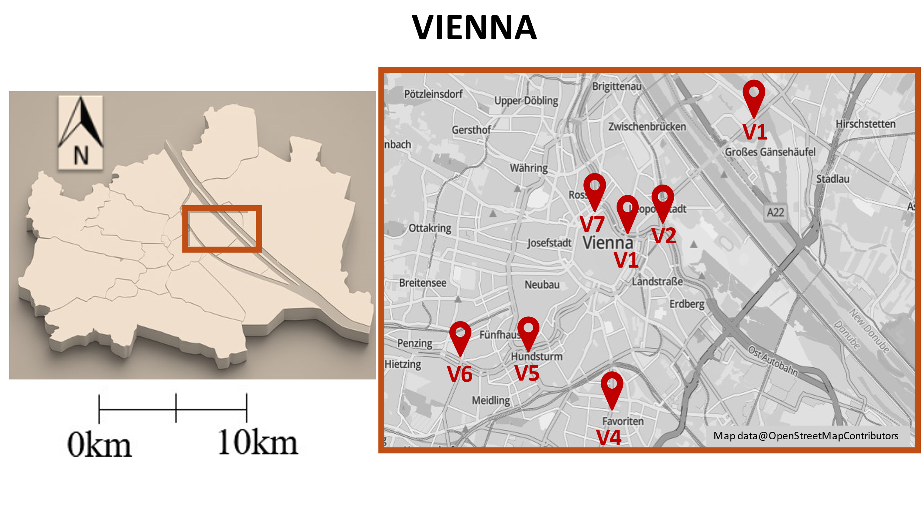
Figure 1. The locations of the road dust sampling sites (V1–V7) in Vienna, Austria. The inset map illustrates the position of the city within the country, while the main panel indicates the seven sampling points situated in the central and southern urban district.
  - Magnetic separation procedure
Magnetic separation was performed with a manually operated neodymium separator [80] (Enes Magnetics, Poland) intended for extracting ferromagnetic grains from fine particulate materials. The separator contains a high-intensity neodymium magnet enclosed in a sealed cylindrical stainless-steel tube (AISI 304) with a diameter of 32 mm and an active length of 200 mm. The device features an ergonomic plastic handle connected to a mechanical plunger, which enables the magnet to be withdrawn vertically inside the housing. Pulling the handle upward retracts the magnet, allowing the adhered particles to detach and fall into a separate container. Because the sample never directly touches the magnet, the risk of contamination is minimized, and operational safety is improved. Following the collection of road-dust material designated for chemical and magnetic analyses, the remaining portions of each sample were subjected to magnetic separation. The dust from each site was evenly spread on a clean, non-magnetic working surface made of glass and thick cardboard. The magnetic bar was then passed slowly over the material in gentle sweeping motions, enabling magnetic grains to accumulate on the stainless-steel casing. Once the separator reached its collection limit, it was lifted, and the plunger mechanism was used to release the captured particles into a pre-cleaned glass container.
  - Physicochemical characterization methods
Before the measurements, the powder samples were mixed and homogenised to obtain a representative portion of the sample for each analysis. XRD, FTIR, and TG-MS analyses were performed at the Claylab, Institute of Geological Sciences, Polish Academy of Sciences (Cracow, Poland).
  - X-ray diffraction (XRD)
To produce uniform and fine particle size, the samples for quantitative X-ray diffraction (QXRD) analysis should be milled before the measurements (e.g., in a McCrone mill). However, this procedure was not applied to preserve the texture and structure of powder samples with a fraction <50µm, including the occurrence of aggregates and clusters of organic and inorganic compounds. Therefore, the quality of QXRD data would be slightly affected by coarse powder of samples (large particles), influencing XRD reflections' broadening, sharpness, and orientations of particles.
XRD measurements for quantitative and qualitative mineralogical analyses were determined on randomly oriented powder specimens. The samples previously measured were side-loaded into holders for X-ray diffraction. The measurements were carried out using a Rigaku Smartlab SE diffractometer equipped with a Cu lamp, CBO-α optics, and D/Tex Ultra 250 detector. The measurements were performed in the range of 3 - 70° 2Θ, with a step size of 0.02°. The quality of measurement was verified by replicate measurements on a selected sample. Initial qualitative analysis was performed using EVA software (ver. 4.2.0.31), the Crystallography Open Database (COD), the ICDD Powder Diffraction File (PDF), and RRUFF sample data. Profex/BGMN 3.14.2 software package with structural models based on the ICSD database was used for quantitative analysis. This program allows for estimating the weight fractions of crystalline phases-based Rietveld refinement procedure [81]. To evaluate the fitting quality, the weighted residual square sum R_{wp} was taken as the difference between the measured and calculated XRD diagrams [81], R_{wp}<10% was considered acceptable for a reliable fit when dealing with such challenging samples (Table S2 in Supplementary Materials). The detection limit for quantitative analysis was ~3%.
  - Fourier-transform infrared spectroscopy (FTIR)
Fourier-transform infrared (FTIR) spectroscopy measurements were conducted using a Nicolet 6700 spectrometer equipped with a DTGS KBr detector (Thermo Scientific). The samples were measured using a single-reflection diamond Attenuated Total Reflection (ATR) accessory (MIRacle by PIKE Technologies, Madison, Wisconsin, USA). About 1 mg of each sample was placed on a diamond crystal mold and pressed to create a thin film. Spectra were collected across the range of 4000–550 cm⁻¹, measured as 100-scan averages with a resolution of 4 cm⁻¹. The measurements were repeated two times on different portions of the sample. The repeatability verification is provided in Figure S1 (Supplementary Material).
  - Thermogravimetry coupled with quadrupole mass spectrometry (TG-MS)
Thermogravimetry coupled with quadrupole mass spectrometry (TG-MS) was used to characterize thermal properties of materials due to decomposition of organic and inorganic components during heating. TA Discovery thermogravimetr (TA Instruments, USA) was coupled to a ThermoStarTM, GDS 320 quadrupole mass spectrometer (Pfeiffer Vacuum, Germany), to simultaneously monitor mass changes and evolved volatiles as a function of temperature. Fifteen mg of powder samples was loaded into a Pt crucible, and then heated with a rate of 20°C/min up to 1000°C in dry nitrogen gas (>99.999% purity) with a flow rate of 100 cm³/min. Upon reaching 1000 °C, the purging gas was changed to dry synthetic air (>99.99% purity), with a flow rate of 100 cm³/min, and the sample was heated isothermally for 10 min to create oxidation conditions. A mean relative standard deviation of 0.10 % was found for mass loss during ramp heating between 30 and 1000°C in N₂. Among all volatiles, which could evolve during the thermal decomposition of minerals and organic compounds of road dust, only expected molecules were selected for analysis (too many collected data would reduce the quality of other spectra). The selected molecules were monitored as m/z (m – mass and z – charge of ions): 2, 12, 15, 16, 17, 18, 22, 25, 26, 27, 28, 32, 35, 36, 37, 38, 39, 41, 42, 43, 44, 45, 50, 53, 55, 56, 64, 68, 69, 77, 78, 79, 91, 92, 100, 106, 115, 136, and 149. An electron ionization energy of the MS was set to 70 eV. To avoid vapor condensation, the transfer capillary was heated to 200°C, and the gas inlet was kept at 120°C. All measurements were performed in duplicate to ensure reproducibility. Mass losses (Δm) were calculated between minima determined on the DTG curves (the first derivative of the TG curve over time) and/or on the QMS spectra. The total mass loss (Δm_{t}) was determined between 30 and 1000°C (in the range of N₂ carrier gas). The TG-MS system background contributions and capillary transfer were verified via blank (empty TG pan) runs between sample measurements and a cleaning run with an empty pan in synthetic air flow. For the method verification, parallel MS measurements were provided in Figure S2 (Supplementary Materials).

  - Elemental analysis (CHNS)
The elemental CHNS analysis was performed using a Vario EL III (Elementar GmbH), with He carrier gas by the thermal conductivity detector method (TCD). The content of carbon, hydrogen, nitrogen, and sulfur was determined in mass %. The measurements were performed in duplicates. Carbon % values were presented as the weighted average of two measurements. The instrumental detection limits (absolute) were 0.1–1 µg for N, 0.5–1 µg for C and H, and 1–2 µg for S. The absolute accuracy was < 0.1% for standard materials, with an estimated analytical uncertainty of ±0.1–0.3% for road dust samples. Measurements were conducted within the dynamic working range (C: 0.03–20 mg; H: 0.03–3 mg; N: 0.03–2 mg; S: 0.03–6 mg). The precision of this instrumental analysis was 0.1-0.3%. Due to the H, N, and S concentrations close to the instrument precision, only carbon concentrations were used for further analysis. To determine total organic carbon (TOC), samples were weighed into decontaminated silver capsules and acidified with 10% HCl/H₂O in steps of 20 μL to eliminate inorganic carbon. After digestion, the material was dried at 95°C for 30 min and 1h at 110°C. The results were summarized in Table S3 of the Supplementary Materials.

  - Scanning electron microscope combined with energy dispersive X-ray spectrometer (SEM-EDS)
Scanning Electron Microscope (SEM) observations were conducted using the FEI Nova NanoSEM 450, a versatile scanning electron microscope suitable for micro- and nanoscale research, equipped with a Through-Lens Detector (TLD) for secondary electron imaging. The analyses were performed under high-vacuum conditions of 10⁻⁶ mbar, at an accelerating voltage of 10 keV and a working distance of 4.8 mm. High-resolution micrographs were captured using a dwell time of 20 ms per line, resulting in a total frame acquisition time of approximately 20 seconds per region of interest. The element composition was characterized using Energy-Dispersive X-ray Spectroscopy (EDS) using an EDAX Octane Elect system featuring Silicon Drift Detector (SDD) technology. The measurements were carried out under the same vacuum conditions, but with a higher electron beam energy of 15 keV to provide optimal X-ray excitation. The magnetic fraction of the road dust was transferred onto conductive carbon tape mounted on aluminum stubs. Subsequently, a stream of compressed air was applied to remove loosely attached particles and ensure sample stability for SEM-EDS analysis.
  - Magnetic susceptibility (χ) and frequency-dependent magnetic susceptibility (χfd%) measurement

Magnetic susceptibility (χ) quantifies how strongly a material becomes magnetized when subjected to an external magnetic field. The value of this parameter is influenced by several factors, including the concentration of magnetic particles, their mineralogical characteristics, and the relative abundance of fine-grained magnetic minerals [82]. In environmental research, χ is frequently applied as an indirect proxy for anthropogenic magnetic particles (AMPs), such as ferro- and ferrimagnetic iron-bearing phases that are typically associated with pollution sources.
In the present study, the road dust material was placed into standard plastic sample holders with a volume of 8 cm³ (Vo). Magnetic susceptibility was measured using a multifunctional Kappabridge MFK1-FA instrument (AGICO, Czech Republic) operated at two excitation frequencies, 976 Hz (low frequency) and 15,616 Hz (high frequency). The system provides a sensitivity of 2 × 10⁻⁸ SI units and applies a magnetic field intensity of 200 A/m. This field strength is widely used because it minimizes the contribution of paramagnetic minerals while improving the detection of ferromagnetic particles, which reach saturation in relatively weak magnetic fields [40], [82]. The mass-specific magnetic susceptibility (χ, m³ kg⁻¹) was calculated following Equation (2).

$$χ=\frac{K × Vo}{m} (2)$$

where χ represents the mass-specific magnetic susceptibility (m³ kg⁻¹), K denotes the volume-specific magnetic susceptibility (dimensionless), and V₀ is the sample volume (m³).
The frequency-dependent magnetic susceptibility (χfd%) was determined to assess the relative change in susceptibility between low- and high-frequency measurements. First, the difference between the two values was calculated as χfd = χlf − χhf, and this difference was subsequently converted into a percentage according to Equation (3).

$$χfd\% = \frac{(χlf-χhf)}{χlf}×100 (3)$$
where parameters χlf and χhf denote magnetic susceptibility values measured at low and high frequencies, respectively [83], [84].

  - Hysteresis loops and anhysteretic remanent susceptibility (χ_{ARM})
For the anhysteretic remanent magnetization (ARM) and hysteresis loop analyses, the samples were placed in cylindrical gelatin capsules measuring approximately 12 mm in length and 6 mm in diameter. Each capsule contained 200 mg of road dust.
Hysteresis measurements were performed with a Vibrating Sample Magnetometer (VSM, Molspin, Great Britain), operating with a maximum magnetic field of 1 T. After subtracting the linear paramagnetic component from the recorded loops, key magnetic parameters were obtained, including saturation magnetization (MS), saturation remanent magnetization (MRS), and coercive force (HC). A subsequent application of a direct-current back-field allowed the determination of the remanent coercivity (HCR) through isothermal remanent magnetization (IRM) measurements.
Anhysteretic remanent magnetization was produced by applying an alternating magnetic field of 100 mT together with a direct current (DC) bias field of 100 μT using an LDA-5 demagnetizer (AGICO). The induced ARM was then quantified with a JR-6 Dual Speed Spinner Magnetometer (AGICO). ARM susceptibility (χARM) was calculated by normalizing the ARM intensity to the strength of the DC bias field (H = 79.62 A/m).
  - Thermomagnetic curves of κ(T)
The curve of κ(T) was measured in an air atmosphere by the Kappabridge KLY-3 coupled with the CS-3 high-temperature furnace over the temperature range of 30°C–700°C. The Curie temperatures (TC) were estimated by the differential method [85]. The measurements were performed on the raw samples and the magnetic fraction of dust.
  - Assessment of strong and weak magnetic road dust fraction loading
The relative mass loading (ML; %) of the separated fractions - strongly magnetic (MLS; %) and weakly magnetic (MLW; %) - was calculated using the following Equation (4):

$$ML strong magnetic fraction (\%) = \frac{WS}{WS+WW} ×100 (4)$$
where WS and WW denote the masses of the strongly magnetic and weakly magnetic fractions obtained from each road dust sample.
  - Hierarchical Cluster Analysis (HCA)
Hierarchical Cluster Analysis (HCA) was performed to identify natural groupings among the road dust samples based on their integrated physicochemical and magnetic properties. The primary goal was to uncover similarities between magnetic parameters, mineralogical phases and organic matter content, allowing for a clear distinction between geogenic background and anthropogenic-technogenic signatures. HCA is an unsupervised clustering method that organizes samples into a dendrogram without requiring a predefined number of clusters. It works by iteratively merging objects based on their multidimensional similarity, ensuring that samples within the same cluster are more alike than those in different groups. The analysis employed Ward’s [86]method and Euclidean distance to measure the dissimilarity between objects [87], providing a robust framework for identifying hierarchical relationships among the samples. All statistical procedures were conducted using Statistica 13.3 software. To normalize the data, all variables were standardized to z-scores (mean=0, SD=1) before the hierarchical clustering was executed. To account for the compositional nature of the mineralogical data (XRD), which are constrained by a constant sum of 100%, a centered log-ratio (clr) transformation was applied. This procedure is essential to overcome the 'closure effect' and the problem of spurious correlations inherent in compositional datasets [88], [89]. The clr-transformation was calculated according to Equation (5):

$$clr\left(x\right)=log \frac{x}{g \left(x\right)} (5)$$
where x represents the vector of mineral concentrations and g(x) is the geometric mean of all components in the sample. The clr-transformation provides a one-by-one link between the original compositional parts and the transformed variables, effectively mapping the data from the constrained simplex to real space. This allows for the valid application of HCA without mathematical bias.

- Results and discussion
  - Mineralogical characterization
XRD analysis did not show significant differences in mineralogical composition between all examined samples (Figure 2, Figure S3, Table S2). The QXRD analysis revealed the domination of carbonates in all samples (Table S2, Figure 2). The road dust samples consist of quartz, dolomite, calcite, feldspars (plagioclase and microcline), and muscovite as major phases (~90%), whereas chlorite, kaolinite, hornblende, biotite, and amphiboles (e.g. actynolite) were minor phases (7-10%) (Figure 2). Moreover, traces of magnetite, hematite, wuestite, and rutile were detected as well, but under the detection limit of quantitative analysis. The XRD reflections of iron (hydr-) oxides were “blurry” and broadened, thus difficult to determine by the refinement (Figure S3). Complementary FTIR measurements (see below) also revealed the presence of magnetite and indicated a Fe-rich type of chlorite (chamosite). The samples differed in dolomite and quartz contents, simultaneously revealing a similar amount of calcite (10%). Among all samples, V2 and V4 stood out; V4 showed the enrichment in quartz and depletion in carbonates. In turn, sample V2 showed a high amount of dolomite. The discrepancies observed in the V2 samples are primarily attributed to the site proximity to a recently constructed parking area situated just beyond the sampling edge. This construction involved materials such as cement and sand, which likely modified the element composition of the local road dust (see Table S1). The overall mineralogical composition of the examined road dust was consistent with particulate dust pollution in Vienna reported by [90]. Similar mineralogical characteristics have been reported from Thessaloniki, Greece [44], and/or in urban dust from Portugal [24], outside Europe, for example, in Tehran, Iran [45] and in Philadelphia, PA, USA [21].
Variation of mineral composition of the tested road dust fraction did not find the correlation with traffic density (Table S1). These findings indicated that the mineralogical composition of the examined samples resulted from natural geological sources of the Vienna basin [90], [91]; see Section SM1 in Supplementary Materials), such as the erosion of local carbonate-rich rocks and soils, and from various anthropogenic (human-made) sources [50], [92]. Quartz, muscovite, feldspars, and amphiboles likely stem from the geological formation of the Vienna basin, as well as chlorite and kaolinite, which could also be derived from local soils resuspension. Carbonates and quartz enrichment in the samples come from geogenic and anthropogenic sources, construction materials, de-icing agents, road pavement, and fly ash or emissions from coal heating. TG-MS analysis revealed a potential geoanthropogenic source of the calcite present in all samples (see description below). Some populations of quartz and amphiboles are considered to be of anthropogenic origin. The ultramafic rock (e.g., actinolite) is used in crushing for unpaved road construction and surfacing.
SEM study showed a significant amount of slag glasses (balls, rods), which are formed by industrial combustion processes.
Figure 2. The mineralogical composition of road samples based on QXRD analysis.

  - Functional groups characteristic
To achieve a comprehensive characterization of road dust material and identification of functional groups of organic and inorganic compounds, FTIR analysis was performed. The FTIR spectra of all examined samples revealed the same IR bands, but with some differences in the intensity (Figure 3). The high frequency number interval revealed OH stretching bands at about 3625 cm⁻¹ and a broad band between 3700 and 3000 cm⁻¹, indicating the presence of structural and adsorbed water due to the presence of phyllosilicates [51]. The character and position of the bands did not change significantly among samples. In turn, the IR region between 3000 and 2800cm⁻¹ revealed the presence of organic matter, the bands with the shoulders at 2952, 2920, 2872, and 2850 cm⁻¹ due to CH₂ and CH₃ stretching vibrations corresponding to aliphatic C-H hydrocarbons. These bands directly indicated the organic compounds presented in road dust samples. The intensity of IR bands quantitatively corresponds to the amount of the compounds. The intensity of these bands' changes among samples, in descending order for V6, V7, V5, V2, V1, V3, and V4. This trend strictly reflects organic carbon contents obtained via element analysis (see Section 3.4. below and Table 1). The low-intense bands between 2700-2500 cm⁻¹ and the band at 1796 cm⁻¹ were associated with overtones of combination bands due to carbonates occurring in the samples. The band at 1640 cm⁻¹ corresponded to the bending vibration of adsorbed water, thus occurring in hydrated minerals (phyllosilicates) and organic compounds. The high and broad band with the maximum at ~1435 cm⁻¹ corresponded to C-O stretching vibrations due to the presence of calcite and dolomite, 1430 cm⁻¹ (calcite) and 1440 cm⁻¹ (dolomite) [51]. Sample V2 revealed the highest intensity of the bands. The carbonates were easily recognizable also by revealing the sharp band at 875 cm⁻¹ corresponding to in-plane bending vibrations of CO₃ in dolomite and calcite. To distinguish between calcite and dolomite, two bands were diagnostic, at 728 and 712 cm⁻¹ corresponding to dolomite and calcite, respectively. All samples showed a higher intensity of 728 cm⁻¹ bands, revealing dolomite domination in the samples. The high band at 1010 cm⁻¹ with the accompanying bands on the slope at 1168 and 1080 cm⁻¹ corresponded to stretching vibrations of Si-O due to quartz and silicates. Two bands at 795 and 778 cm⁻¹ are a diagnostic doublet for α-quartz. The changes in intensity of these two bands and the position shifts among all samples indicated various crystallinity and/or possible cations of substitutions. The band at 694 cm⁻¹ is primarily associated with Si-O bending vibrations of quartz. The IR region below 650 cm⁻¹ is complex and difficult to identify due to overlapping metal-oxygen vibrations from all samples and the detection limitations. However, all samples revealed bands around 600 and 570 cm⁻¹, which are diagnostic for Fe-O stretching vibration in octahedral and tetrahedral sites in magnetite [51]; the bands were the most intense for V5 and V6 samples (Figure 3).
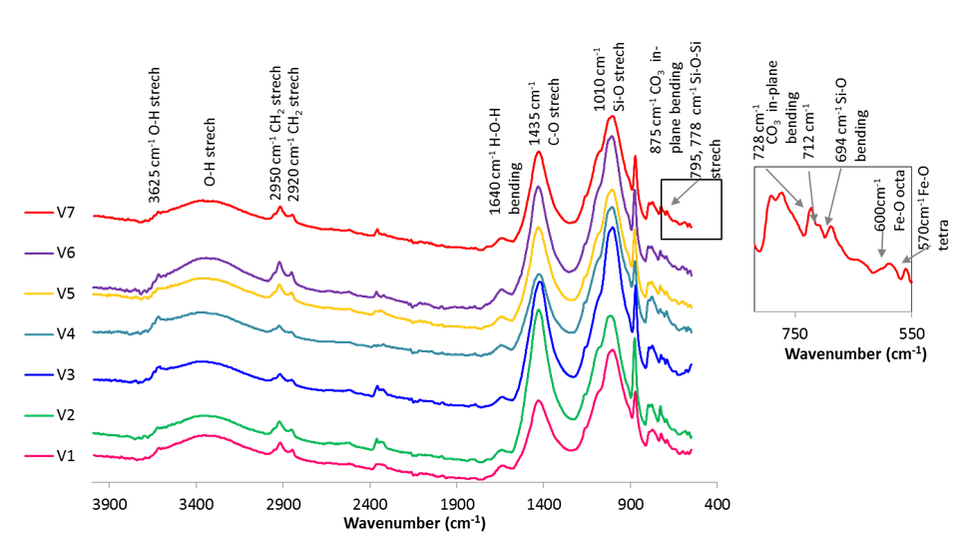
Figure 3. FTIR spectra of road dust samples obtained via the ATR technique, showing characteristic vibrations of functional groups prestent in road dust.

  - Thermal analysis of road dust
TG analysis allowed quantitatively analyzing the sample components, which change the mass during heating, by determining the total mass loss (Δm_{t}) and other mass losses (Δm) contributed to adequate DTG effects (Table 1, Figure 4a). In turn, a compilation of DTG and QMS patterns allowed qualitatively tracing and identifying the processes responsible for the mass changes (Figure 4b-h). The determined Δm_{t} slightly varied between examined samples (Table 1), from 18.49 wt% to 31.08 wt%, between sample V4 and V2. The mass loss was continued above 1000°C due to the presence of phyllosilicates that require higher temperatures to decompose (biotite, muscovite, and amphiboles). Generally, the values of Δm_{t} and thermal decomposition of all samples were dominated by the presence of the carbonates and organic compounds; samples V4 and V2 showed the lowest and the highest carbonates (dolomite) contents, respectively. The moisture content was determined between 30 and 180 °C and was about 1.3 wt% for all samples; samples V4 and V6 differed, with values of 1.0 and 1.6 wt%, respectively (Table 1). Moreover, the Δm_{AIR1000°C} values determined as the difference between the endpoint of heating in N₂ and the endpoint of heating in air at 1000°C, indicated the presence of oxidative phases: Fe²⁺ -bearing minerals and carbon black. The V2, V3, V4, V5, and V7 samples, which gained mass after oxidative conditions changed (in ascending order), indicated the presence of Fe²⁺-bearing phases, which underwent oxidation (Table 1). QMS spectra of m/z 44 allowed the oxidation of black carbon to be distinguished and the associated reactions to be identified (Figure S4 in Supplementary Materials). Conversely, as the oxidation of Fe²⁺ remains undetectable via mass spectrometry, the observed mass gain serves as the primary diagnostic indicator. A high signal in the m/z 44 spectrum, with a slight continuation, suggests a minor content of black carbon in all examined samples. QMS volatiles evolution profiles were well consistent with DTG curves (Figure 4 c-h). DTG curves showed the same thermal events for all samples, only with variations in the peak intensity, revealing on DTG curves four major thermal events, with T_{max} at: 35, 320, 460, and ~740°C (the major event) (Figure 4b). The DTG effects were interpreted as follows.

Table 1. Mass losses obtained by thermogravimetric analysis of road dust samples, including the determined contents of: moisture, Fe²⁺-bearing minerals, organic matter, and carbon.
Sample | Δm_{t}  (wt%) | Moisture content  Δm_{30-180°C}  (wt%) | Δm_{220-540°C}  (wt%) | Oxidative phases  Δm_{AIR1000°C}  (wt%) | Theoretical Δm_{H2O,220-540°C}  (wt%) | Organic matter  (wt%) | Total organic carbon  (wt%) | Total  inorganic carbon  (wt%)
V1 | 26.6 | 1.29 | 6.66 | 0.368 | 0.255 | 6.40 | 5.96 | 3.937
V2 | 31.1 | 1.25 | 6.66 | -0.178 | 0.177 | 6.48 | 5.99 | 5.570
V3 | 24.4 | 1.25 | 4.77 | -0.338 | 0.181 | 4.58 | 4.29 | 4.488
V4 | 18.5 | 0.99 | 3.42 | -0.333 | 0.280 | 3.14 | 2.92 | 3.312
V5 | 28.2 | 1.30 | 6.99 | -0.550 | 0.258 | 6.69 | 6.35 | 3.812
V6 | 30.1 | 1.64 | 8.98 | 0.476 | 0.226 | 8.75 | 8.62 | 3.498
V7 | 27.0 | 1.43 | 7.65 | -0.603 | 0.373 | 7.27 | 6.95 | 4.040

Notes: Δm_{t} - the total mass loss determined between 30 and 1000°C in N₂; Δm_{30-180°C} - moisture content determined between 30 and 180°C in N₂ Δm_{220-540°C} - mass loss determined between 220 and 540°C; Δm_{AIR1000°C} - mass loss determined at 1000°C when nitrogen was switched on synthetic air flow for 10 minutes, the parameter involved the mass contribution of carbon black and Fe²⁺-bearing phases, negative values indicate the mass gain due to Fe²⁺ oxidation; theoretical Δm_{H2O,220-520°C} – the determined mass contributions of structural and adsorbed water decomposition between 220 and 540°C due to the presence of OH-bearing phyllosilicates, which take into account the mass contribution of the mineral in each sample; Organic matter (wt%) – the organic matter content in examined samples determined by subtracting Δm_{H2O,220-540°C} from Δm_{220-520°C}; Total organic carbon (TOC) – obtained via element analysis. The mean values with standard deviations calculated from two TG measurements are provided in Table S4 (Supplementary Materials).

Evolved gas analysis revealed that the low-temperature DTG thermal event (at 35°C) was attributed to weakly adsorbed/physisorbed water on the sample surface; the effect corresponded to a peak on m/z 18, H₂O spectrum (Figure 4c). In turn, the QMS analysis showed that two DTG peaks occurring at 320°C and 460°C involved overlapping thermal effects due to the decomposition of water and organic matter compounds (primarily hydrocarbons) (Figure 4b-h). The m/z 18 spectra of all samples showed the water release between 220 and 520°C, with a dominant role of the effect at 320°C (Figure 4c). The m/z 18 spectra strongly resembled the shape and the intensity (among samples) of the other m/z spectra corresponding to hydrocarbon release between 220°C and 540°C. Therefore, water release resulted from the breaking of chemical bonds (C-O, C-H, O-H) and bound moisture in organic compounds, as well as the dehydration and dehydroxylation of OH-bearing phyllosilicates present in all samples: chlorites, kaolinite, biotite, and amphiboles [93]. In turn, the DTG and QMS thermal effects at about 460°C corresponded to the maximum temperature of organic compounds decomposition [60], [62], [67] (Figure 4d-h). The QMS spectra of all examined samples showed single or double peaks on monitored m/z ions between 220 and 540°C (apart from m/z: 35, 136, and 149) (Figures S4-S10). Selected m/z spectra were presented in Figure 4. No individual sample showed distinctive features; all samples showed similarities in composition of evolved volatiles, and only the intensity of the ions changed among the samples. The intensity of all observed QMS effects increased among the samples: V4, V3, V1, V2, V5, V7, and V6 (Figure 4 d-h), corresponding to determined organic carbon contents (Table 1). Due to excessive fragmentation during molecular ionization in the TG-MS system used, and the wide variety of organic compounds in road dust, leading to overlapping m/z signals, it was impossible to directly identify the organic components in the examined samples [60]. However, some daughter and parent ions with characteristic m/z signatures provided stronger evidence for the presence of certain constituents. All observed m/z fragments are commonly observed in the mass spectra of various aliphatic hydrocarbons and other organic compounds like biomass burning products, tire wire, and microplastic, which are major components of road dust [60], [61], [62], [67]. Moreover, the m/z signals of aromatic compounds fragments, which are formed during polymer degradation, as benzene (m/z: 39, 50, 77, and 78), toluene (m/z: 91, 92, and 77), and xylene (m/z: 91 and 106) were revealed, thus corresponding to deposited fuel residues, spilled petroleum products and polymers such as polystyrene (PS) and styrene-butadiene rubber (SBR) presence (Figure 4 g-h) [60], [61], [94]. Most of observed m/z signals showed uniform or low-temperature asymmetric peak shapes with the maximum at 460°C, however the spectra of m/z: 43 (C₃H₇, CH₃C=O) (Figure 4e), 44 (CO₂) (Figure 4d), 53 (C₄H₅+), 64 (SO₂) (Figure 4f), 68 (C₅H₈, C₄H₄O, C₃H₄O₂-cyclic ethers), and 69 (C₅H₉) revealed double effect with additional peaks at about 370°C, indicting the presence of aliphatic or olefinic components in oxidized species (Figures S5-S11) [60], [61]. Moreover, the doubled effect of m/z 43 may indicated acetyl group (CH₃CO⁺) or a propyl/isopropyl group (C₃H₇⁺) (Figure 4e), the most common substance producing this fragment and showing multi-step degradation in QMS is poly(vinyl acetate) (PVAc) or similar acetate-containing polymers [60]. The low temperature release of sulfur dioxide (Figure 4f, m/z=64) was indicative of sulfonic groups degradation in the organic matter, including PAHs and materials which can contain sulfur-based additives (e.g tire wear, bitumen). In turn, SO₂ releases in higher temperatures: the peak at 740°C of sample V2 and the slight curve rising at 900°C of sample V1, indicated the trace of sulfates incorporated into carbonate structures and gypsum/anhydrite, respectively. In turn, the signals of m/z 50- 56 (unsaturated hydrocarbon fragments) revealed for all samples are common byproducts of the thermal degradation of a wide variety of polymers [94], [95]. The major DTG effect with T_{max} at ~740°C corresponded to a strong CO₂ signal on m/z 44 spectra (cf. Figure 4b and 4d), due to the decomposition of carbonates (calcite and dolomite). The T_{max} of this effect shifted to a higher temperature with an increasing amount of dolomite in the samples. Intriguing, that despite ~10% of calcite present in all samples (Figure 2), a typical calcite decomposition effect, which should occur between 800 and 900°C, was not observed, neither on DTG nor on m/z 44 spectrum [93]. The effect due to calcite decomposition probably shifted to a lower temperature and overlapped with the dolomite decomposition effect. Lower crystallinity, less ordering, and structure disintegration by the weathering process decreased the temperature of calcite decomposition [93]. These features suggest that the calcite in the studied samples is of anthropogenic and/or geo-anthropogenic origin. The anthropogenic calcite produced through pyrotechnological activities, and being the component of materials such as lime binders and wood ash, due to the specific properties (e.g., lower degree of crystallinity, structural defects), reveals significantly lower thermal stability [96], [97], [98]. A clear geo-anthropogenic calcite, resulting from the mechanical attrition of mineral aggregates in road pavements and the accumulation of construction-derived particles, can reveal thermal properties similar to geogenic calcite. These features may indicate an anthropogenic origin of calcite rather than a geo-anthropogenic origin, but more structural analyses are required for confirmation. [21], [24], [44], [50], [67], [99].
To further differentiate the complex organic matrix, the TG-MS profiles were evaluated based on specific mass-to-charge ratios (m/z) associated with aromatic fragmentation patterns. The signals at m/z 77 (phenyl cation, C₆​H₅⁺​) and m/z 78 (benzene radical cation, C₆​H₆₊∙​) serve as primary indicators for the thermal cracking of Styrene-Butadiene Rubber (SBR), originating from the depolymerization of styrene cross-links within tire tread elastomers [16], [100].
The prominent peak at m/z 91 (tropylium cation, C₇​H₇⁺​), resulting from the rearrangement of benzyl fragments, points to the presence of alkyl-substituted benzenes such as toluene, ethylbenzene, and xylenes. These compounds are established markers for the pyrolytic release of bitumen binders from asphalt matrix abrasion and the desorption of unburned petroleum hydrocarbons from fuel residues [101], [102], [103]. Furthermore, the contribution of Polycyclic Aromatic Hydrocarbons (PAHs) was identified through stable fragments of anthracene and pyrene derivatives [104]. The presence of phenolic fragments (e.g., hydroxybenzene derivatives) indicates the thermal degradation of phenol-formaldehyde resins used as binding agents in brake friction materials [105], [106]. Additionally, roadside thermoplastic microplastics, specifically polystyrene, contribute to the m/z 77 and m/z 104 (styrene monomer) signals via random chain scission processes [103], [107]. This detailed ion-specific classification ensures a rigorous differentiation of the anthropogenic organic load in the investigated road dust samples.

Figure 4. TG (a) and DTG curves (b) of road dust samples combined with selected QMS spectra of the evolving gases: H₂O⁺, m/z 18 (c), CO₂⁺, m/z 44 (d) and hydrocarbons fragments: C₃H₇⁺, CH₃C=O⁺, m/z 43 (e); SO₂⁺, m/z 64 (f); C₆H₆⁺m/z 78 (g); C₇H₇⁺, m/z 91(h) obtained during ramp heating with 20°C/min up to 1000°C in N₂.

  - Organic matter versus organic carbon determination
Because organic compounds undergo complete destruction during heating, mass losses obtained from TG analysis were used to determine the organic matter content of the samples. The temperature range corresponding to organic compounds pyrolysis, thus, hydrocarbons release (220–540°C), was used for the calculations (Table 1). The dehydration and dehydroxylation of OH-bearing phyllosilicates also occurred [108] within this temperature range [108]. Therefore, the mass loss associated with the release of structural water derived from lattice hydroxyl groups (OH−) [109] of these minerals was first determined. The theoretical mass losses due to water release between 220 and 540°C were calculated for chlorite, kaolinite, biotite, and amphiboles; these values were next multiplied by the percentage contributions of each mineral in the individual samples (Table 1, Table S2). To determine the organic matter content, the mass loss measured between 220 and 540°C was reduced by the contribution of water released during the decomposition of OH-bearing phyllosilicates. The results were presented in Table 1, the determined organic matter content revealed the greatest value for sample V6 (8.75wt%), and the lowest for V4 (3.14%). The CHNS and TOC/TOI results were presented in Table S3. The obtained values of N, S, and H elements were close to the instrument precision limits, due to this they were not interpreted. In turn, C contents showed the variations among examined samples, from 6.24 wt% for V4 to 12.12 wt% for V6, due to the presence of carbonate minerals and organic matter. TOC analysis revealed significant mass contributions of organic carbon typical for urban areas [108], showing: low content for V4 (2.92 wt%), medium for samples V1, V2, and V3 (5.96, 5.98, and 4.28 wt%, respectively), and high for V5, V6, and V7 (6,35, 8.62, and 6.95 wt%, respectively). The determined organic matter contents showed only slightly higher values than the carbon content.
While FTIR analysis showed a dominance of aliphatic compounds, the more precise TG-MS method also detected fractions of aromatic fragments and other organic compounds. The complex organic profile of the investigated road dust is primarily shaped by a variety of anthropogenic inputs, with a dominant contribution from long-chain aliphatic compounds. Tire Wear Particles (TWP) are a primary contributor, consisting of polyisoprene (NR) and polybutadiene (BR) elastomers, along with paraffinic waxes [110]. Road marking paints introduce significant amounts of polyethylene (PE) and polypropylene (PP), which are used as thermoplastic binders [111]. The infrastructure also contributes through bitumen, which is rich in n-alkanes and cycloalkanes. When road dust is analyzed using thermal methods, these components release characteristic aliphatic fragments [101]. Furthermore, aliphatic plasticizers, such as adipates (e.g., bis(2-ethylhexyl) adipate), originate from automotive plastics and polymer-modified bitumen, adding to the total C−H signal [112], [113].
Nowadays, thermoanalytical methods coupled with mass spectroscopy offer promising opportunities for the characterization of environmental samples, revealing their complex composition, including microplastics, without the need for sample pretreatment [63], [65], [66], [94], [95], [114]. Solvent-based chromatographic techniques, including Pyrolysis–Gas Chromatography–Mass Spectrometry (Pyrolysis-GC–MS) [115] and High-Performance Liquid Chromatography (HPLC) [116], provide both qualitative and quantitative analysis, allowing for the separation, identification, and precise measurement of compound concentrations in complex mixtures, including polymers [114], [117]. TG-MS analysis provides limitations in the determination of the individual components of a sample mixture, which complicates the clear identification and interpretation [65], [95]. Nevertheless, GC-MS and HPLC require multi-step extraction and purification procedures that may introduce extraction bias and lead to the underestimation of polymers strongly embedded in mineral matrices or poorly soluble in organic solvents [118]. In contrast, the solvent-free TG–MS approach enables direct thermal analysis of the entire solid or liquid sample, preserving the full mass balance of polymer material and minimizing sample manipulation. As reported by [119] in an interlaboratory study, traditional HPLC with Fluorescence Detection (HPLC-FLD) and GC-MS methods can yield discrepancies as high as 50% when analyzing complex combustion-related matrices (e.g., diesel exhaust). These variations are often attributed to undefined matrix interferences and extraction inefficiencies, further justifying the need for a direct, solvent-free analytical approach like the proposed TG-MS framework. The analysis of highly complex matrices (such as road dust) presents considerable analytical challenges, particularly when the objective is the identification of microplastics [94], [95]. TG–MS offers significant advantages for the characterization of heterogeneous environmental samples, because it enables direct investigation without requiring laborious and time-consuming pretreatment procedures that may alter the chemical or physical nature of the sample. In contrast, chromatographic approaches require specific and often time-consuming separation and calibration procedures, especially when dealing with complex sample matrices [114], [116], [120]. Monitoring mass losses together with the simultaneous evolution of volatiles enables the identification of mineral phases during high-temperature decomposition, particularly when TG–MS data are complemented by other analytical techniques. However, these processes may generate interfering signals that influence aerosol mass spectrometry measurements above ~600 °C [121]. Taken together, the integrated TG–MS, QXRD, and FTIR approach provides a robust framework for resolving organic–mineral associations in road dust, particularly within magnetically enriched fractions where metal-rich particles, mineral phases, and microplastics coexist.

  - Morphology analysis of particles (SEM-EDS)
The SEM study revealed the presence of micro-aggregates and heterogeneous particles differing in size, shape, surface, and morphology, which were similar across all samples (Figure S12). The geometrical characteristics of particles in road dust can indicate the interaction with the environment and the provenance from geogenic and anthropogenic sources [24], [56], [72]. EDS point chemical analysis was used for selected, distinctive particles. Two types of aggregates were observed: composed of only minerals (Figure 5a) and a mixture of anthropogenic particles and minerals (Figure 5b). The size of the examined particles and micro-aggregates did not exceed 100 µm; however, the material comprised a large fraction of very fine particles (< 1 µm) that formed the aggregates and were attached to the surfaces of larger particles. Among all samples, only V4 differed slightly, exhibiting coarser quartz particles with sharper edges than in the other samples (Figure S12). The particles revealing irregular and subangular shapes, and those with plate-like morphology, show chemical composition (including Si, Al, K, Ca, Mg, Fe, O, C) indicating minerals detected by XRD. Phyllosilicates revealed more plate-like shapes, fine fraction, and rough (uneven) surface, while carbonates and quartz showed more angular shapes with an even surface. Minerals are highly susceptible to erosion and weathering, hence they showed more rounded edges, in contrast to the sharp edges of anthropogenic crystalline material (Figure 5a, Figure S13a). Some particles revealed linear marks (grooves or scratches) on the surface indicting the mechanical abrasion of particles driven by everyday vehicular activities (Figure S13a). All samples also showed the presence of elongated (e.g. rods, Figure S13b, f), fibrous (Figure 5b, Figure S13e), and spherical (Figure 5c, Figure S13c) shaped particles, which are uncommon in the case of naturally formed minerals. Sample V6 also includes the plate, layered fragments with honeycomb structures (Figure S13d); EDS analysis revealed Si, Al, and O elements, indicating that the fragment originates from a breakdown of automotive catalytic converters made of ceramic material. In turn, elongated and fibrous structures showed high C and O content, which suggests the material can derive from organic sources, such as synthetic fibers from tire wear or polymeric microplastics. Some organic fragments exhibited an affinity for the attachment of fine mineral particles to their surfaces, indicating a preference for crystal precipitation and adsorption onto synthetic particles (Figure 5a, Figure S13f). Spherical particles were the most frequent anthropogenic particles present in the samples, and they varied in chemical composition, containing O, C, and Ca; O, C, Si, Fe, and Al; O, C, Si, and Al; or O and Fe. These particles are of anthropogenic origin, resulting from high-temperature braking and combustion (forming iron oxide and fly ash spheres [24], [122], [123], as well as from the mechanical wear of road markings [4], [6], [10], [11]. Specifically, the Si-Al-Ca-rich spheres are consistent with glass microspherules. While a definitive distinction between these amorphous phases and anisotropic geogenic minerals like quartz would require petrographic microscopy to confirm their isotropic nature, the high-resolution SEM imaging allowed for the identification of their characteristic micro-morphological wear (e.g., pitting and fractures), which is typical for glass beads in the road environment [13].

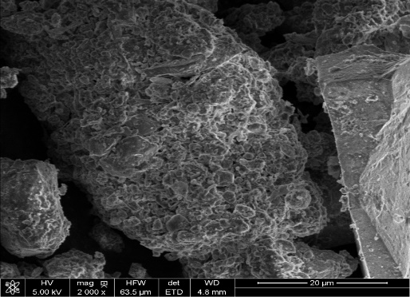
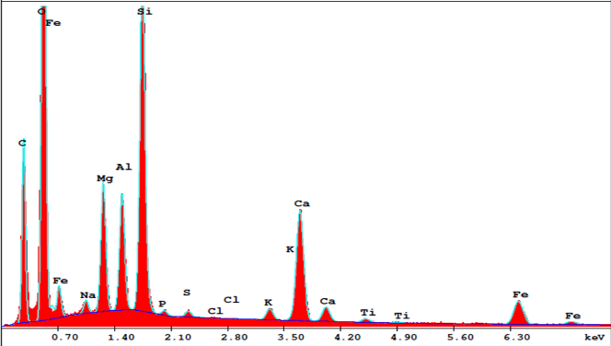
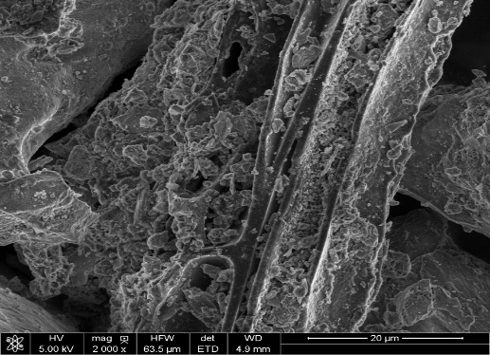
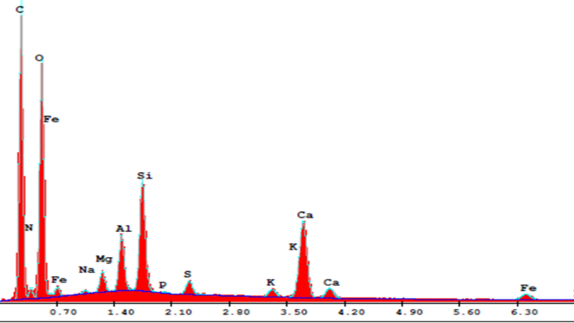
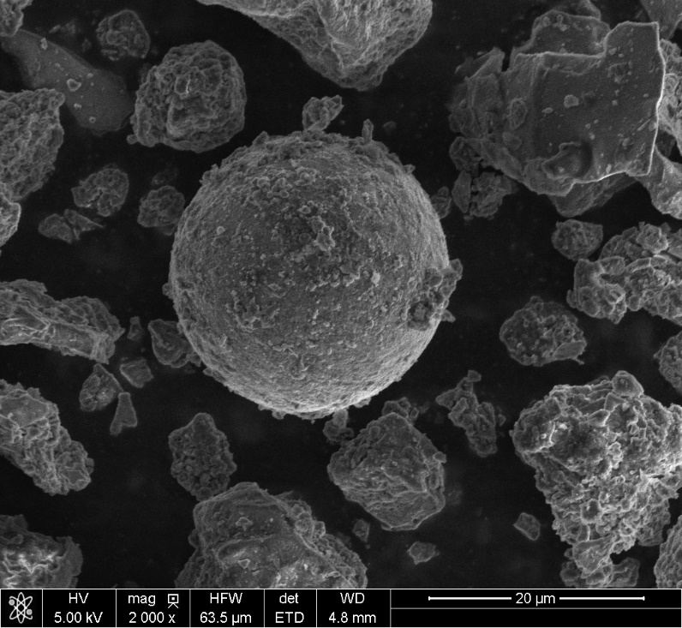
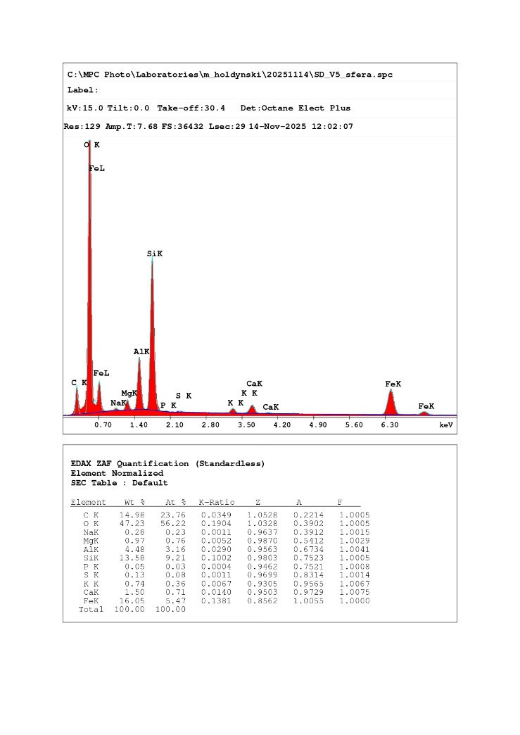
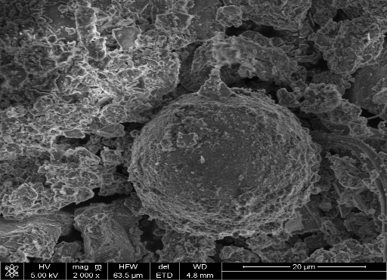
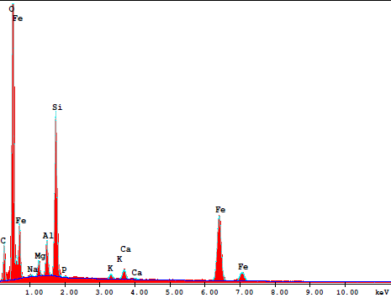
20µm
a
b
c
20µm
20µm
20µm
d

Figure 5. SEM and EDS analysis of road dust samples. The micro-aggregates composed of minerals of sample V6 (a); a fiber microplastic with attached and overgrowths minerals of sample V4 (b); a spherical anthropogenic particle of sample V5 (c), V7 (d). The corresponding EDS spectra were acquired at the locations marked with crosses.
  - Magnetic properties
    - Magnetic susceptibility (χ), frequency-dependent magnetic susceptibility (χfd%)
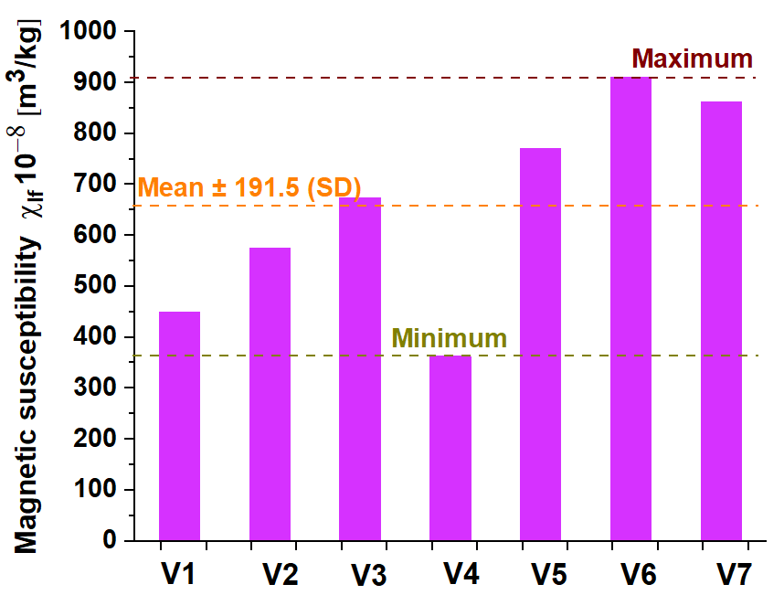

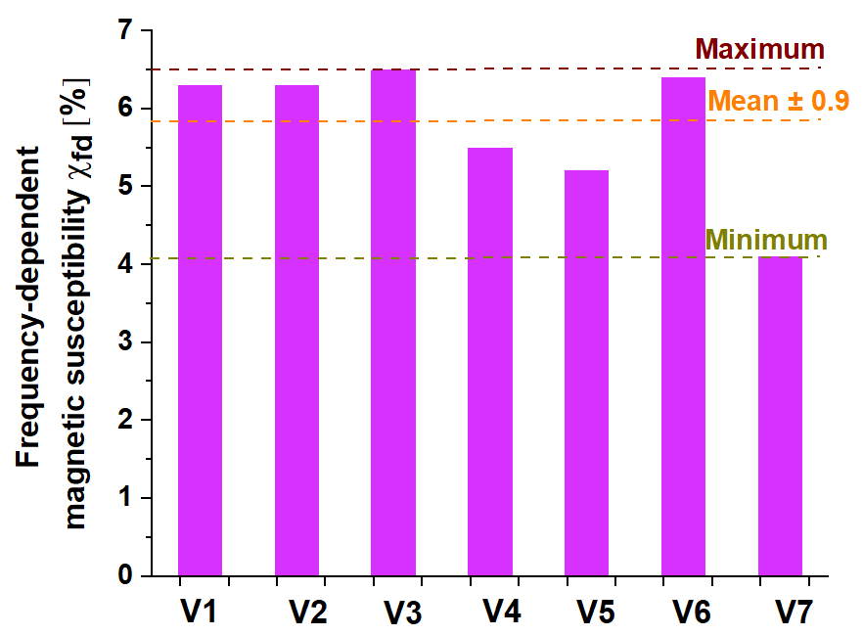
Figure 6. Top: Magnetic susceptibility (χlf) of road dust samples from seven locations (V1–V7). Bottom: Frequency-dependent magnetic susceptibility (χfd%) of road dust samples collected at different sampling sites (V1–V7) for three grain-size fractions.
The analysis focused exclusively on the finest grain-size fraction (<50 µm) of the road dust samples collected at seven different sites (V1–V7). Within this fraction, all sites exhibited a 100% strongly magnetic component, indicating a complete absence of weakly magnetic minerals. This observation is consistent with previous studies in urban and industrial environments. For instance, in Thessaloniki, Greece, the strong magnetic fraction (MF) in road dust accounted for 2.2–14.7%, with the remainder being non-magnetic [31]. Similarly, in an industrial area, strongly magnetic particles represented 44.7% of the total fraction [124]. It should be noted that direct comparison of the proportions of strongly and weakly magnetic fractions with literature data is challenging, as many previous studies either analyzed bulk dust samples without fractionation or used different grain-size categories.
The predominance of strongly magnetic minerals in the finest fraction likely results from multiple factors. These include the higher density and surface reactivity of magnetic minerals, which favor their enrichment in fine-grained material, as well as anthropogenic contributions such as industrial emissions and combustion-derived particles, which are typically fine and strongly magnetic. Furthermore, natural sorting during sediment transport may enhance the concentration of strongly magnetic minerals in the smallest fractions, due to selective transport and deposition based on particle size and magnetic properties.
The analysis was focused exclusively on the finest fraction (<50 µm) of road dust samples collected from seven urban sites (V1–V7). Low-field mass-specific magnetic susceptibility (χ_{lf}) is presented in Figure 6 (top). Values range from 362 × 10⁻⁸ m³/kg (V4) to 911 × 10⁻⁸ m³/kg (V6), with the highest susceptibilities observed at V6 and V7, indicating a significant enrichment of strongly magnetic minerals in this granulometric fraction. The lowest magnetic susceptibility value observed at V4 is strongly linked to its mineralogical composition, specifically the highest quartz content (45.75%). As previously demonstrated in the study of pollution passive samplers in Warsaw (Poland) [125], quartz-dominated matrices (such as those used in passive samplers) exhibit near-zero or even negative magnetic susceptibility values. Therefore, the high concentration of quartz in V4 acts as a geogenic diluent, physically masking the anthropogenic magnetic signal. This mineralogical 'dilution effect' explains why V4 shows lower susceptibility than other sites, despite being located within an urban environment. Lower values at V1 and V4 suggest either reduced anthropogenic input or a stronger contribution of geogenic material.
The frequency-dependent susceptibility (χfd%) for the same fraction is reported in Figure 6 (bottom). χfd% values vary between 4.1% (V7) and 6.5% (V3), with a mean of 5.8% (SD = 0.9). χfd% provides insight into the contribution of superparamagnetic (SP) particles. According to the interpretive framework of Dearing et al. [83], these values signify a substantial superparamagnetic (SP) contribution, characteristic of an intermediate group (2–6%) representing a mixture of SP and stable single-domain/multi-domain (SD/MD) grains. The peak value of 6.5% (V3) indicates a near-dominance of the SP fraction. These findings stand in stark contrast to previously reported values for soil [126], ash [127] street dust [83][128][127][37], [39], [129], where χfd​% typically remains below 2%. Notably, even studies focusing on atmospheric dustfall [128], which inherently consists of finer fractions, have reported χfd​% values under the 2% threshold. This discrepancy highlights that while dustfall is naturally finer, it still contains significant non-magnetic mass that dilutes the SP signal. In contrast, the magnetic separation and isolation of the fine fraction (<50 μm) performed in this study effectively reduced this dilution from the bulk matrix. This enrichment approach significantly enhanced the detection of the ultrafine SP component, even though it remains partially associated with non-magnetic phases within complex mineral aggregates.
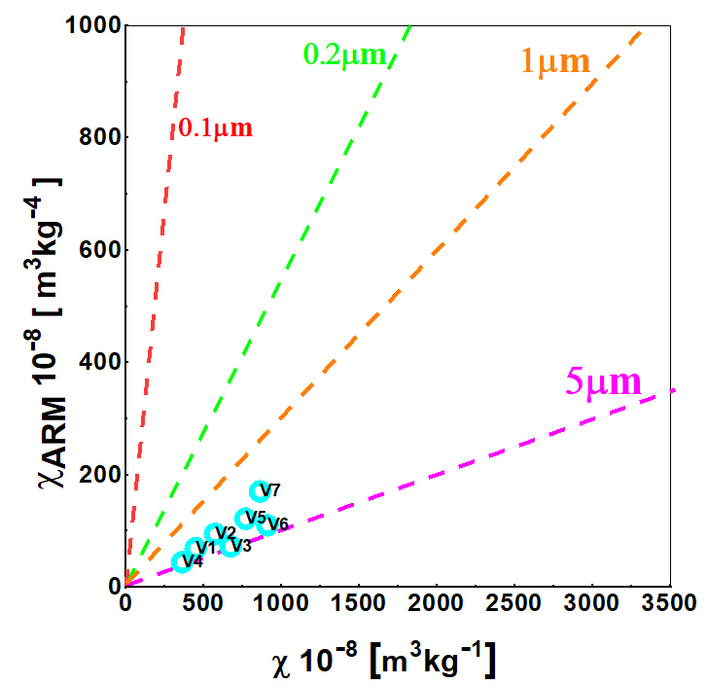
    - Hysteresis loops and King plot

Figure 7. Top: Plot of Mrs/Ms versus Hcr/Hc based on the Day diagram [128], as modified by Dunlop [129]. The solid red line represents the theoretical trend for multidomain (MD) grains, dashed magenta lines indicate mixing trends between single-domain (SD) and MD grains, and the solid green line shows a calculated mixing curve for SD grains combined with ~10 nm superparamagnetic (SP) particles. Bottom: Biplot displaying χ_{ARM} vs. χ. Reference lines for the plot were retrieved from [130]. The dashed lines represent theoretical grain size trends for magnetic particles of 0.1 µm (red), 0.2 µm (green), 1 µm (orange), and 5 µm (magenta).

To characterize the magnetic domain state and grain size distribution of the samples, the plot of Mrs/Ms versus Hcr/Hc based on the Day diagram [128] as modified by Dunlop [129] is shown in Figure 7. This diagram is commonly used to distinguish contributions from single-domain (SD), multidomain (MD), and superparamagnetic (SP) grains within magnetic mineral assemblages. The measured values of Mrs/Ms and Hcr/Hc for samples V1 to V7, ranging from 0.057 to 0.089 and 4.44 to 6.18, respectively, are reported in Table S5 (Supplementary Materials). The measured hysteresis parameters reflect the properties of the concentrated ferrimagnetic fraction, as the geogenic background is magnetically weak and does not significantly contribute to the signal. The positioning of samples V1–V7 within the PSD region indicates that the dominant magnetic carriers are stable grains. However, the high χfd​% values (mean 5.8%) reveal that a substantial portion of this magnetic fraction consists of ultrafine superparamagnetic (SP) particles. According to Dunlop [133], the observed downward shift on the Day-Dunlop plot is a direct consequence of this SP contribution, highlighting the presence of anthropogenic, combustion-derived minerals within the isolated <50 μm fraction. Notably, sample V4 deviates slightly from this trend, suggesting subtle variations in its magnetic grain composition. The close clustering of all samples on the Day-Dunlop plot, including the quartz-rich sample V4, indicates a homogenous magnetic mineralogy across the study area. This suggests that while geogenic minerals (quartz, carbonates) significantly dilute the concentration of magnetic carriers in V4, the origin of these carriers remains consistent with the anthropogenic inputs identified at the other sites. Overall, these results indicate that the magnetic properties of the road dust are primarily controlled by fine, stable magnetic grains, reflecting the environmental formation and alteration processes. The plot presented in Figure 7 shows the relationship between anhysteretic remanent magnetization susceptibility (χ_{ARM}) and magnetic susceptibility (χ) for the analyzed road dust samples. Detailed numerical values are provided in Table S5 in the Supplementary Materials. The King plot shows that the sample points cluster within the lower range of the plot, aligning below the 5 µm trend line. This indicates that the bulk magnetic remanence is carried by relatively coarser grains compared to the ultrafine fraction. However, this observation must be reconciled with the high χfd​% values (mean 5.8%) and the Day-Dunlop results. The combined data suggest a bimodal distribution or a complex mixture where coarser magnetic particles (reflected in the King plot) coexist with a significant population of superparamagnetic (SP) grains (reflected in χfd​%).

    - Thermomagnetic curves of κ(T)
Figure 8 and Figures S14-S18 (Supplementary Materials) represent a set of k(T) curves measured for exemplary sample locations for street dust chosen based on the average χ. The cooling curves ran above the heating ones, indicating the strong magnetic enhancement after the heating-cooling cycle. At all heating curves around 280–350 °C, a hump-shaped increase of magnetization is observed. [129] interprets this behavior as the presence of maghemite, which was converted to hematite. [131] suggest that the hump is a result of realizing internal stress in low-temperature oxidized magnetite grains. All the samples for magnetic fractions continued to decline and/or did not reach zero magnetization value beyond ~700 °C on the heating curves. This indicates a second Curie temperature above 700°C, characteristic of anthropogenic iron alloys or metallic iron [132], [133] protected within a mineral matrix. This interpretation is further corroborated by SEM-EDS microanalysis of Fe-rich spherules (e.g., 64.28 wt.% Fe, 0.59 wt.% Mn; Figure 5d), where a relict metallic core is preserved beneath a partially oxidized surface shell [134]. From 400 to 550 °C, χ increased quickly with a marked peak at ~ 550 °C. This behavior could be a result of the transformation of hematite to magnetite in an oxygen-free environment [135] and/or a depiction of the Hopkinson effect in magnetite just below its Curie point [136], [137]. On the cooling curve, a rise in the intensity of κ appeared at T_{CMg}, followed by a relatively narrow Hopkinson-like peak and a gradual drop that started at 400 °C, which could be a result of the formation of new magnetite from the products of the thermal-activated chemical alteration of diamagnetic or/and paramagnetic minerals [136], [137].

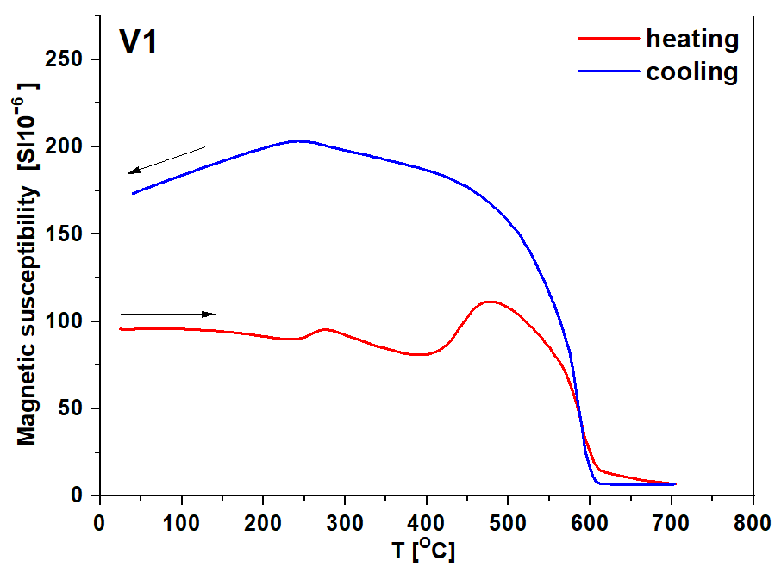
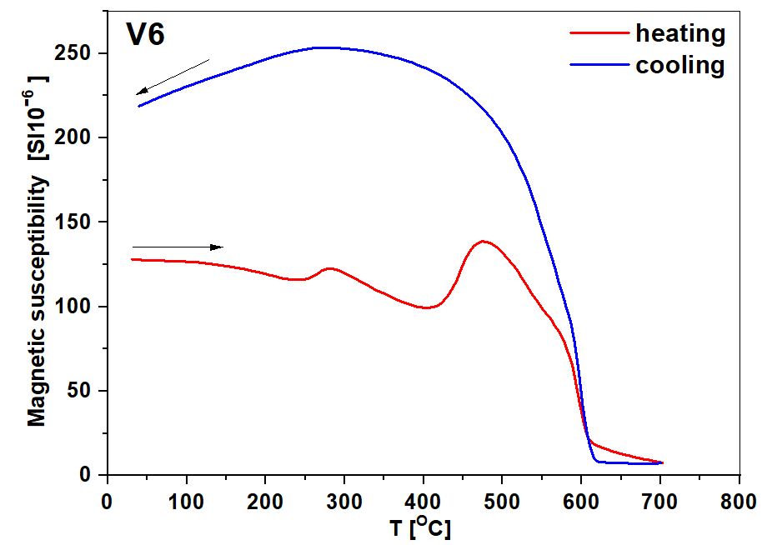
Figure 8. Thermomagnetic curves showing the temperature dependence of magnetic susceptibility κ(T) for samples V1 (left) and V6 (right). Red lines represent the heating run, while blue lines indicate the cooling run.

These findings are further supported by other analytical methods. While XRD analysis showed only weak, broad reflections-likely due to the nanosized or non-stoichiometric nature of the grains-the concentration of these phases remains below the XRD detection limit (~3%). However, the presence of iron (hydr-) oxides was confirmed by FTIR, which identified Fe-O tetrahedral bands, and by SEM/EDS, which clearly showed Fe-oxide clusters. TG analysis in air conditions showed that samples V1 and V6 contained more Fe³⁺-bearing iron (hydr-) oxides, while other samples evidently showed the oxidation of Fe²⁺-containing minerals (Table 1).

3.7. Correlation among parameters
The strongest positive correlations in the dataset are observed between Organic Matter and Total Organic Carbon (r=0.998), as well as between Total Carbon and Total Organic Carbon (r=0.92), indicating a highly consistent source of carbonaceous material in the road dust. Within the magnetic parameters, there is a very high internal consistency evidenced by the correlation between saturation magnetization (Ms​) and saturation remanent magnetization (Mrs​) (r=0.92), and between the coercivity parameters Hc​ and Hcr​ (r=0.89). These strong links suggest that the magnetic signal is dominated by a uniform mineralogical phase, likely magnetite or maghemite derived from vehicular wear. Furthermore, χ (magnetic susceptibility) shows strong positive associations with Organic Matter (r=0.76) and Total Organic Carbon (r=0.71), implying that magnetic minerals and organic pollutants are co-deposited and share common anthropogenic sources, such as fossil fuel combustion and tire degradation.

 | Qtz | Cal | Dol | Fld | Ms | Chl | Amp | TC | TOC | TIC | OM | MC | χfd% | χ | χ_{ARM} | Ms | Mrs | Hc | Hcr | T
Qtz | 1,00
Cal | 0,05 | 1,00
Dol | -0,68 | 0,30 | 1,00
Fld | 0,41 | -0,26 | -0,59 | 1,00
Ms | 0,31 | 0,55 | -0,24 | -0,12 | 1,00
Chl | 0,23 | -0,90 | -0,43 | 0,08 | -0,37 | 1,00
Amp | -0,61 | -0,43 | 0,18 | 0,10 | -0,83* | 0,15 | 1,00
TC | -0,86* | 0,04 | 0,89* | -0,69 | -0,22 | -0,18 | 0,29 | 1,00
TOC | -0,91* | -0,15 | 0,67 | -0,61 | -0,15 | -0,02 | 0,37 | 0,92* | 1,00
TIC | -0,04 | 0,49 | 0,71 | -0,34 | -0,21 | -0,42 | -0,12 | 0,38 | 0,00 | 1,00
OM | -0,92* | -0,15 | 0,71 | -0,60 | -0,19 | -0,03 | 0,39 | 0,94* | 1,00* | 0,05 | 1,00
MC | -0,89* | -0,03 | 0,57 | -0,56 | 0,00 | -0,13 | 0,30 | 0,85* | 0,95* | -0,07 | 0,93* | 1,00
χfd% | 0,11 | 0,70 | 0,24 | -0,03 | 0,76* | -0,69 | -0,72 | 0,05 | -0,06 | 0,27 | -0,06 | 0,02 | 1,00
χ | -0,81* | 0,05 | 0,44 | -0,63 | -0,15 | -0,12 | 0,49 | 0,71 | 0,78* | -0,05 | 0,76* | 0,86* | -0,28 | 1,00
χ_{ARM} | -0,73 | -0,34 | 0,45 | -0,48 | -0,66 | 0,25 | 0,77* | 0,67 | 0,70 | 0,07 | 0,70 | 0,65 | -0,67 | 0,82* | 1,00
Ms | -0,42 | -0,48 | 0,12 | -0,46 | -0,60 | 0,53 | 0,64 | 0,39 | 0,46 | -0,10 | 0,45 | 0,40 | -0,85* | 0,68 | 0,90 | 1,00
Mrs | -0,30 | -0,30 | 0,21 | -0,64 | -0,51 | 0,42 | 0,48 | 0,38 | 0,38 | 0,07 | 0,39 | 0,26 | -0,73 | 0,57 | 0,78* | 0,92* | 1,00
Hc | 0,04 | 0,64 | 0,42 | -0,78* | 0,33 | -0,33 | -0,44 | 0,32 | 0,10 | 0,60 | 0,10 | 0,15 | 0,28 | 0,30 | 0,09 | 0,11 | 0,33 | 1,00
Hcr | -0,26 | 0,71 | 0,54 | -0,69 | 0,30 | -0,53 | -0,23 | 0,49 | 0,30 | 0,56 | 0,30 | 0,43 | 0,32 | 0,55 | 0,24 | 0,12 | 0,20 | 0,89* | 1,00
T | -0,07 | 0,44 | -0,19 | 0,09 | -0,01 | -0,49 | 0,36 | -0,26 | -0,23 | -0,14 | -0,24 | -0,13 | -0,13 | 0,26 | 0,07 | 0,08 | 0,12 | 0,03 | 0,13 | 1,00
 | Qtz | Cal | Dol | Fld | Ms | Chl | Amp | TC | TOC | TIC | OM | MC | χfd% | χ | χ_{ARM} | Ms | Mrs | Hc | Hcr | T
* Statistically significant Pearson correlation coefficient (p<0.05).
Figure 9. Pearson correlation coefficients (r) between mineralogical composition (after
centered log-ratio (clr) transformation [88]), carbon content, and magnetic parameters in road dust samples. Qtz - Quartz; Cal - Calcite; Dol - Dolomite; Fld - Feldspar; Ms - Muscovite; Chl - Chlorite; Amp - Amphibole; TC - Total carbon; TOC - Total organic carbon; TIC - Total inorganic carbon; OM - Organic matter; MC – Moisture content; χ - mass-specific magnetic susceptibility; χfd​% - frequency-dependent magnetic susceptibility; χ_{ARM} - anhysteretic magnetic susceptibility; Ms​ - saturation magnetization; Mrs​ - saturation remanent magnetization; Hc​ - coercivity; Hcr​ - coercivity of remanence; T- Traffic intensity.

In contrast, Quartz acts as a primary geogenic component that exerts a significant "dilution effect" on these anthropogenic markers. Quartz exhibits a strong negative correlation with χ (r=-0.81), χ_{ARM​} (r=-0.73) (Figure 9), and very high negative correlations with Total Organic Carbon (r=-0.91) and Organic Matter (r=-0.93). These results indicate that as the mineralogical fraction of quartz originating from natural soil or road base materials increases, there is a proportional decrease in the relative concentration of organic and magnetic pollutants. This confirms that Quartz serves as a diamagnetic diluent within the urban street environment. Additionally, the frequency-dependent susceptibility (χfd​%) demonstrates a strong negative correlation with Ms​ (r=-0.85), suggesting that the contribution of ultra-fine superparamagnetic grains (typically natural or pedogenic) decreases as the total concentration of coarser, anthropogenic magnetic particles increases.
A crucial finding is the behavior of χ_{ARM}​, representing fine-grained single-domain (SD) ferrimagnetic particles. It exhibits very strong positive correlations with Ms​ (r=0.90), χ (r=0.82), and amphibole (r=0.77), as well as strong associations with organic components like OM (r=0.7) and TOC (r=0.70). These links confirm that fine SD magnetic carriers are a significant part of the anthropogenic load. Conversely, the strong negative correlation between χ_{ARM}​ and χfd%​ (r=−0.67) emphasizes the distinction between coarser anthropogenic fractions and ultra-fine superparamagnetic (SP) grains typical of natural soil processes.
Moisture content (MC) constitutes a distinct statistical cluster with carbon fractions and magnetic susceptibility, showing exceptionally strong positive correlations with TC (r = 0.95), OM (r = 0.93), χ (r = 0.86), and TOC (r = 0.85). These high r-values indicate that the variance in MC is strictly synchronized with both the organic load and the concentration of magnetic carriers, identifying them as the primary factors controlling the physical and magnetic properties of the studied road dust.
While vehicular emissions are a primary source of pollutants, the relatively low direct correlation between traffic intensity and total magnetic susceptibility (χ, r=0.26) indicates that the accumulation of contaminants is governed by a complex set of environmental and mechanical variables. Although traffic volume is a key driver, factors such as driving style (frequent braking and acceleration), road gradient, and surface roughness play a crucial role in the localized entrapment and retention of road dust. For instance, higher surface roughness can physically trap particles from brake wear, while the frequency of road cleaning and wind-induced resuspension further modifies the chemical and magnetic signature of the surface material [138]. This is reflected in the moderate correlation of traffic with calcite (r=0.44) and its negative correlation with chlorite (r=-0.49), suggesting that the final composition of road dust is a result of the interaction between anthropogenic input and the specific physical-mechanical characteristics of the road surface.
3.8. Hierarchical Component Analysis (HCA)
Figure 10. Dendrogram of Hierarchical Cluster Analysis (HCA) illustrating the multidimensional relationships between mineralogical, chemical, and magnetic variables in road dust. Mineralogical data were pre-processed using the centered log-ratio (clr) transformation [88] to address the closed composition of XRD data. Qtz - Quartz; Cal - Calcite; Dol - Dolomite; Fld - Feldspar; Ms - Muscovite; Chl - Chlorite; Amp - Amphibole; TC - Total carbon; TOC - Total organic carbon; TIC - Total inorganic carbon; OM - Organic matter; MC – Moisture content; χ - mass-specific magnetic susceptibility; χfd​ - frequency-dependent magnetic susceptibility; χ_{ARM} - anhysteretic magnetic susceptibility; Ms​ - saturation magnetization; Mrs​ - saturation remanent magnetization; Hc​ - coercivity; Hcr​ - coercivity of remanence; T- Traffic intensity.
The Hierarchical Cluster Analysis (HCA) reveals a clear structural organization of the dataset, providing an intuitive visualization of the relationships between mineralogical, chemical, and magnetic variables. The resulting dendrogram (Figure 10) demonstrates a remarkable synergy with the Pearson correlation matrix (Figure 9), effectively partitioning the parameters into distinct geogenic and technogenic clusters.
The first major grouping represents the geogenic background, where primary rock-forming minerals, specifically quartz (Qtz), feldspars (Fld), and chlorite (Chl), cluster together. The spatial separation of this group from the magnetic parameters confirms that the natural lithological composition of the area does not contribute significantly to the magnetic enhancement of the road dust.
In stark contrast, the second primary cluster identifies the technogenic signature, characterized by a tight coupling between traffic intensity (T) and key magnetic proxies (χ, χARM​, Ms​, Mrs​). The high degree of similarity within this cluster, particularly the immediate merging of Ms​ and Mrs​ with total organic carbon (TOC) and organic matter (OM), provides compelling evidence that the magnetic particles are co-deposited with carbonaceous material. This association strongly suggests a common origin linked to vehicular emissions and mechanical wear (braking systems and tires). Furthermore, the clustering of calcite (Cal) and total inorganic carbon (TIC) with traffic intensity (T) points toward the contribution of road surface abrasion and construction materials to the dust composition. Overall, the HCA confirms that magnetic susceptibility in the studied samples serves as a robust proxy for traffic-related anthropogenic pollution.

4. Conclusions
This study provides a comprehensive characterization of the finest road dust fraction (<50 µm) through an integrated approach combining magnetic, mineralogical (XRD), physicochemical (FTIR, SEM/EDS, CHNS), and thermal (TG-MS) analyses. By examining the relationship between iron-bearing minerals and organic pollutants, we have identified key markers of anthropogenic activity in the urban environment. The following conclusions can be drawn from our findings:
1. Magnetic properties and grain size distribution: The magnetic signal of the road dust is dominated by high-concentration ferrimagnetic phases, primarily magnetite and maghemite, as indicated by elevated mass-specific susceptibility (χ) and saturation remanence (Mrs​) values. The frequency-dependent susceptibility (χfd​%) values (4.1%–6.5%), combined with the positioning of samples within the PSD region of the Day-Dunlop plot, demonstrate a substantial contribution of superparamagnetic (SP) particles mixed with stable magnetic carriers (SD/PSD). This grain-size distribution, typical for high-temperature technogenic processes (combustion and friction), identifies these particles as primary anthropogenic markers, clearly distinguishable from the magnetically weaker geogenic background.

2. Multi-methodological identification of anthropogenic input: The study proves that urban road dust is a complex technogenic assemblage where the anthropogenic signature is often masked by the geogenic background. XRD analysis identified quartz (25–45%) and carbonates (calcite and dolomite; 20–50%) as the primary mass constituents, representing the diamagnetic fractions. In turn, the presence of ferrimagnetic magnetite, antiferromagnetic hematite, and paramagnetic rutile or wuestite was only tentatively suggested due to weak and overlapping reflections. Consequently, XRD failed to provide a reliable quantification of this ferrimagnetic fraction. However, the integration of thermomagnetic κ(T) curves and FTIR was essential, allowing for the definitive identification of magnetite and other iron (hydr-) oxides. Furthermore, the non-zero magnetic susceptibility (κ) persisting above the Curie temperature for magnetite (565-575 °C) indicates the presence of an additional iron-bearing phase with a higher magnetic ordering temperature, such as metallic iron (Fe), hematite, or other high-temperature iron-bearing phases.

3. Anthropogenic organic fingerprinting (C-H groups): Complementary FTIR and TG-MS analyses revealed a significant anthropogenic organic load. When FTIR identified mostly aliphatic C–H stretching bands (2920–2850 cm⁻¹), whereas the more precise TG-MS technique also showed ion fragments of aromatic compounds (m/z 39, 50, 77, 78, 91, and 106), which serve as molecular markers for bitumen, tire wear, fuel residues, and microplastics.

4. Magnetic susceptibility as a proxy: A key finding is the significant statistical correlation between magnetic parameters and chemical markers of anthropogenic pollution. Magnetic susceptibility (χ) and χARM​ show strong positive correlations with Total Organic Carbon (TOC: r=0.78) and Organic Matter (OM: r=0.78). Furthermore, χ and χARM​ correlate strongly with Total Carbon (TC: r=0.71 and r=0.67, respectively), as well as with hysteresis loop parameters (Ms​, Mrs​). These high coefficients prove that ferrimagnetic particles and organic pollutants are co-emitted and transport-linked within the urban environment. Consequently, χ serves as a reliable, rapid, and non-destructive proxy for the total anthropogenic organic loading in the fine road dust fraction.

5. Multivariate synthesis of sources: The Hierarchical Cluster Analysis (HCA) integrated all variables into a consistent binary source model. It confirmed a strong hierarchical coupling between traffic intensity (T), magnetic proxies (χ, Ms​, Mrs​), and organic markers (TOC, OM), forming a distinct technogenic cluster. This was clearly separated from the geogenic cluster (Qtz, Fld), proving that magnetic susceptibility is a reliable integrated proxy for total anthropogenic loading, independent of the local geological background.

5. The geogenic dilution effect: The study quantifies the "dilution effect" of the geogenic matrix. Quartz, the main component in XRD, shows a strong negative correlation (r= -0.81) with χ and (r= -0.91) with TOC. This indicates that a high quartz content mathematically "dilutes" the concentration of pollutants. Therefore, an integrated approach that normalizes magnetic and chemical data against the mineralogical background is essential for an accurate assessment of the pollution load index in urban environments.

6. TG-MS provided quantitative data on the mass content of moisture, organic matter, Fe(II)-bearing minerals, and qualitative information regarding the identification of anthropogenic and natural components of road dust, including geoanthropogenic calcite or/and hazardous volatiles evolving during pyrolysis. This insight study on the thermal decomposition of road dust using TG-MS provides a new approach for a comprehensive investigation of road dust without requiring pretreatment protocols for environmental samples.
5. Limitations and future research
While this study provides important insights, its scope is limited by the specific geographical setting and the detection limits of standard mineralogical techniques for trace-level components. Although the integrated approach successfully identified key anthropogenic markers, the precise quantitative separation of complex organic mixtures remains a challenge. Future research should focus on validating the observed correlations between magnetic properties and organic pollutants across diverse urban environments to establish more universal environmental proxies. Additionally, combining these findings with quantitative chemical modeling and investigating the long-term stability of the magnetic-organic link will be crucial for developing robust, large-scale monitoring tools. Furthermore, another limitation relates to the minimal pre-processing of the samples. In this study, we intentionally avoided procedures such as fine grinding, plastic separation, and carbonate removal. While these steps are often standard for enhancing the detection of specific mineral phases, they were omitted here to preserve the integrity of the soil aggregates and the original associations between various components. Future research could benefit from comparing such 'raw' samples with pre-processed ones to determine how the removal of carbonates or plastics affects magnetic signals. However, for the scope of this work, maintaining the natural structural relationships was prioritized to better understand the samples in their environmental context. While this study utilized SEM for morphological analysis, future research should integrate petrographic microscopy as a complementary diagnostic tool. As demonstrated in the literature [13], the isotropic properties of glass microspheres under polarized light provide a rapid criterion to distinguish them from anisotropic geogenic minerals like quartz. Combining such optical identification with high-resolution SEM analysis of surface pitting and conchoidal fractures will further refine the quantification of transport-related technogenic markers. Combining such optical identification with high-resolution SEM analysis of surface pitting and conchoidal fractures will further refine the quantification of transport-related technogenic markers. Future research stages will incorporate a comprehensive geochemical assessment, including heavy metals quantification and specific rubber polymer identification via Py-GC-MS (Pyrolysis-Gas Chromatography-Mass Spectrometry). These additional indicators will facilitate the validation of our magnetic and thermal proxies, enhancing the resolution of source apportionment models. This will allow us to bridge the gap between the identified technogenic magnetic phases and the overall environmental burden in this specific urban environment.
Funding
This research was funded in whole by the National Science Centre, Poland under grant number 2021/43/D/ST10/00996.
Acknowledgments
This research was funded in whole by the National Science Centre (Poland) grant number 2021/43/D/ST10/00996. The authors would like to warmly thank our dear colleague and distinguished scientist, Magdalena Mrokowska, who recognized our shared research interests and introduced the collaborators to each other. For the purpose of Open Access, the author has applied a CC-BY public copyright licence to any Author Accepted Manuscript (AAM) version arising from this submission. This work was supported by a subsidy from the Polish Ministry of Education and Science for the Institute of Geophysics, Polish Academy of Sciences.

References
[1] T. Kormoker et al., “Road dust–driven elemental distribution in megacity Dhaka, Bangladesh: environmental, ecological, and human health risks assessment,” Environmental Science and Pollution Research, vol. 29, no. 15, pp. 22350–22371, Mar. 2022, doi: 10.1007/s11356-021-17369-7.
[2] Y. Nazzal et al., “Heavy Metal Pollution in Arid Urban Environments: Anthropogenic and Geogenic Insights from Road Dust in the United Arab Emirates,” Arch. Environ. Contam. Toxicol., vol. 89, no. 3, pp. 313–334, Oct. 2025, doi: 10.1007/s00244-025-01145-6.
[3] A. Rehman et al., “Unveiling sources, contamination, and eco-human health implications of potentially toxic metals from urban road dust,” Sci. Rep., vol. 15, no. 1, p. 10673, Mar. 2025, doi: 10.1038/s41598-025-95205-5.
[4] T. E. Burghardt, A. Pashkevich, D. Babić, H. Mosböck, D. Babić, and L. Żakowska, “Microplastics and road markings: the role of glass beads and loss estimation,” Transp. Res. D Transp. Environ., vol. 102, p. 103123, Jan. 2022, doi: 10.1016/j.trd.2021.103123.
[5] T. E. Burghardt, A. Pashkevich, and K. M. Wenzel, “A study of premium glass beads for road marking materials,” Roads and Bridges - Drogi i Mosty, vol. 20, no. 2, pp. 125–138, Jun. 2021, doi: 10.7409/rabdim.021.008.
[6] T. E. Burghardt, D. Babić, and A. Pashkevich, “Performance and environmental assessment of prefabricated retroreflective spots for road marking,” Case Studies in Construction Materials, vol. 15, p. e00555, Dec. 2021, doi: 10.1016/j.cscm.2021.e00555.
[7] D. Babić, T. E. Burghardt, and D. Babić, “APPLICATION AND CHARACTERISTICS OF WATERBORNE ROAD MARKING PAINT,” INTERNATIONAL JOURNAL FOR TRAFFIC AND TRANSPORT ENGINEERING, vol. 5, no. 2, pp. 150–169, Jun. 2015, doi: 10.7708/ijtte.2015.5(2).06.
[8] Z. West-Clarke and A. Turner, “Contamination of Thames Estuary sediments by retroreflective glass microbeads, road marking paint fragments and anthropogenic microfibres,” Science of The Total Environment, vol. 912, p. 169257, Feb. 2024, doi: 10.1016/j.scitotenv.2023.169257.
[9] M. Killian and A. Turner, “Microplastics and other plastic-like microdebris in sediments from the Dart River and Estuary, southwest England,” Estuar. Coast. Shelf Sci., vol. 321, p. 109324, Aug. 2025, doi: 10.1016/j.ecss.2025.109324.
[10] I. Järlskog et al., “Differentiating and Quantifying Carbonaceous (Tire, Bitumen, and Road Marking Wear) and Non-carbonaceous (Metals, Minerals, and Glass Beads) Non-exhaust Particles in Road Dust Samples from a Traffic Environment,” Water Air Soil Pollut., vol. 233, no. 9, p. 375, Sep. 2022, doi: 10.1007/s11270-022-05847-8.
[11] Z. M. Migaszewski, A. Gałuszka, S. Dołęgowska, and A. Michalik, “Glass microspheres in road dust of the city of Kielce (south-central Poland) as markers of traffic-related pollution,” J. Hazard. Mater., vol. 413, p. 125355, Jul. 2021, doi: 10.1016/j.jhazmat.2021.125355.
[12] A. Turner and J. Keene, “Glass microbeads in coastal sediments as a proxy for traffic-related particulate contamination,” Mar. Pollut. Bull., vol. 188, p. 114663, Mar. 2023, doi: 10.1016/j.marpolbul.2023.114663.
[13] K. M. Wenzel, T. E. Burghardt, A. Pashkevich, and W. A. Buckermann, “Glass Beads for Road Markings: Surface Damage and Retroreflection Decay Study,” Applied Sciences, vol. 12, no. 4, p. 2258, Feb. 2022, doi: 10.3390/app12042258.
[14] T. E. Burghardt, “Glass Beads for Road Markings and Other Industrial Applications,” 2025. doi: 10.5772/intechopen.1009295.
[15] T. E. Burghardt, K. Ettinger, B. Köck, and C. Hauzenberger, “Glass beads for road markings and other industrial usage: Crystallinity and hazardous elements,” Case Studies in Construction Materials, vol. 17, p. e01213, Dec. 2022, doi: 10.1016/j.cscm.2022.e01213.
[16] P. J. Kole, A. J. Löhr, F. Van Belleghem, and A. Ragas, “Wear and Tear of Tyres: A Stealthy Source of Microplastics in the Environment,” Int. J. Environ. Res. Public Health, vol. 14, no. 10, p. 1265, Oct. 2017, doi: 10.3390/ijerph14101265.
[17] Y. Cho, W. J. Shim, S. Y. Ha, G. M. Han, M. Jang, and S. H. Hong, “Microplastic emission characteristics of stormwater runoff in an urban area: Intra-event variability and influencing factors,” Science of The Total Environment, vol. 866, p. 161318, Mar. 2023, doi: 10.1016/j.scitotenv.2022.161318.
[18] G. Schernewski, H. Radtke, R. Hauk, C. Baresel, M. Olshammar, and S. Oberbeckmann, “Urban Microplastics Emissions: Effectiveness of Retention Measures and Consequences for the Baltic Sea,” Front. Mar. Sci., vol. 8, Apr. 2021, doi: 10.3389/fmars.2021.594415.
[19] M. Philippe et al., “Fate of antimony contamination generated by road traffic – A focus on Sb geochemistry and speciation in stormwater ponds,” Chemosphere, vol. 313, p. 137368, Feb. 2023, doi: 10.1016/j.chemosphere.2022.137368.
[20] H. M. Haynes, K. G. Taylor, J. Rothwell, and P. Byrne, “Characterisation of road-dust sediment in urban systems: a review of a global challenge,” J. Soils Sediments, vol. 20, no. 12, pp. 4194–4217, Dec. 2020, doi: 10.1007/s11368-020-02804-y.
[21] M. J. O’Shea, D. R. Vann, W.-T. Hwang, and R. Gieré, “A mineralogical and chemical investigation of road dust in Philadelphia, PA, USA,” Environmental Science and Pollution Research, vol. 27, no. 13, pp. 14883–14902, May 2020, doi: 10.1007/s11356-019-06746-y.
[22] S. Du, M. Akin, D. Bergner, G. Xu, and X. Shi, “Material application methodologies for winter road maintenance: a renewed perspective,” Canadian Journal of Civil Engineering, vol. 49, no. 1, pp. 1–10, Jan. 2022, doi: 10.1139/cjce-2019-0465.
[23] H. A. Alharbi, A. I. Rushdi, A. Bazeyad, and K. F. Al-Mutlaq, “Aliphatic and cyclic hydrocarbons in urban street dust from Riyadh city, Saudi Arabia: Levels, distribution, and sources,” Atmos. Pollut. Res., vol. 15, no. 11, p. 102261, Nov. 2024, doi: 10.1016/j.apr.2024.102261.
[24] C. Candeias, E. Vicente, M. Tomé, F. Rocha, P. Ávila, and A. Célia, “Geochemical, Mineralogical and Morphological Characterisation of Road Dust and Associated Health Risks,” Int. J. Environ. Res. Public Health, vol. 17, no. 5, p. 1563, Feb. 2020, doi: 10.3390/ijerph17051563.
[25] H. Q. Anh, T. M. Tran, N. T. Thu Thuy, T. B. Minh, and S. Takahashi, “Screening analysis of organic micro-pollutants in road dusts from some areas in northern Vietnam: A preliminary investigation on contamination status, potential sources, human exposure, and ecological risk,” Chemosphere, vol. 224, pp. 428–436, Jun. 2019, doi: 10.1016/j.chemosphere.2019.02.177.
[26] N. H. Hishamuddin et al., “The Sources of Polycyclic Aromatic Hydrocarbons in Road Dust and Their Potential Hazard,” Sustainability, vol. 15, no. 16, p. 12532, Aug. 2023, doi: 10.3390/su151612532.
[27] H.-M. Hwang, M. J. Fiala, T. L. Wade, and D. Park, “Review of pollutants in urban road dust: Part II. Organic contaminants from vehicles and road management,” International Journal of Urban Sciences, vol. 23, no. 4, pp. 445–463, Oct. 2019, doi: 10.1080/12265934.2018.1538811.
[28] T. Morioka, S. Tanaka, Y. Yamada, S. Yukioka, and F. Aiba, “Quantification of microplastic by particle size down to 1.1 μm in surface road dust in an urban city, Japan,” Environmental Pollution, vol. 334, p. 122198, Oct. 2023, doi: 10.1016/j.envpol.2023.122198.
[29] X. S. Wang, “Polycyclic aromatic hydrocarbons in urban street dust: sources and health risk assessment,” Environ. Geochem. Health, vol. 40, no. 1, pp. 383–393, Feb. 2018, doi: 10.1007/s10653-017-9918-5.
[30] S. Dytłow, M. Kida, and S. Ziembowicz, “Magnetic association of microplastics in urban road dust: Size distribution and ecological risk,” Environ. Res., p. 124263, Mar. 2026, doi: 10.1016/j.envres.2026.124263.
[31] A. Bourliva, L. Papadopoulou, and E. Aidona, “Study of road dust magnetic phases as the main carrier of potentially harmful trace elements,” Science of The Total Environment, vol. 553, pp. 380–391, May 2016, doi: 10.1016/j.scitotenv.2016.02.149.
[32] B. A. Maher et al., “Magnetite pollution nanoparticles in the human brain,” Proceedings of the National Academy of Sciences, vol. 113, no. 39, pp. 10797–10801, Sep. 2016, doi: 10.1073/pnas.1605941113.
[33] D. Navarro-Ciurana, M. Corbella, and D. Meroño, “Effects of Road Dust Particle Size on Mineralogy, Chemical Bulk Content, Pollution and Health Risk Analyses,” Int. J. Environ. Res. Public Health, vol. 20, no. 17, p. 6655, Aug. 2023, doi: 10.3390/ijerph20176655.
[34] Z. Niu et al., “Nanosized magnetite particles in urban road dust: distribution characteristics and their potential risk,” Environ. Sci. Nano, vol. 12, no. 10, pp. 4592–4602, 2025, doi: 10.1039/D4EN01036A.
[35] A. Aguilera et al., “Spatial distribution of magnetic material in urban road dust classified by land use and type of road in San Luis Potosí, Mexico,” Air Qual. Atmos. Health, vol. 13, no. 8, pp. 951–963, Aug. 2020, doi: 10.1007/s11869-020-00851-5.
[36] F. Botsou et al., “Estimating remobilization of potentially toxic elements in soil and road dust of an industrialized urban environment,” Environ. Monit. Assess., vol. 194, no. 8, p. 526, Aug. 2022, doi: 10.1007/s10661-022-10200-x.
[37] T. Salazar-Rojas, F. R. Cejudo-Ruiz, and G. Calvo-Brenes, “Assessing magnetic properties of biomonitors and road dust as a screening method for air pollution monitoring,” Chemosphere, vol. 310, p. 136795, Jan. 2023, doi: 10.1016/j.chemosphere.2022.136795.
[38] T. Yang, Q. Liu, H. Li, Q. Zeng, and L. Chan, “Anthropogenic magnetic particles and heavy metals in the road dust: Magnetic identification and its implications,” Atmos. Environ., vol. 44, no. 9, pp. 1175–1185, Mar. 2010, doi: 10.1016/j.atmosenv.2009.12.028.
[39] Y.-S. Zhang, X.-F. Hu, X.-D. Wang, L.-S. Mei, and Y.-T. Jia, “Magnetic enhancement of road dusts in Shanghai and its implications for the urban environment,” J. Soils Sediments, vol. 24, no. 5, pp. 1969–1987, May 2024, doi: 10.1007/s11368-024-03759-0.
[40] M. E. Evans and F. Heller, Environmental magnetism: principles and applications of enviromagnetics. . Academic Press (Elsevier), New York, 2003.
[41] E. F. Bertaut, “Raies de Debye–Scherrer et repartition des dimensions des domaines de Bragg dans les poudres polycristallines,” Acta Crystallogr., vol. 3, no. 1, pp. 14–18, Jan. 1950, doi: 10.1107/S0365110X50000045.
[42] D. Kiani, “X-Ray Diffraction (XRD),” 2023, pp. 519–539. doi: 10.1007/978-3-031-07125-6_25.
[43] F. Amato et al., “Sources and variability of inhalable road dust particles in three European cities,” Atmos. Environ., vol. 45, no. 37, pp. 6777–6787, Dec. 2011, doi: 10.1016/j.atmosenv.2011.06.003.
[44] A. Bourliva et al., “Characterization, heavy metal content and health risk assessment of urban road dusts from the historic center of the city of Thessaloniki, Greece,” Environ. Geochem. Health, vol. 39, no. 3, pp. 611–634, Jun. 2017, doi: 10.1007/s10653-016-9836-y.
[45] S. Dehghani, F. Moore, L. Vasiluk, and B. A. Hale, “The geochemical fingerprinting of geogenic particles in road deposited dust from Tehran metropolis, Iran: Implications for provenance tracking,” J. Geochem. Explor., vol. 190, pp. 411–423, Jul. 2018, doi: 10.1016/j.gexplo.2018.04.011.
[46] F. Bardelli, E. Cattaruzza, F. Gonella, G. Rampazzo, and G. Valotto, “Characterization of road dust collected in Traforo del San Bernardo highway tunnel: Fe and Mn speciation,” Atmos. Environ., vol. 45, no. 35, pp. 6459–6468, Nov. 2011, doi: 10.1016/j.atmosenv.2011.07.035.
[47] J. Epp, “X-ray diffraction (XRD) techniques for materials characterization,” in Materials Characterization Using Nondestructive Evaluation (NDE) Methods, Elsevier, 2016, pp. 81–124. doi: 10.1016/B978-0-08-100040-3.00004-3.
[48] F. Fujiwara et al., “Spatial and chemical patterns of size fractionated road dust collected in a megacitiy,” Atmos. Environ., vol. 45, no. 8, pp. 1497–1505, Mar. 2011, doi: 10.1016/j.atmosenv.2010.12.053.
[49] S. S. Ram et al., “Physico-chemical characterization of street dust and re-suspended dust on plant canopies: An approach for finger printing the urban environment,” Ecol. Indic., vol. 36, pp. 334–338, Jan. 2014, doi: 10.1016/j.ecolind.2013.08.010.
[50] D. Varrica, G. Dongarrà, G. Sabatino, and F. Monna, “Inorganic geochemistry of roadway dust from the metropolitan area of Palermo, Italy,” Environmental Geology, vol. 44, no. 2, pp. 222–230, Jun. 2003, doi: 10.1007/s00254-002-0748-z.
[51] M. J. Wilson, Clay Mineralogy: Spectroscopic and Chemical Determinative Methods. Chapman & Hall, London., 1994.
[52] J. B. Bates, “Fourier Transform Infrared Spectroscopy,” Science (1979)., vol. 191, no. 4222, pp. 31–37, Jan. 1976, doi: 10.1126/science.1246596.
[53] A. Dutta, “Fourier Transform Infrared Spectroscopy,” in Spectroscopic Methods for Nanomaterials Characterization, Elsevier, 2017, pp. 73–93. doi: 10.1016/B978-0-323-46140-5.00004-2.
[54] B. C. Smith, Fundamentals of Fourier transform infrared spectroscopy. CRC Press, 2011.
[55] I. Anıl, K. Golcuk, and F. Karaca, “ATR-FTIR Spectroscopic Study of Functional Groups in Aerosols: The Contribution of a Saharan Dust Transport to Urban Atmosphere in Istanbul, Turkey,” Water Air Soil Pollut., vol. 225, no. 3, p. 1898, Mar. 2014, doi: 10.1007/s11270-014-1898-9.
[56] A. A. El-Zahhar, A. M. Idris, K. F. Fawy, and M. Arshad, “SEM, SEM-EDX, µ-ATR-FTIR and XRD for urban street dust characterisation,” Int. J. Environ. Anal. Chem., vol. 101, no. 7, pp. 988–1006, May 2021, doi: 10.1080/03067319.2019.1674849.
[57] R. Mohandoss, C. D. Jain, B. L. Madhavan, and M. Venkat Ratnam, “Spectroscopic and chemical compositional analysis of the atmospheric aerosols in urban and rural tropical environment of southern India,” Atmos. Environ., vol. 360, p. 121431, Nov. 2025, doi: 10.1016/j.atmosenv.2025.121431.
[58] S. Pongpiachan et al., “Using synchrotron based ATR-FTIR, EXAFS, and XRF to characterize the chemical compositions of TSP in industrial estate area,” Heliyon, vol. 10, no. 20, p. e39215, Oct. 2024, doi: 10.1016/j.heliyon.2024.e39215.
[59] P. Stacey, F. Clegg, and C. Sammon, “Multicomponent Measurement of Respirable Quartz, Kaolinite and Coal Dust using Fourier Transform Infrared Spectroscopy (FTIR): A Comparison Between Partial Least Squares and Principal Component Regressions,” Ann. Work Expo. Health, vol. 66, no. 5, pp. 644–655, Jun. 2022, doi: 10.1093/annweh/wxab081.
[60] J. H. . Gross, Mass spectrometry : a textbook. Second edition. Heidelberg: Springer, 2011.
[61] M. Wang, Z. Li, W. Huang, J. Yang, and H. Xue, “Coal pyrolysis characteristics by TG–MS and its late gas generation potential,” Fuel, vol. 156, pp. 243–253, Sep. 2015, doi: 10.1016/j.fuel.2015.04.055.
[62] L. Lin, S. Yang, F. Zhang, M. Liu, D. Liu, and L. Shi, “TG-MS Analysis for Elemental Composition of Organic Matters and Their Structural Properties,” Anal. Chem., vol. 97, no. 1, pp. 862–871, Jan. 2025, doi: 10.1021/acs.analchem.4c05453.
[63] E. K. Gibson and S. M. Johnson, “Thermogravimetric-quadrupole mass-spectrometric analysis of geochemical samples,” Thermochim. Acta, vol. 4, no. 1, pp. 49–56, May 1972, doi: 10.1016/0040-6031(72)87062-X.
[64] K. Jayaraman, M. V. Kok, and I. Gokalp, “Thermogravimetric and mass spectrometric (TG-MS) analysis and kinetics of coal-biomass blends,” Renew. Energy, vol. 101, pp. 293–300, Feb. 2017, doi: 10.1016/j.renene.2016.08.072.
[65] H. A. Nel et al., “An Untargeted Thermogravimetric Analysis-Fourier Transform Infrared-Gas Chromatography-Mass Spectrometry Approach for Plastic Polymer Identification,” Environ. Sci. Technol., vol. 55, no. 13, pp. 8721–8729, Jul. 2021, doi: 10.1021/acs.est.1c01085.
[66] K. S. Evans, D. Baqer, M.-K. Mafina, and M. Al-Sid-Cheikh, “Qualitative and Quantitative Analysis of Tire Wear Particles (TWPs) in Road Dust Using a Novel Mode of Operation of TGA-GC/MS,” Environ. Sci. Technol. Lett., vol. 12, no. 1, pp. 79–84, Jan. 2025, doi: 10.1021/acs.estlett.4c00937.
[67] C. He and W. Jiang, “Research on particle size distribution and composition of road deposit dust in Xi’an: From the perspective of non-exhaust emissions,” J. Clean. Prod., vol. 470, p. 143269, Sep. 2024, doi: 10.1016/j.jclepro.2024.143269.
[68] B. A. M. Bandowe, M. A. Nkansah, S. Leimer, D. Fischer, G. Lammel, and Y. Han, “Chemical (C, N, S, black carbon, soot and char) and stable carbon isotope composition of street dusts from a major West African metropolis: Implications for source apportionment and exposure,” Science of The Total Environment, vol. 655, pp. 1468–1478, Mar. 2019, doi: 10.1016/j.scitotenv.2018.11.089.
[69] P. Jha, A. K. Biswas, B. L. Lakaria, R. Saha, M. Singh, and A. S. Rao, “Predicting Total Organic Carbon Content of Soils from Walkley and Black Analysis,” Commun. Soil Sci. Plant Anal., vol. 45, no. 6, pp. 713–725, Mar. 2014, doi: 10.1080/00103624.2013.874023.
[70] R. J. M. van Kaam, M. Kölling, M. Elvert, K.-U. Hinrichs, and M. Zabel, “Dust deposition directly affects the concentration of dissolved organic carbon in the ocean,” Mar. Chem., vol. 271, p. 104531, Jul. 2025, doi: 10.1016/j.marchem.2025.104531.
[71] I. Chandra Yadav, N. L. Devi, J. Li, and G. Zhang, “Examining the role of total organic carbon and black carbon in the fate of legacy persistent organic pollutants (POPs) in indoor dust from Nepal: Implication on human health,” Ecotoxicol. Environ. Saf., vol. 175, pp. 225–235, Jul. 2019, doi: 10.1016/j.ecoenv.2019.03.048.
[72] M. A. Azahari et al., “Morphological and Elements of Roadside Dust at Academic Institutions in Perlis,” E3S Web of Conferences, vol. 589, p. 01002, Nov. 2024, doi: 10.1051/e3sconf/202458901002.
[73] A. P. Ault et al., “Single-Particle SEM-EDX Analysis of Iron-Containing Coarse Particulate Matter in an Urban Environment: Sources and Distribution of Iron within Cleveland, Ohio,” Environ. Sci. Technol., vol. 46, no. 8, pp. 4331–4339, Apr. 2012, doi: 10.1021/es204006k.
[74] S. Choung et al., “Comparison of physicochemical properties between fine (PM2.5) and coarse airborne particles at cold season in Korea,” Science of The Total Environment, vol. 541, pp. 1132–1138, Jan. 2016, doi: 10.1016/j.scitotenv.2015.10.021.
[75] H. Niu, W. Cheng, W. Hu, and W. Pian, “Characteristics of individual particles in a severe short-period haze episode induced by biomass burning in Beijing,” Atmos. Pollut. Res., vol. 7, no. 6, pp. 1072–1081, Nov. 2016, doi: 10.1016/j.apr.2016.05.011.
[76] U. Panda and T. Das, “Micro-structural analysis of individual aerosol coarse particles during different seasons at an eastern coastal site in India,” Atmos. Pollut. Res., vol. 8, no. 1, pp. 196–207, Jan. 2017, doi: 10.1016/j.apr.2016.08.012.
[77] “Stadt Wien Official Portal of the City of Vienna.” Accessed: Feb. 15, 2026. [Online]. Available: www.wien.gv.at
[78] VOR, “VOR,” Verkehrsverbund Ost-Region (VOR). Accessed: Feb. 14, 2026. [Online]. Available: www.vor.at/fileadmin/CONTENT/Downloads/KordonerhebungWien_2022_barr..pdf
[79] USDA Soil survey manual Soil Survey Division Staff, “Soil Conservation Service Volume Handbook 18, U.S. Department of Agriculture (chapter 3),” 2017.
[80] “Enes, Poland.” [Online]. Available: https://magnesy.eu/zbierak-magnetyczny-32x200-n.html
[81] N. Doebelin and R. Kleeberg, “Profex: a graphical user interface for the Rietveld refinement program BGMN,” J. Appl. Crystallogr., vol. 48, no. 5, pp. 1573–1580, Oct. 2015, doi: 10.1107/S1600576715014685.
[82] R. Thompson and F. Oldfield, Environmental Magnetism. Dordrecht: Springer Netherlands, 1986. doi: 10.1007/978-94-011-8036-8.
[83] J. A. Dearing, K. L. Hay, S. M. J. Baban, A. S. Huddleston, E. M. H. Wellington, and P. J. Loveland, “Magnetic susceptibility of soil: an evaluation of conflicting theories using a national data set,” Geophys. J. Int., vol. 127, no. 3, pp. 728–734, Dec. 1996, doi: 10.1111/j.1365-246X.1996.tb04051.x.
[84] J. A. Dearing et al., “Frequency-dependent susceptibility measurements of environmental materials,” Geophys. J. Int., vol. 124, no. 1, pp. 228–240, Jan. 1996, doi: 10.1111/j.1365-246X.1996.tb06366.x.
[85] L. Tauxe, Lectures in paleomagnetism. Tauxe, L., 2005. Lectures in paleomagnetism. http://earthref.org/MAGIC/books/Tauxe/2005/. 2005.
[86] J. H. Ward, “Hierarchical Grouping to Optimize an Objective Function,” J. Am. Stat. Assoc., vol. 58, no. 301, pp. 236–244, Mar. 1963, doi: 10.1080/01621459.1963.10500845.
[87] X. Ran, Y. Xi, Y. Lu, X. Wang, and Z. Lu, “Comprehensive survey on hierarchical clustering algorithms and the recent developments,” Artif. Intell. Rev., vol. 56, no. 8, pp. 8219–8264, Aug. 2023, doi: 10.1007/s10462-022-10366-3.
[88] J. Aitchison, “The Statistical Analysis of Compositional Data,” J. R. Stat. Soc. Series B Stat. Methodol., vol. 44, no. 2, pp. 139–160, Jan. 1982, doi: 10.1111/j.2517-6161.1982.tb01195.x.
[89] M. Greenacre, “Compositional Data Analysis,” Annu. Rev. Stat. Appl., vol. 8, no. 1, pp. 271–299, Mar. 2021, doi: 10.1146/annurev-statistics-042720-124436.
[90] M. Kralik, “Environmental geology in Austria,” Mitteilungen der Österreichischen Geographischen Gesellschaft, vol. 92, pp. 313–335, 1999.
[91] S. Gier, R. H. Worden, and P. Krois, “Comparing clay mineral diagenesis in interbedded sandstones and mudstones, Vienna Basin, Austria,” Geological Society, London, Special Publications, vol. 435, no. 1, pp. 389–403, Jan. 2018, doi: 10.1144/SP435.9.
[92] F. Amato, M. Pandolfi, M. Viana, X. Querol, A. Alastuey, and T. Moreno, “Spatial and chemical patterns of PM10 in road dust deposited in urban environment,” Atmos. Environ., vol. 43, no. 9, pp. 1650–1659, Mar. 2009, doi: 10.1016/j.atmosenv.2008.12.009.
[93] M. Földvári, Handbook of thermogravimetric system of minerals and its use in geological practice. , vol. 213. Budapest: Geological Institute of Hungary, 2011.
[94] N. Yakovenko, A. Carvalho, and A. ter Halle, “Emerging use thermo-analytical method coupled with mass spectrometry for the quantification of micro(nano)plastics in environmental samples,” TrAC Trends in Analytical Chemistry, vol. 131, p. 115979, Oct. 2020, doi: 10.1016/j.trac.2020.115979.
[95] C. Goedecke et al., “Evaluation of thermoanalytical methods equipped with evolved gas analysis for the detection of microplastic in environmental samples,” J. Anal. Appl. Pyrolysis, vol. 152, p. 104961, Nov. 2020, doi: 10.1016/j.jaap.2020.104961.
[96] S. Calandra et al., “Evaluation of ATR-FTIR spectroscopy for distinguish anthropogenic and geogenic calcite.,” J. Phys. Conf. Ser., vol. 2204, no. 1, p. 012048, Apr. 2022, doi: 10.1088/1742-6596/2204/1/012048.
[97] V. Chu, L. Regev, S. Weiner, and E. Boaretto, “Differentiating between anthropogenic calcite in plaster, ash and natural calcite using infrared spectroscopy: implications in archaeology,” J. Archaeol. Sci., vol. 35, no. 4, pp. 905–911, Apr. 2008, doi: 10.1016/j.jas.2007.06.024.
[98] M. B. Toffolo, I. Pinkas, A. Á. Gallo, and E. Boaretto, “Crystallinity assessment of anthropogenic calcites using Raman micro-spectroscopy,” Sci. Rep., vol. 13, no. 1, p. 12971, Aug. 2023, doi: 10.1038/s41598-023-39842-8.
[99] A. G. Paltinean, I. Petean, G. Arghir, D. F. Muntean, L.-D. Bobos, and M. Tomoaia-Cotisel, “Atmospheric induced nanoparticles due to the urban street dust,” Particulate Science and Technology, vol. 34, no. 5, pp. 580–585, Sep. 2016, doi: 10.1080/02726351.2015.1090509.
[100] M. L. Kreider, J. M. Panko, B. L. McAtee, L. I. Sweet, and B. L. Finley, “Physical and chemical characterization of tire-related particles: Comparison of particles generated using different methodologies,” Science of The Total Environment, vol. 408, no. 3, pp. 652–659, Jan. 2010, doi: 10.1016/j.scitotenv.2009.10.016.
[101] W. F. Rogge, L. M. Hildemann, M. A. Mazurek, G. R. Cass, and B. R. T. Simoneit, “Sources of fine organic aerosol. 3. Road dust, tire debris, and organometallic brake lining dust: roads as sources and sinks,” Environ. Sci. Technol., vol. 27, no. 9, pp. 1892–1904, Sep. 1993, doi: 10.1021/es00046a019.
[102] I. Järlskog et al., “Traffic-related microplastic particles, metals, and organic pollutants in an urban area under reconstruction,” Science of The Total Environment, vol. 774, p. 145503, Jun. 2021, doi: 10.1016/j.scitotenv.2021.145503.
[103] F. Sommer et al., “Tire Abrasion as a Major Source of Microplastics in the Environment,” Aerosol Air Qual. Res., vol. 18, no. 8, pp. 2014–2028, 2018, doi: 10.4209/aaqr.2018.03.0099.
[104] K. Ravindra, E. Wauters, and R. Van Grieken, “Variation in particulate PAHs levels and their relation with the transboundary movement of the air masses,” Science of The Total Environment, vol. 396, no. 2–3, pp. 100–110, Jun. 2008, doi: 10.1016/j.scitotenv.2008.02.018.
[105] B. D. Garg, S. H. Cadle, P. A. Mulawa, P. J. Groblicki, C. Laroo, and G. A. Parr, “Brake Wear Particulate Matter Emissions,” Environ. Sci. Technol., vol. 34, no. 21, pp. 4463–4469, Nov. 2000, doi: 10.1021/es001108h.
[106] J. H. J. Hulskotte, G. D. Roskam, and H. A. C. Denier van der Gon, “Elemental composition of current automotive braking materials and derived air emission factors,” Atmos. Environ., vol. 99, pp. 436–445, Dec. 2014, doi: 10.1016/j.atmosenv.2014.10.007.
[107] I. Goßmann, M. Halbach, and B. M. Scholz-Böttcher, “Car and truck tire wear particles in complex environmental samples – A quantitative comparison with ‘traditional’ microplastic polymer mass loads,” Science of The Total Environment, vol. 773, p. 145667, Jun. 2021, doi: 10.1016/j.scitotenv.2021.145667.
[108] K. K. Shandilya, M. Khare, and A. B. Gupta, “Organic matter determination for street dust in Delhi,” Environ. Monit. Assess., vol. 185, no. 6, pp. 5251–5264, Jun. 2013, doi: 10.1007/s10661-012-2941-1.
[109] K. S. Meyers and R. F. Speyer, “Thermal Analysis of Clays,” 2003, pp. 261–306. doi: 10.1016/S1573-4374(03)80010-9.
[110] S. Wagner, T. Hüffer, P. Klöckner, M. Wehrhahn, T. Hofmann, and T. Reemtsma, “Tire wear particles in the aquatic environment - A review on generation, analysis, occurrence, fate and effects,” Water Res., vol. 139, pp. 83–100, Aug. 2018, doi: 10.1016/j.watres.2018.03.051.
[111] T. E. Burghardt and A. Pashkevich, “Road markings and microplastics – A critical literature review,” Transp. Res. D Transp. Environ., vol. 119, p. 103740, Jun. 2023, doi: 10.1016/j.trd.2023.103740.
[112] Tony. McNally, Polymer modified bitumen : properties and characterisation. Woodhead Pub., 2011.
[113] G. Wang et al., “Molecular Distribution and Stable Carbon Isotopic Composition of Dicarboxylic Acids, Ketocarboxylic Acids, and α-Dicarbonyls in Size-Resolved Atmospheric Particles From Xi’an City, China,” Environ. Sci. Technol., vol. 46, no. 9, pp. 4783–4791, May 2012, doi: 10.1021/es204322c.
[114] R. Peñalver, N. Arroyo-Manzanares, I. López-García, and M. Hernández-Córdoba, “An overview of microplastics characterization by thermal analysis,” Chemosphere, vol. 242, p. 125170, Mar. 2020, doi: 10.1016/j.chemosphere.2019.125170.
[115] E. S. Rødland et al., “Analytical challenges and possibilities for the quantification of tire-road wear particles,” TrAC Trends in Analytical Chemistry, vol. 165, p. 117121, Aug. 2023, doi: 10.1016/j.trac.2023.117121.
[116] M. Oehme, U. Berger, S. Brombacher, F. Kuhn, and S. Kölliker, “Trace analysis by HPLC-MS: contamination problems and systematic errors,” TrAC Trends in Analytical Chemistry, vol. 21, no. 5, pp. 322–331, May 2002, doi: 10.1016/S0165-9936(02)00503-4.
[117] L. H. M. L. M. Santos, S. Insa, M. Arxé, G. Buttiglieri, S. Rodríguez-Mozaz, and D. Barceló, “Analysis of microplastics in the environment: Identification and quantification of trace levels of common types of plastic polymers using pyrolysis-GC/MS,” MethodsX, vol. 10, p. 102143, 2023, doi: 10.1016/j.mex.2023.102143.
[118] N. Ramírez, A. Cuadras, E. Rovira, F. Borrull, and R. M. Marcé, “Comparative study of solvent extraction and thermal desorption methods for determining a wide range of volatile organic compounds in ambient air,” Talanta, vol. 82, no. 2, pp. 719–727, Jul. 2010, doi: 10.1016/j.talanta.2010.05.038.
[119] L. D. Gratz, S. T. Bagley, D. G. Leddy, J. H. Johnson, C. Chiu, and P. Stommel, “Interlaboratory comparison of HPLC-fluorescence detection and GC/MS: analysis of PAH compounds present in diesel exhaust,” J. Hazard. Mater., vol. 74, no. 1–2, pp. 37–46, May 2000, doi: 10.1016/S0304-3894(99)00197-1.
[120] J. La Nasa, G. Biale, D. Fabbri, and F. Modugno, “A review on challenges and developments of analytical pyrolysis and other thermoanalytical techniques for the quali-quantitative determination of microplastics,” J. Anal. Appl. Pyrolysis, vol. 149, p. 104841, Aug. 2020, doi: 10.1016/j.jaap.2020.104841.
[121] P. F. DeCarlo et al., “Field-Deployable, High-Resolution, Time-of-Flight Aerosol Mass Spectrometer,” Anal. Chem., vol. 78, no. 24, pp. 8281–8289, Dec. 2006, doi: 10.1021/ac061249n.
[122] B. KUTCHKO and A. KIM, “Fly ash characterization by SEM–EDS,” Fuel, vol. 85, no. 17–18, pp. 2537–2544, Dec. 2006, doi: 10.1016/j.fuel.2006.05.016.
[123] J. M. Michalik et al., “Magnetic fraction of the atmospheric dust in Kraków – physicochemical characteristics and possible environmental impact,” Atmos. Chem. Phys., vol. 23, no. 2, pp. 1449–1464, Jan. 2023, doi: 10.5194/acp-23-1449-2023.
[124] H. Jeong and K. Ra, “Investigations of Metal Pollution in Road Dust of Steel Industrial Area and Application of Magnetic Separation,” Sustainability, vol. 14, no. 2, p. 919, Jan. 2022, doi: 10.3390/su14020919.
[125] S. Dytłow and B. Górka-Kostrubiec, “Effective and universal tool for evaluating heavy metals—passive dust samplers,” Environmental Pollution, vol. 247, 2019, doi: 10.1016/j.envpol.2019.01.030.
[126] X.-F. Hu, Y. Su, R. Ye, X.-Q. Li, and G.-L. Zhang, “Magnetic properties of the urban soils in Shanghai and their environmental implications,” Catena (Amst)., vol. 70, no. 3, pp. 428–436, Aug. 2007, doi: 10.1016/j.catena.2006.11.010.
[127] R. Maity, M. Venkateshwarlu, S. Mondal, M. R. Kapawar, D. Gain, and P. Paul, “Magnetic and microscopic characterization of anthropogenically produced magnetic particles: a proxy for environmental pollution,” International Journal of Environmental Science and Technology, vol. 18, no. 7, pp. 1793–1808, Jul. 2021, doi: 10.1007/s13762-020-02902-x.
[128] R. Day, M. Fuller, and V. A. Schmidt, “Hysteresis properties of titanomagnetites: Grain-size and compositional dependence,” Physics of the Earth and Planetary Interiors, vol. 13, no. 4, pp. 260–267, Jan. 1977, doi: 10.1016/0031-9201(77)90108-X.
[129] D. J. Dunlop, “Theory and application of the Day plot ( Mrs/Ms versus Hcr/Hc) 2. Application to data for rocks, sediments, and soils,” J. Geophys. Res. Solid Earth, vol. 107, no. B3, Mar. 2002, doi: 10.1029/2001JB000487.
[130] J. King, S. K. Banerjee, J. Marvin, and Ö. Özdemir, “A comparison of different magnetic methods for determining the relative grain size of magnetite in natural materials: Some results from lake sediments,” Earth Planet. Sci. Lett., vol. 59, no. 2, pp. 404–419, Jul. 1982, doi: 10.1016/0012-821X(82)90142-X.
[131] A. J. van Velzen and M. J. Dekkers, “Low-Temperature Oxidation of Magnetite in Loess-Paleosol Sequences: a Correction of Rock Magnetic Parameters,” Studia Geophysica et Geodaetica, vol. 43, no. 4, pp. 357–375, Oct. 1999, doi: 10.1023/A:1023278901491.
[132] T. F. Connolly, “Bibliography of Magnetic Materials and Tabulation of Magnetic Transition Temperatures,” Springer Science & Business Media, 2012.
[133] S. Itani, Y. Zhang, and J. Zang, “The northeast materials database for magnetic materials,” Nat. Commun., vol. 16, no. 1, p. 9415, Oct. 2025, doi: 10.1038/s41467-025-64458-z.
[134] W. Zhang, H. Jiang, C. Dong, Q. Yan, L. Yu, and Y. Yu, “Magnetic and geochemical characterization of iron pollution in subway dusts in Shanghai, China,” Geochemistry, Geophysics, Geosystems, vol. 12, no. 6, p. n/a-n/a, Jun. 2011, doi: 10.1029/2011GC003524.
[135] E. A. Oches and S. K. Banerjee, “Rock-magnetic proxies of climate change from loess -paleosol sediments of the Czech Republic,” Studia Geophysica et Geodætica, vol. 40, no. 3, pp. 287–300, Jul. 1996, doi: 10.1007/BF02300744.
[136] D. J. Dunlop and Ö. Özdemir, Rock Magnetism. Cambridge University Press, 1997. doi: 10.1017/CBO9780511612794.
[137] R. D. Elmore, A. R. Muxworthy, and M. Aldana, “Remagnetization and chemical alteration of sedimentary rocks,” Geological Society, London, Special Publications, vol. 371, no. 1, pp. 1–21, Jan. 2012, doi: 10.1144/SP371.15.
[138] M. G. Lee et al., “Influence of road roughness and slope on the accumulation and distribution of tire-wear particles and heavy metals in road dust,” Environ. Res., vol. 282, p. 122079, Oct. 2025, doi: 10.1016/j.envres.2025.122079.

