The Version of Record of this article is published in Journal of Hazardous Materials Elsevier, and is available online at https://doi.org/10.1016/j.jhazmat.2026.141944. This version has not undergone any post-acceptance improvements or corrections.

Supplementary Materials
An integrated methodological framework for the characterization of fine urban road dust (<50 μm): magnetic, mineralogical, and thermal analyses

Sylwia Dytłow
Institute of Geophysics, Polish Academy of Sciences, Księcia Janusza 64, 01-452 Warsaw, Poland
ORCID 0000-0001-6968-6491
skdytlow@igf.edu.pl

Małgorzata Lempart-Drozd
Institute of Geological Sciences, Polish Academy of Sciences, Research Centre in Krakow, Senacka St. No. 1, PL-31002, Poland
ORCID 0000–0001-7394–5951
ndlempar@cyf-kr.edu.pl
*E-mail address of the corresponding Author: skdytlow@igf.edu.pl

Supplementary Materials Contents
SM1. Quaternary Geology of Vienna

List of Tables

Table S1. Details of sampling sites: ID, coordinates, description, traffic intensity (vehicles/day), site type, sampling strategy/mode, effective sampling area (m2), road dust loading (g/m2), and percentage contribution of <50 μm to the total sample mass (%).

Table S2. The mineralogical composition of road samples based on QXRD analysis.

Figure S3. The XRD patterns of the examined road dust samples with showing the position of magnetite (M) reflections.

Table S3. Elemental analysis of road dust samples, including organic and inorganic carbon contents.

Table S4. Thermogravimetric data for road dust samples (V1–V7), including mean values and standard deviations (n=3).

Table S5. Magnetic ratios Mrs/Ms and Hcr/Hc for road dust samples V1 through V7. Mrs/Ms is the ratio of saturation remanent magnetization (Mrs) to saturation magnetization (Ms), indicating the stability and domain state of magnetic grains. Hcr/Hc is the ratio of coercivity of remanence (Hcr) to coercivity (Hc).

List of Figures

Figure S1. IR spectra presenting the repeatability verification: the IR spectra of parallel samples (a), the spectral variance between replicates (b), and both spectra of sample V1 (c).

Figure S2. Complementary MS measurements for repeated samples corresponding to Figure 4 in the manuscript. TG (a) and DTG curves (b) of road dust samples combined with selected QMS spectra of the evolving gases: H₂O⁺, m/z 18 (c), CO₂⁺, m/z 44 (d) and hydrocarbons fragments: C₃H₇⁺, CH₃C=O⁺, m/z 43 (e); SO₂⁺, m/z 64 (f); C₆H₆⁺m/z 78 (g); C₇H₇⁺, m/z 91(h) obtained during ramp heating with 20°C/min up to 1000°C in N₂.
Figure S3. The XRD patterns of the examined road dust samples with showing the position of magnetite (M) reflections.

Figure S4. The m/z 44 spectra showing gas switching moment at 1000 °C. The y-axis represents a normal ion current, linear scale (a), and the logarithm of the ion intensity (b) to show the hidden spectra of the blank sample.

Figure S5. QMS spectra of all monitored ions as m/z during heating with 20°C/min up to 1000°C in N₂ for sample V1.

Figure S6. QMS spectra of all monitored ions as m/z during heating with 20°C/min up to 1000°C in N₂ for sample V2.

Figure S7. QMS spectra of all monitored ions as m/z during heating with 20°C/min up to 1000°C in N₂ for sample V3.

Figure S8. QMS spectra of all monitored ions as m/z during heating with 20°C/min up to 1000°C in N₂ for sample V4.

Figure S9. QMS spectra of all monitored ions as m/z during heating with 20°C/min up to 1000°C in N₂ for sample V5.

Figure S10. QMS spectra of all monitored ions as m/z during heating with 20°C/min up to 1000°C in N₂ for sample V6.

Figure S11. QMS spectra of all monitored ions as m/z during heating with 20°C/min up to 1000°C in N₂ for sample V7.

Figure S12. SEM images of representative road dust samples of V1 (a), V2 (b), V3 (c), V4 (d), V5 (e), V6 (f), and V7 (g).

Figure S13. The SEM images with geometrical characteristics indicating an anthropogenic source of particles. The angular quartz particle of V4 sample showing grooves or scratches on the surface indicting the mechanical abrasion (a); a rod of SiO2 of sample V6 (b); a sphere of iron oxides of sample V7 (c); plate fragment with honeycomb structure of sample V6 (d); microplastic fiber of sample V6 (e); mineral particles attached to the microplastic fiber of sample V6.

Figure S14. Thermomagnetic curve showing the temperature dependence of magnetic susceptibility κ(T) for sample V2. Red lines represent the heating run, while blue lines indicate the cooling run.

Figure S15. Thermomagnetic curve showing the temperature dependence of magnetic susceptibility κ(T) for sample V3. Red lines represent the heating run, while blue lines indicate the cooling run.

Figure S16. Thermomagnetic curve showing the temperature dependence of magnetic susceptibility κ(T) for sample V4. Red lines represent the heating run, while blue lines indicate the cooling run.

Figure S17. Thermomagnetic curve showing the temperature dependence of magnetic susceptibility κ(T) for sample V5. Red lines represent the heating run, while blue lines indicate the cooling run.

Figure S18. Thermomagnetic curve showing the temperature dependence of magnetic susceptibility κ(T) for sample V7. Red lines represent the heating run, while blue lines indicate the cooling run.

SM1. Quaternary Geology of Vienna
The geology of the Vienna region is characterized by the interaction between the Vienna Basin and the Flysch Zone, producing a complex stratigraphic framework dominated by Neogene basin fill overlain by widespread Quaternary sediments [1]. Quaternary deposits occur extensively along the Danube and across the basin floor, where glacial–interglacial cycles produced alternating gravel terraces, silty overbank sediments, and loess-dominated surficial layers [2]. These sediments show significant textural and mineralogical variability, with fine-grained units frequently enriched in illite-smectite and other expandable clay minerals that affect hydrogeological and mechanical behavior [1], [3]. In the marginal Flysch-derived terrains bordering Vienna, Quaternary colluvial and slope deposits accumulate above weathered marls and sandstones, locally reducing slope stability due to their clay-rich composition[2]. Recent reservoir and cuttings-based studies further highlight that flysch source rocks in the northeastern Vienna Basin contain similar fine-grained mineral assemblages, demonstrating continuity between basin stratigraphy and modern surface deposits [4].
References
[1] S. Gier, R. H. Worden, and P. Krois, “Comparing clay mineral diagenesis in interbedded sandstones and mudstones, Vienna Basin, Austria,” Geological Society, London, Special Publications, vol. 435, no. 1, pp. 389–403, Jan. 2018, doi: 10.1144/SP435.9.
[2] M. Mayrhofer, F. Ottner, B. Terhorst, E. Köttritsch, and B. Damm, “The influence of clay minerals on slope stability in Quaternary sediments in landslide areas of the Wienerwald Flysch Zone.,” in Geophysical Research Abstracts, 11, EGU2009-10362., 2009.
[3] L. Skerbisch et al., “Regional mudstone compaction trends in the Vienna Basin: top seal assessment and implications for uplift history,” International Journal of Earth Sciences, vol. 112, no. 7, pp. 1901–1921, Oct. 2023, doi: 10.1007/s00531-023-02331-4.
[4] J. A. Ölmez et al., “Reservoir characterization and well production proxy analyses on drill cuttings: Case study from the Flysch play in the Vienna Basin (NE Austria),” Energy Geoscience, vol. 6, no. 4, p. 100461, Dec. 2025, doi: 10.1016/j.engeos.2025.100461.

Sample ID | Coordinates | Description of sampling site | Traffic intensity approx. [veh./day] | Site type | Sampling strategy/mode | Effective sampling area aprox A[m²] | Road Dust Loading L [g/m²] | Fine Fraction <50 μm [%]
V1 | 48°14′09.53″ N, 16°25′24.10″ E | The site is situated on Wagramer Straße in Vienna’s Donaustadt (22nd) district, featuring a mix of office buildings, residential areas, and green spaces. As a major local route connecting Donau City with other parts of Vienna and the U1 metro line, the street experiences moderate to high traffic, especially during peak hours. Recent urban improvements, including cycle lanes, pedestrian paths, and landscaped areas, enhance traffic flow and create a more pedestrian-friendly environment. | 9600 | mixed-use commercial and residential area | Transect to road axis (during traffic lights) | 7.5 | 85.64 | 19.53%
V2 | 48°13′01.02″ N, 16°23′29.00″ E | The site is located on Franzensbrückenstraße, next to Praterstern in Vienna’s Leopoldstadt (2nd district), at the junction connecting the square with surrounding streets and the Wiener Prater park. The area features a mix of residential, commercial, and service buildings and benefits from the nearby transport hub, including metro lines U1 and U2, regional trains, trams, and buses. Traffic is moderate to high, particularly during peak hours, with significant pedestrian and cyclist flows due to the station, shops, and park access, making it a lively urban edge combining mobility, commerce, and green space. Additionally, a newly constructed parking lot is situated directly adjacent to the sampling perimeter. The construction of this area involved the use of materials such as cement and sand, which were present in the immediate vicinity of the collection point during the sampling period. | 9400 | mixed-use area near a major transit hub | Transect to road axis (during traffic lights) | 7.5 | 102.41 | 19.62%
V3 | 48°12′41.94″ N, 16°22′44.33″ E | The site is located on Franz‑Josefs‑Kai at Schwedenplatz in Vienna’s 1st district, along the right bank of the Donaukanal. This historic quay serves as a major urban artery and transport hub, with access to metro lines U1 and U4, trams, buses, and water-based transport. The area features a mix of residential, historic, and commercial buildings, cafés, shops, and riverside amenities. Pedestrian and public-transport traffic is high, while vehicular traffic is significant along this central city route, making it a highly accessible, mixed-use urban quay that combines historic character with strong multimodal connectivity. | 43400 | mixed-use area by transit and canal | Focused curb sampling (high traffic intensity) | 4.0 | 158.63 | 26.23%
V4 | 48°10′38.21″ N, 16°22′24.74″ E | The site is at the intersection of Laxenburger Straße and Erlachgasse in Vienna’s Favoriten (10th district), where a main arterial road meets a smaller residential street. The area is mixed-use, with residential buildings, shops, and local services, while Laxenburger Straße carries heavier traffic. Traffic is moderate to high during peak hours, with pedestrians and cyclists present, making the site a residential edge that combines accessibility, local amenities, and a predominantly low- to mid-rise urban environment. | 20200 | residential street along main arterial | Wide transect to road axis | 10.0 | 59.18 | 9.69%
V5 | 48°11′09.71″ N, 16°20′42.50″ E | The site is at the intersection of Bräuhausgasse and Margaretenstraße in Vienna’s Margareten (5th) district, where a smaller residential street meets a main urban arterial. The area is mixed-use, with historic residential buildings, shops, and local services. Traffic is moderate, with vehicles on Margaretenstraße and pedestrians along both streets, making it a representative urban edge site that combines local flows with accessibility and suitability for short-term monitoring. | 50200 | residential-main street junction | Focused curb sampling (extreme traffic) | 4.0 | 164,3 | 17.66%
V6 | 48°11′09.78″ N, 16°19′14.77″ E | The site is located at the main approach to Schönbrunn Palace in Vienna’s 13th district, near the junction of the palace access road and Winckelmannstraße. The area combines historical and cultural heritage with low- to mid-rise residential and service buildings and nearby transit infrastructure. With high pedestrian and tourist activity, periodic vehicle traffic, and local residential mobility, this short-term sampling site represents a heritage-edge urban fringe, reflecting a mix of visitor flows, local mobility, and urban dynamics. | 15000 | arterial street at tourist edge | Curb sampling (due to 1–2 cm dust accumulation) | 3.0 | 250..8 | 30.30%
V7 | 48°12′59.51″ N, 16°21′58.32″ E | The site is at the intersection of Schlickplatz and Maria-Theresien-Straße in Vienna, in a mixed-use area with residential buildings, shops, and local services. Maria-Theresien-Straße carries moderate to high traffic, while Schlickplatz serves pedestrians accessing nearby businesses and residences. This short-term sampling site captures the dynamics of a residential-arterial edge, reflecting both vehicular and pedestrian activity. | 18500 | roadside residential-arterial junction | Transect to road axis (during traffic lights) | 7.5 | 80.52 | 20.84%
Table S1. Details of sampling sites: ID, coordinates, description, traffic intensity (vehicles/day), site type, sampling strategy/mode, effective sampling area (m²), road dust loading (g/m²), and percentage contribution of <50 μm to the total sample mass (%).

Sample Minerals (%) | V1 | V2 | V3 | V4 | V5 | V6 | V7
Quartz | 29.50 | 28.99 | 31.53 | 45.75 | 27.31 | 24.36 | 29.33
Calcite | 11.20 | 11.9 | 14.56 | 10.17 | 13.02 | 12.51 | 11.04
Dolomite | 27.06 | 36.14 | 22.27 | 11.82 | 27.95 | 28.96 | 28.51
Plagioclase | 12.26 | 5.96 | 8.85 | 11.29 | 10.27 | 7.35 | 10.4
Muscovite | 7.80 | 7.22 | 11.02 | 10.62 | 7.08 | 15.06 | 4.95
Microcline | 3.19 | 3.63 | 3.94 | 1.43 | 2.51 | 3.49 | 3.55
Chlorite | 2.89 | 2.32 | 1.72 | 3.82 | 2.64 | 2.83 | 4.80
Kaolinite | 1.48 | 0.581 | 1.59 | 0.95 | 1.2 | 0.93 | 0.493
Amphibole | 1.661 | 0.927 | 1.217 | 0.858 | 2.64 | 1.138 | 3.136
Hornblende | 1.24 | 1.26 | 1.23 | 0.97 | 1.67 | 1.42 | 1.10
Biotite | 0.698 | 0.407 | 1.23 | 1.04 | 2.18 | 1.083 | 1.405
SUM | 98.979 | 99.335 | 99.157 | 98.718 | 98.47 | 99.131 | 98.714
Rwp | 9.62 | 8.85 | 9.19 | 9.87 | 9.81 | 7.91 | 8.49
Table S2. The mineralogical composition of road samples based on QXRD analysis.

Figure S1. IR spectra presenting the repeatability verification: the IR spectra of parallel samples (a), the spectral variance between replicates (b), and both spectra of sample V1 (c).
Figure S2. Complementary MS measurements for repeated samples corresponding to Figure 4 in the manuscript. TG (a) and DTG curves (b) of road dust samples combined with selected QMS spectra of the evolving gases: H₂O⁺, m/z 18 (c), CO₂⁺, m/z 44 (d) and hydrocarbons fragments: C₃H₇⁺, CH₃C=O⁺, m/z 43 (e); SO₂⁺, m/z 64 (f); C₆H₆⁺m/z 78 (g); C₇H₇⁺, m/z 91(h) obtained during ramp heating with 20°C/min up to 1000°C in N₂.

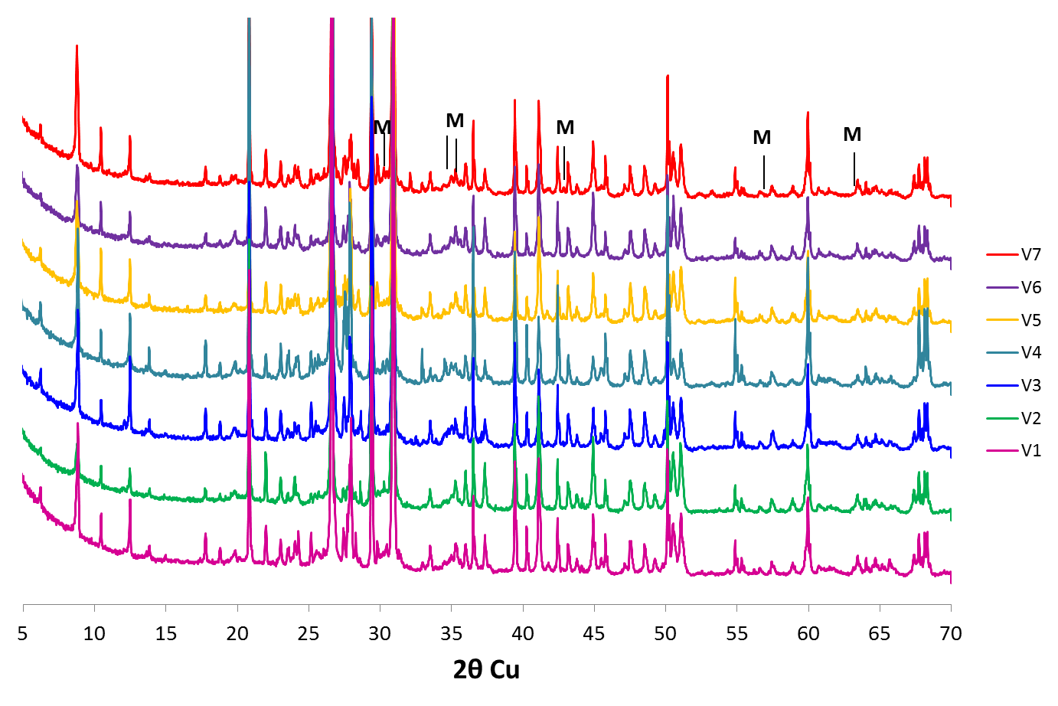Figure S3. The XRD patterns of the examined road dust samples with showing the position of magnetite (M) reflections.

Sample | Nitrogen*  (wt%) | Carbon  (wt%) | Sulfur*  (wt%) | Hydrogen*  (wt%) | Total organic carbon  (wt%) | Total  inorganic carbon  (wt%)
V1 | 0.441±0.027 | 9.9015±0.036 | 0.16±0.059 | 0.5765±0.058 | 5.964±0.05 | 3.9375±0.05
V2 | 0.445±0.022 | 11.56±0.210 | 0.2205±0.017 | 0.4105±0.027 | 5.9895±0.10 | 5.5705±0.10
V3 | 0.3735±0.026 | 8.777±0.076 | 0.2005±0.012 | 0.334±0.042 | 4.2885±0.18 | 4.4885±0.18
V4 | 0.2485±0.006 | 6.2355±0.074 | 0.1105±0.026 | 0.2705±0.019 | 2.9235±0.63 | 3.3120±0.63
V5 | 0.3975±0.017 | 10.1625±0.407 | 0.233±0.017 | 0.306±0.030 | 6.35±0.66 | 3.8125±0.66
V6 | 0.477±0.005 | 12.12±0.180 | 0.2415±0.001 | 0.3325±0.006 | 8.6215±0.15 | 3.4985±0.15
V7 | 0.453±0.006 | 10.99±0.120 | 0.2635±0.006 | 0.3225±0.008 | 6.95±0.10 | 4.040±0.10
* The elements are close to the instrument's precision limits.
Table S3. Elemental analysis of road dust samples, including organic and inorganic carbon contents.

Figure S4. The m/z 44 spectra showing gas switching moment at 1000 °C. The y-axis represents a normal ion current, linear scale (a), and the logarithm of the ion intensity (b) to show the hidden spectra of the blank sample.

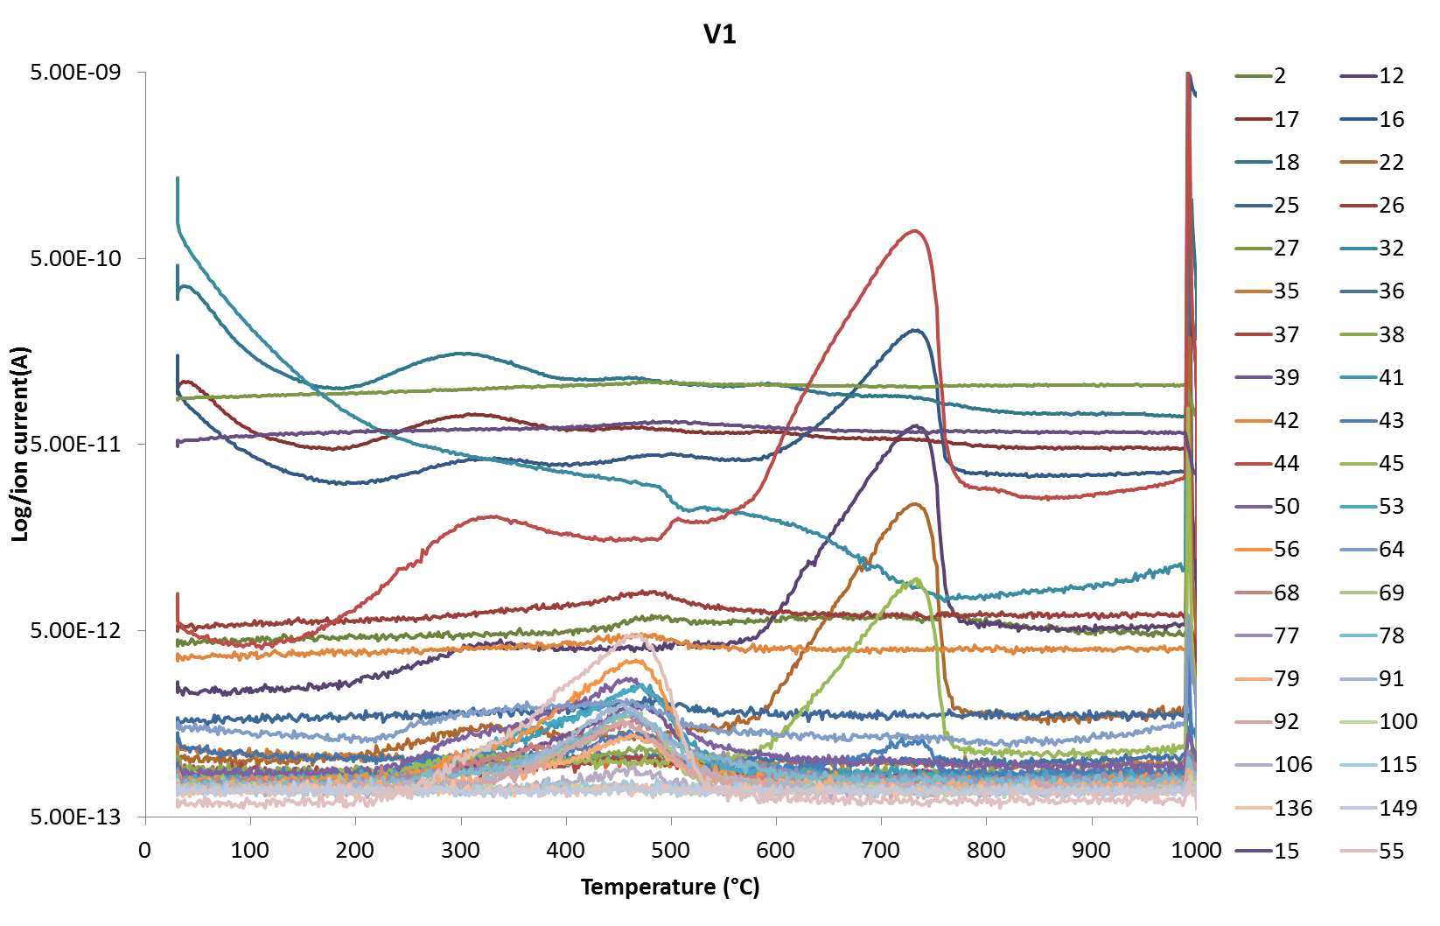
Figure S5. QMS spectra of all monitored ions as m/z during heating with 20°C/min up to 1000°C in N2 for sample V1.

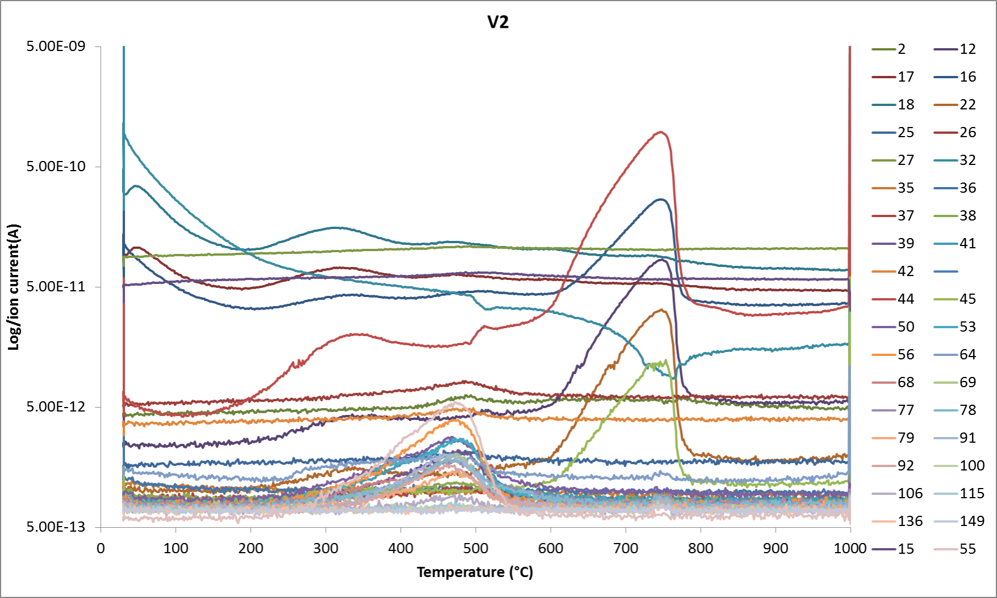
Figure S6. QMS spectra of all monitored ions as m/z during heating with 20°C/min up to 1000°C in N2 for sample V2.

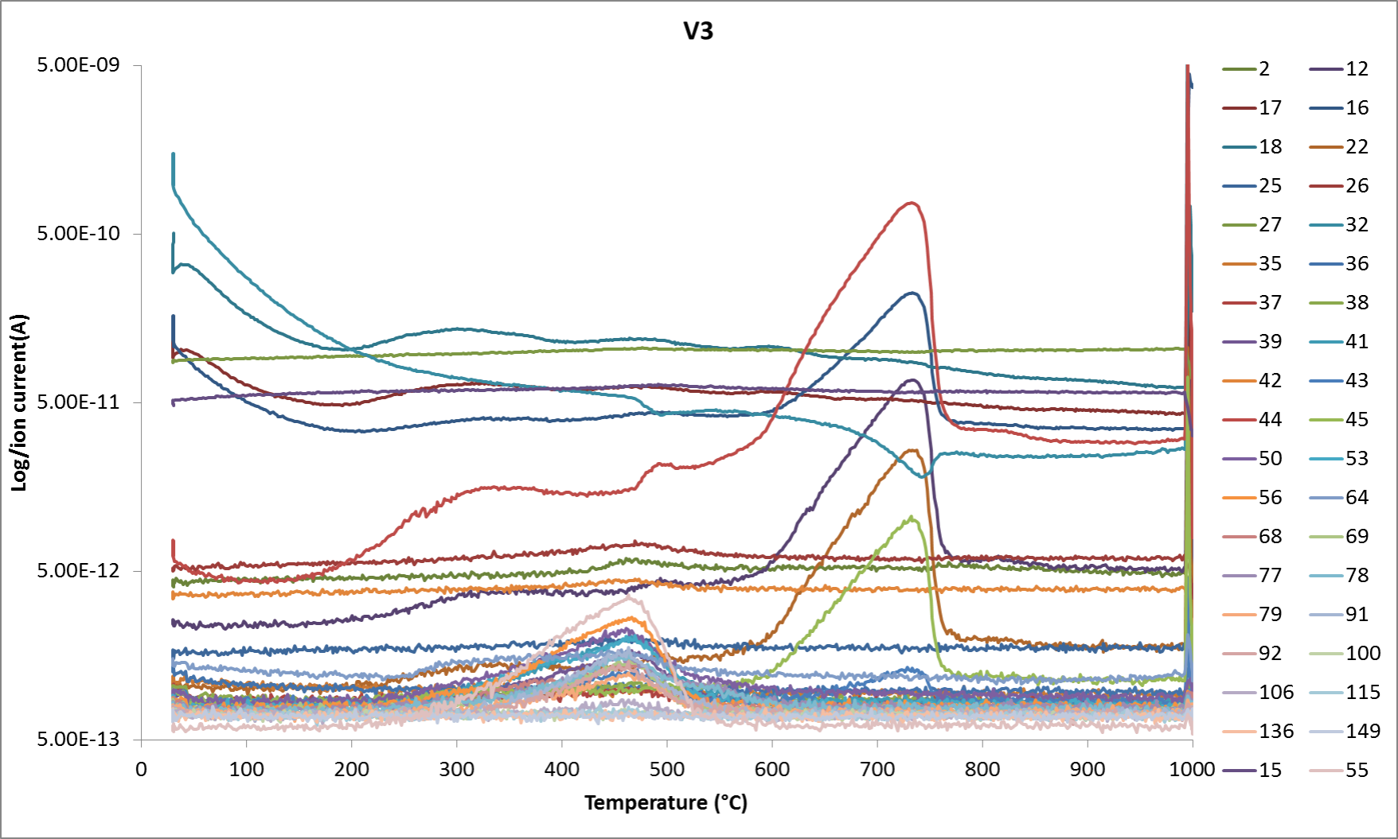
Figure S7. QMS spectra of all monitored ions as m/z during heating with 20°C/min up to 1000°C in N2 for sample V3.

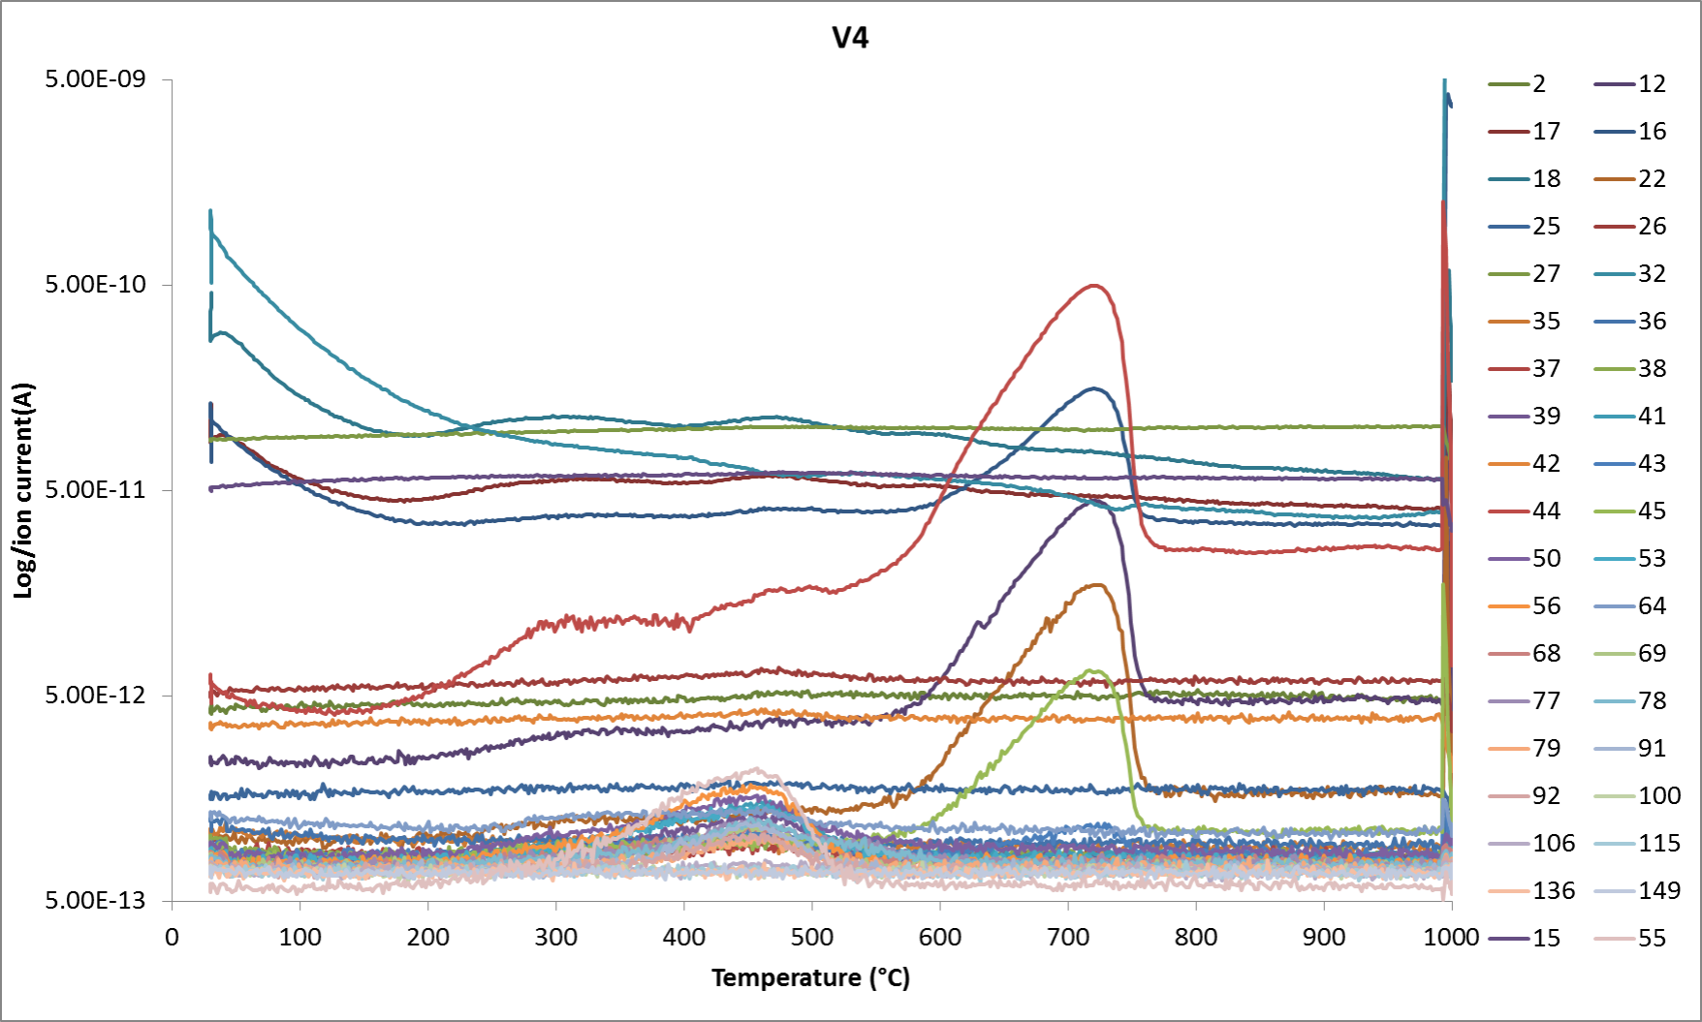
Figure S8. QMS spectra of all monitored ions as m/z during heating with 20°C/min up to 1000°C in N2 for sample V4.

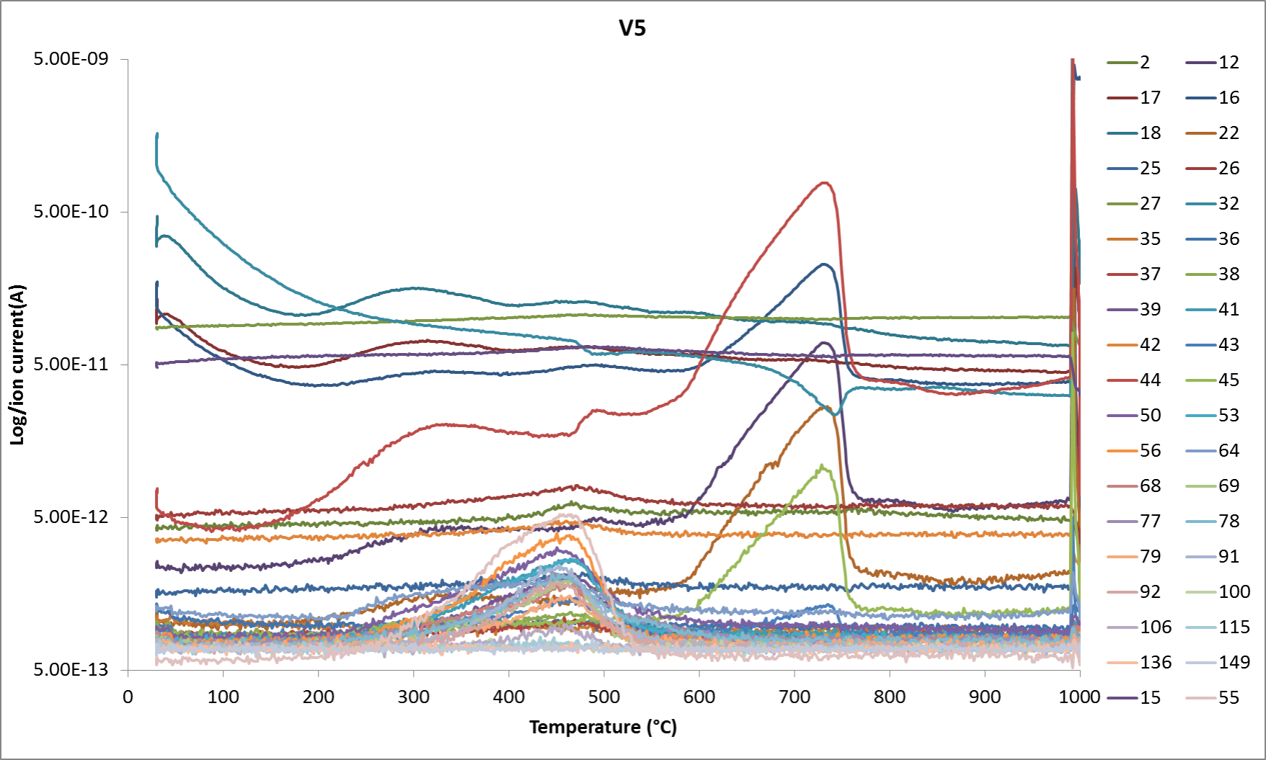
Figure S9. QMS spectra of all monitored ions as m/z during heating with 20°C/min up to 1000°C in N2 for sample V5.

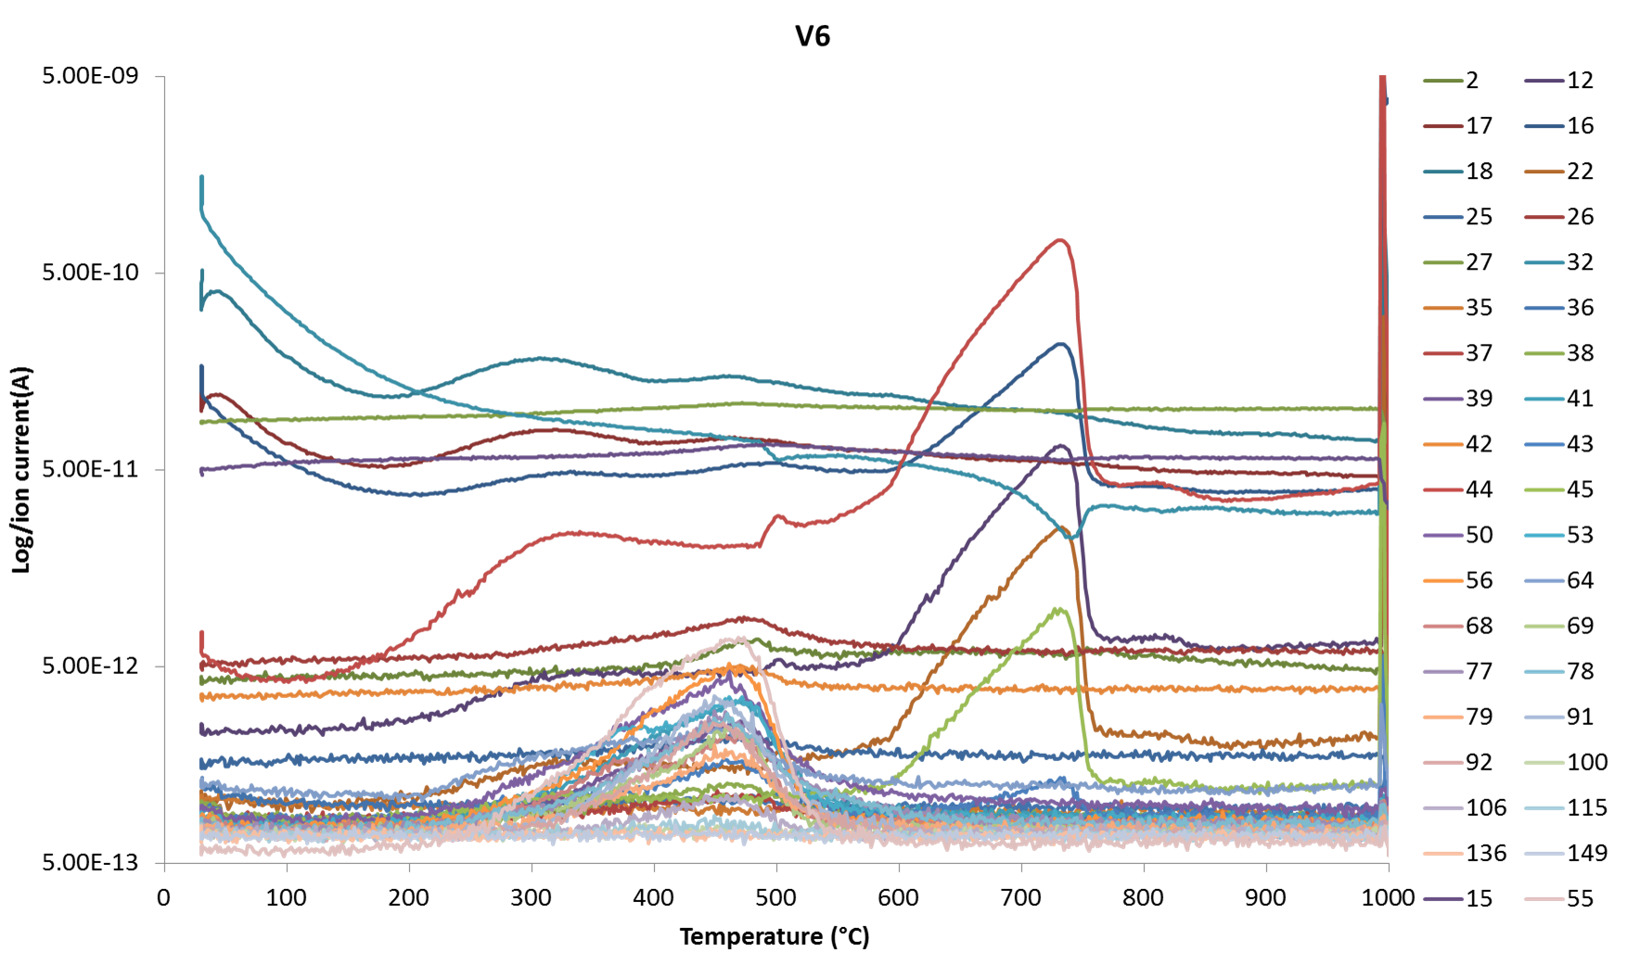
Figure S10. QMS spectra of all monitored ions as m/z during heating with 20°C/min up to 1000°C in N2 for sample V6.

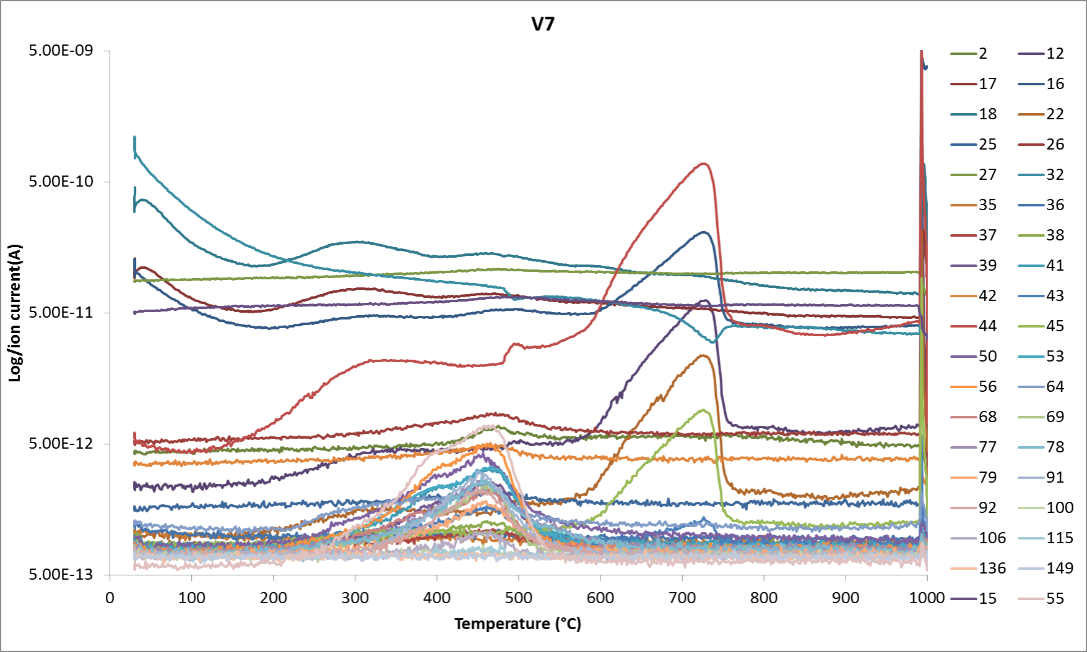
Figure S11. QMS spectra of all monitored ions as m/z during heating with 20°C/min up to 1000°C in N2 for sample V7.

Sample | Δm_{t}  (wt%) | Moisture content,  Δm_{30-180°C}  (wt%) | Δm_{220-540°C}  (wt%) | Oxidative phases,  Δm_{AIR1000°C}  (wt%)
V1 | 26.786±0.307 | 1.265±0.033 | 6.692±0.046 | 0.225±0.201
V2 | 31.121±0.059 | 1.231±0.030 | 6.705±0.060 | -0.149±0.042
V3 | 24.636±0.302 | 1.258±0.006 | 4.894±0.182 | -0.391±0.075
V4 | 18.532±0.065 | 0.950±0.064 | 3.436±0.021 | -0.336±0.005
V5 | 28.070±0.117 | 1.309±0.006 | 6.973±0.037 | -0.475±0.107
V6 | 30.249±0.160 | 1.653±0.015 | 9.100±0.174 | 0.455±0.030
V7 | 27.129±0.154 | 1.416±0.017 | 7.642±0.008 | -0.481±0.172
Table S4. Thermogravimetric data for road dust samples (V1–V7), including mean values and standard deviations (n=3).

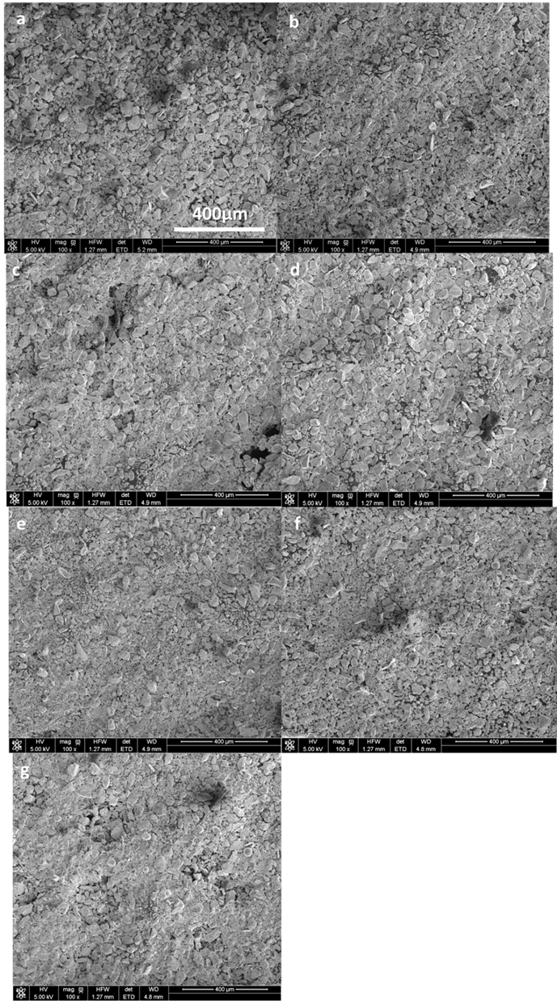
Figure S12. SEM images of representative road dust samples of V1 (a), V2 (b), V3 (c), V4 (d), V5 (e), V6 (f), and V7 (g).

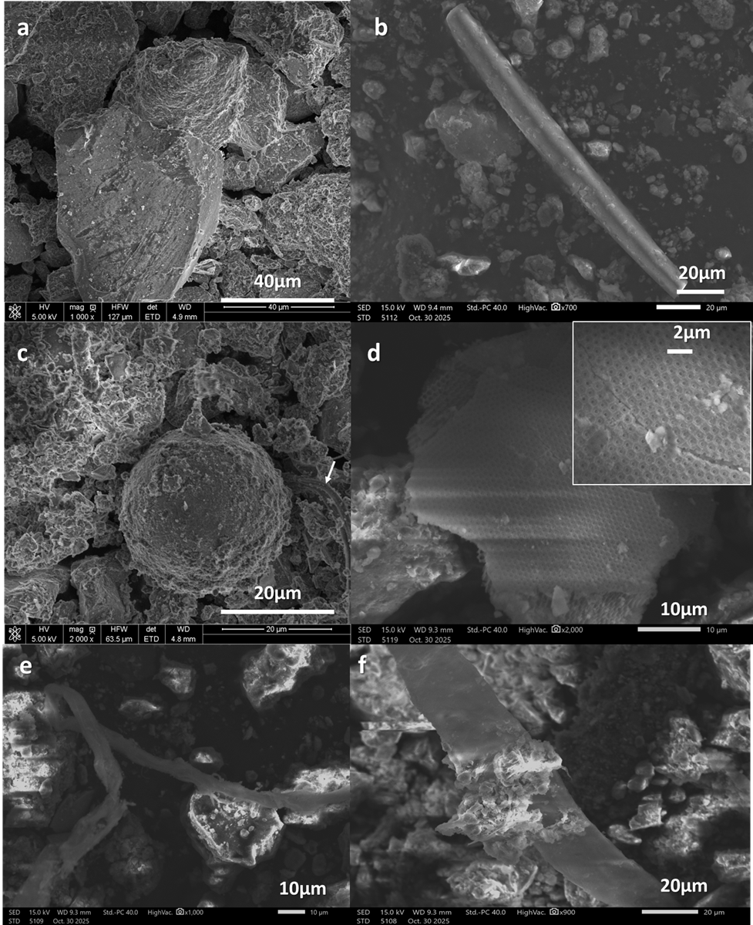
Figure S13. The SEM images with geometrical characteristics indicating an anthropogenic source of particles. The angular quartz particle of V4 sample showing grooves or scratches on the surface indicting the mechanical abrasion (a); a rod of SiO₂ of sample V6 (b); a sphere of iron oxides of sample V7 (c); plate fragment with honeycomb structure of sample V6 (d); microplastic fiber of sample V6 (e); mineral particles attached to the microplastic fiber of sample V6.

Sample ID | Mrs/Ms | Hcr/Hc | χ [10⁻⁸ m³/kg] | χ_{ARM} [10⁻⁸ m³/kg]
V1 | 0,057 | 6,000 | 448,806 | 69,107
V2 | 0,089 | 5,077 | 575,007 | 94,792
V3 | 0,065 | 6,182 | 674,249 | 72,812
V4 | 0,077 | 4,444 | 362,483 | 44,56
V5 | 0,083 | 5,333 | 770,603 | 122,025
V6 | 0,072 | 5,818 | 910,561 | 110,281
V7 | 0,069 | 5,889 | 862,758 | 170,444

Table S5. Magnetic ratios Mrs/Ms and Hcr/Hc for road dust samples V1 through V7. Mrs/Ms is the ratio of saturation remanent magnetization (Mrs) to saturation magnetization (Ms), indicating the stability and domain state of magnetic grains. Hcr/Hc is the ratio of coercivity of remanence (Hcr) to coercivity (Hc).

Figure S14. Thermomagnetic curve showing the temperature dependence of magnetic susceptibility κ(T) for sample V2. Red lines represent the heating run, while blue lines indicate the cooling run.

Figure S15. Thermomagnetic curve showing the temperature dependence of magnetic susceptibility κ(T) for sample V3. Red lines represent the heating run, while blue lines indicate the cooling run.

Figure S16. Thermomagnetic curve showing the temperature dependence of magnetic susceptibility κ(T) for sample V4. Red lines represent the heating run, while blue lines indicate the cooling run.

Figure S17. Thermomagnetic curve showing the temperature dependence of magnetic susceptibility κ(T) for sample V5. Red lines represent the heating run, while blue lines indicate the cooling run.

Figure S18. Thermomagnetic curve showing the temperature dependence of magnetic susceptibility κ(T) for sample V7. Red lines represent the heating run, while blue lines indicate the cooling run.

