The Version of Record of this article is published in Environmental Pollution Elsevier, and is available online at https://doi.org/10.1016/j.envpol.2026.128225. This version has not undergone any post-acceptance improvements or corrections.

Prediction Models of Polycyclic Aromatic Hydrocarbons in Urban Road Dust via Magnetic Properties, Particle Size, and Urban Environmental Features

Sylwia Dytłow ^{1*} Małgorzata Kida² Kamil Pochwat³ Grzegorz Karasiński¹ Jakub Karasiński⁴
Małgorzata Kida² and Kamil Pochwat³ contributed equally to this work.
¹ Institute of Geophysics, Polish Academy of Sciences, Księcia. Janusza 64, 01-452 Warsaw, Poland
² Department of Chemistry and Environmental Engineering; Faculty of Civil and Environmental Engineering and Architecture; Rzeszów University of Technology, 35--959 Rzeszów, Ave Powstańców Warszawy 6, Poland; Telephone number: +48 17 7432407
³ Department of Infrastructure and Water Management, Faculty of Civil and Environmental Engineering and Architecture, Rzeszów University of Technology, Ave Powstańców Warszawy 6, 35–959 Rzeszów, Poland
⁴ University of Warsaw, Faculty of Chemistry, Biological and Chemical Research Centre, Warsaw, Poland
0000-0001-6968-6491 Sylwia Dytłow ORCID
*E-mail address of the corresponding Author: skdytlow@igf.edu.pl

Keywords
Road dust; Magnetic susceptibility; PAH; Machine learning; Urban pollution
Abstract
This study explores the novel application of artificial neural networks to predict polycyclic aromatic hydrocarbons (PAHs) pollution in urban road dust by integrating magnetic properties, particle size distributions, and urban environmental features. A comprehensive dataset from 284 samples from Warsaw, Poland, included magnetic susceptibility (χ), saturation magnetization (Ms), remanent magnetization (Mrs), traffic intensity, granulometric fractions, and parameters such as building height, building layout, connection to the municipal central heating network, and geospatial coordinates. Principal component analysis (PCA) revealed that ∑PAH16 accumulation patterns are governed by the interplay between magnetic proxies (χ, Ms​, Mrs​), traffic intensity (T), and urban structural configurations, specifically heating grid status (C), building height (H), and building continuity (B; attached vs. detached structures), collectively accounting for 60.21% of the total variance. The predictive performance of the models was evaluated using 5-fold cross-validation. While the Linear Regression (LR) model showed low and unstable accuracy (R² ranging from 0.05 to 0.32, mean 0.18), the Random Forest (RF) model provided a significantly more robust framework for capturing the nonlinear relationships between variables. SHAP (SHapley Additive exPlanations) analysis was employed to interpret the RF model, revealing that grain size fraction (F) and geospatial coordinates (LA, LO) were the primary drivers of PAH accumulation. In contrast, factors such as traffic intensity and building layout exhibited a marginal influence. The comparison of modeling approaches revealed a progressive increase in predictive performance as the ability to capture nonlinear and local relationships improved (R² =≈0.18 for linear regression, ≈0.26 for ANN, and ≈0.40 for RF), indicating that PAH accumulation is governed by complex, context-dependent interactions rather than simple independent predictors. These findings demonstrate that integrating magnetic properties and urban features using machine learning provides a powerful tool for identifying pollution hotspots and understanding the complex mechanisms underlying the distribution of organic pollutants in urban environments.

Highlights
- PCA links magnetic signals and PAHs, explaining 60% of the variance.
- Integrated urban features and magnetic properties to identify PAH drivers.
- Random Forest model effectively captured nonlinear trends in road dust.
- SHAP analysis identified grain size fraction and location as primary factors.
- Linear regression showed low and unstable predictive performance compared to RF.
- Magnetic parameters contribute significantly to the model’s predictive power.
- Introduction

Environmental pollution in urban areas, which involves large numbers of people in a small area, is one of the most important issues worldwide and negatively affects environmental quality and people’s health (WHO, 2016). The United Nations reports that the share of the global population living in cities is expected to reach 68% by 2050 (UN, 2019). This dense urbanization has led to the production of an increasing amount of harmful pollutants, exposing many people to the consequences of anthropogenic activities.
A key component of urban pollution is street dust, a heterogeneous mixture of soils and particles from natural and anthropogenic sources deposited on road surfaces (Z. Cao et al., 2017; Gunawardana et al., 2012; Haynes et al., 2020). Anthropogenic pollutants in street dust originate largely from traffic-related processes, including fuel combustion, tire wear, brake pads, and road surfaces, as well as industrial activities and low-stack emissions (Kreider et al., 2010; Z. Li et al., 2013; Logiewa et al., 2020; Pathak et al., 2013; Tanner et al., 2008; Yıldırım & Tokalıoğlu, 2016). These emissions include heavy metals and polycyclic aromatic hydrocarbons (PAHs).

Human activities and various pollution sources, including fossil fuel combustion, industrial processes, vehicular movement, and tire wear, are responsible for releasing substantial quantities of both heavy metals and magnetic particles into the environment (Christoforidis & Stamatis, 2009; Lanzerstorfer, 2021; Padoan et al., 2017; Shi et al., 2011). Numerous studies have demonstrated that magnetic measurements can be an effective tool for assessing environmental contamination, as strong correlations have been observed between magnetic properties and pollutant concentrations, particularly heavy metals. This approach has been successfully applied to a range of environmental media, including soils (Bondar et al., 2025; Cao et al., 2015; Dytłow et al., 2019; Hu et al., 2007; Jaffar et al., 2017; Wang et al., 2018), road or street dust (Qiao et al., 2011; G. Wang et al., 2019; Zhang et al., 2024), sediments (Chudaničová et al., 2016; Hamdan et al., 2022), plant leaves (Salazar-Rojas et al., 2023), and airborne particulate matter (Power et al., 2023). Polycyclic aromatic hydrocarbons (PAHs) and magnetic particles often share common traffic-related and industrial sources, such as vehicle exhaust, brake wear, and tire abrasion. Therefore, magnetic parameters (e.g., magnetic susceptibility and remanence) are correlated with anthropogenic particle content, and these magnetic carriers can adsorb PAHs, allowing combined physical and chemical assessments of pollution (Ayoubi et al., 2020; Karimian et al., 2023; Morris et al., 1995; Venkatachalapathy et al., 2010).
PAHs are a ubiquitous and persistent class of organic pollutants with two or more fused benzene rings. They are produced mainly by the incomplete combustion and pyrolysis of fossil fuels and biomass (pyrogenic) or by the direct release from petroleum products (petrogenic) (Galatioto et al., 2022; Tobiszewski & Namieśnik, 2012). PAHs are toxic, with many classified as human carcinogens (IARC, 2010, 2016; Loganathan et al., 2013), and exposure is linked to diseases of the respiratory and circulatory systems, cancers, and nervous system damage (Franco et al., 2017; Lorenzi et al., 2011; Majumdar et al., 2017). The Aphekom project highlighted that living near busy roads accounts for a significant proportion of new asthma and coronary heart disease cases (Chanel et al., 2016).
Given these risks, monitoring PAH pollution is a major challenge for public health protection. While determining PAHs is a matter of chemical analysis, understanding their complex relationships with other environmental variables requires advanced modeling techniques. In this context, rock-magnetic parameters (such as magnetic susceptibility, saturation magnetization, and saturation remanent magnetization from hysteresis loops) have emerged as rapid and effective proxies for assessing pollution levels, as they often correlate with anthropogenic, combustion-derived particles.
Machine learning (ML), especially artificial neural networks (ANNs), offers a powerful toolkit for deciphering these complex, nonlinear relationships in environmental data. ML algorithms have been successfully applied to model pollutant interrelationships (Kassandros et al., 2023; Peng et al., 2024), map their spatial distribution (Choubin et al., 2020), and predict pollution levels (Olawoyin, 2016). ANNs, support vector machines (SVMs), and random forest regression have been applied to analyze pollutant release and dynamics during microplastic degradation, providing insights into complex, nonlinear relationships in environmental data (Kida et al., 2024; Kida et al., 2024). Models such as random forests, support vector machines, and neural networks can capture patterns that traditional statistical methods might miss (Cabaneros et al., 2019; Patel et al., 2023).
This research employs a dual-modeling framework, combining an ANN and a Random Forest (RF), to evaluate the influence of diverse environmental drivers on PAH concentrations in urban road dust. A key contribution of this study is the integration of a comprehensive sensitivity analysis, which enables a robust determination of the relative importance of individual features in governing the final output of polycyclic aromatic hydrocarbon levels. For the first time, the model integrates multiple environmental and physical features, including building height, traffic intensity, connection to the municipal heating network, magnetic parameters (e.g., magnetic susceptibility, saturation magnetization, remanent magnetization), particle size distribution, and geospatial coordinates (GPS). The study addresses the following research questions:
1. To what extent can machine learning architectures, specifically Artificial Neural Networks (ANN) and Random Forest (RF), outperform classical linear models in predicting PAH concentrations based on magnetic, traffic, and granulometric features?
2. Which environmental and physical parameters exhibit the highest predictive power for PAH levels, and is their importance consistent across different modeling approaches (ANN vs. RF)?
3. How do global (ANN) and locally adaptive (RF) modeling approaches differ in capturing complex, context-dependent interactions between urban drivers and road dust pollution?
4. Does the integration of SHAP analysis and multi-model comparison provide a reliable framework for source identification and rapid environmental assessment in complex urban systems?
2. Study area and methods
2.1. Study area and sampling campaign for urban road dust
The sampling activities took place in Warsaw, Poland’s capital city, located in the central part of the Mazovian Voivodeship along the Vistula River (52°13′48″N, 21°00′40″E). Road dust samples were collected from 79 sites (Figure S1) distributed across the city to capture the spatial variability associated with different land-use categories and traffic densities. Each sampling site was classified according to its connection to the municipal district heating network (variable C). This binary classification was critical for isolating the contribution of local low-stack emissions from individual household heating systems. Classification was performed using a multistage protocol. Primary data were obtained from the Central Emissions Building Register, provided by the Air Protection and Climate Policy Department of the City of Warsaw (CEEB, 2023), following a formal public information request.
For every sampling point, a spatial analysis was conducted within a 200 m radius to assess the potential influence of nearby off-grid heating sources. Sites were cross-referenced with district-level statistics, which show strong contrasts across the city (e.g., Wesoła: 99.43 %, Wawer: 99.18 % off-grid buildings in peripheral districts versus only 34.24 % in the city centre, Śródmieście). In districts with mixed heating infrastructure (off-grid share < 90 %, such as Ochota or Wola), rigorous on-site inspections were carried out. In cases of remaining uncertainty, direct interviews with building administrators or owners were conducted to verify the actual heating status of structures immediately adjacent to the sampled road segment.
Sampling activities were conducted between September and November 2023, exclusively on dry days, and were scheduled in accordance with the official street cleaning timetable provided by Warsaw City Hall (ZOM, 2025). A detailed description of the study area and sampling campaign is provided in the Supplementary Materials - Chapter S1.
At each sampling location, road dust was collected using clean, nonmetallic tools, including a vacuum cleaner, a brush, and a dustpan, until at least 500 g of material was collected. Each composite sample consisted of several subsamples taken from within the designated area, with their precise positions recorded via a handheld GPS device. The samples were sealed in laboratory shipping containers, transported to the laboratory, air-dried at ambient temperature, and sieved for granulometric analysis. The particle size distribution was determined via an LPzE-2e laboratory shaker (MULTISERW-Morek, Poland) using a calibrated sieve series. Initially, the road dust was sieved to obtain the bulk fraction (< 1.0 mm), which was labeled as 1. Subsequently, this material was further separated into five additional sub-fractions: 1.0–0.8 mm (labeled 0.8), 0.8–0.6 mm (0.6), 0.6–0.4 mm (0.4), 0.4–0.2 mm (0.2), and <0.2 mm (0.1), which were then transferred into 8 cm³ containers and weighed with analytical precision.
2.2. Polycyclic Aromatic Hydrocarbons (PAHs) extraction and quantitative determination
Before quantitative assessment, polycyclic aromatic hydrocarbons were isolated from road dust samples via a modified acetonitrile (ACN) extraction technique adapted from the procedures described by Puy-Alquiza et al. (2016) and Dytłow et al. (2025). Method optimization included systematic evaluation of the extraction time, solvent-to-sample ratio, and preconcentration parameters. These optimizations were performed using a certified reference material (LGC6188) to achieve a balance between extraction efficiency and matrix-effect reduction, thereby improving the analytical signal-to-noise ratio. The final extraction protocol involved weighing approximately 5 g of homogenized road dust and adding 25 ml of ACN. A detailed description of the procedure is provided in the Supplementary Materials – Chapter S2 and Table S1. The quality assurance and quality control (QA/QC) procedures for PAHs are described in detail in the Supplementary Materials – Chapter S3.
2.3. Magnetic susceptibility (χ) and hysteresis loop measurements
Low-field volume magnetic susceptibility (κ) was measured at a frequency of 976 Hz with a sensitivity of 2 · 10⁻⁸ SI at a magnetic field strength (H) of 200 A/m via the multifunction Kappabridge MFK1-FA (AGICO, Czech Republic). A detailed description is provided in the Supplementary Materials – Chapter S4.
2.4. Description and classification of the input data
Each road dust sample was assigned to a specific grain size fraction and characterized using a set of environmental and urban parameters. Additional parameters describing the sampling location were recorded for each site, including traffic intensity (number of vehicles passing in both directions within 24 h), building layout (C–closed, O–open), and height of the surrounding buildings, categorized as N (no buildings), L (low-rise buildings -1–2 floors), M (medium-rise buildings – 3–5 floors), H (high-rise buildings- >5–7 floors), and V (very high buildings - skyscrapers). These factors influence the dispersion of pollutants generated by road traffic and nearby combustion sources. Traffic intensity data were obtained from the Warsaw Traffic Survey (City of Warsaw, 2023). Connection to municipal heating system indicates whether the building is supplied by the municipal central heating network (Y=yes, N=no). When N = no, the building is heated individually, typically using domestic heating systems such as stoves or small boilers operated by the residents.
For each sample, the concentrations of 16 priority PAHs were determined: naphthalene (Nap), acenaphthylene (Acy), acenaphthene (Ace), fluorene (Flu), phenanthrene (Phe), anthracene (Ant), fluoranthene (Flt), pyrene (Pyr), benz[a]anthracene (BaA), chrysene (Chr), benzo[b]fluoranthene (BbF), benzo[k]fluoranthene (BkF), benzo[a]pyrene (BaP), dibenz[a,h]anthracene (DBA), benzo[ghi]perylene (BghiP), and indeno[1,2,3-cd]pyrene (IP). The total PAHs concentration (ΣPAH₁₆) was calculated as the sum of all individual PAHs.
The laboratory-analyzed PAH compound data were subjected to basic statistical analysis and normalization. The obtained results were used to train the neural network. In the first stage, a comprehensive neural network was proposed. In subsequent stages, to improve its predictive performance, it was segmented based on a qualitative variable indicating connection to the municipal district heating network.
The research plan is presented in Figure 1.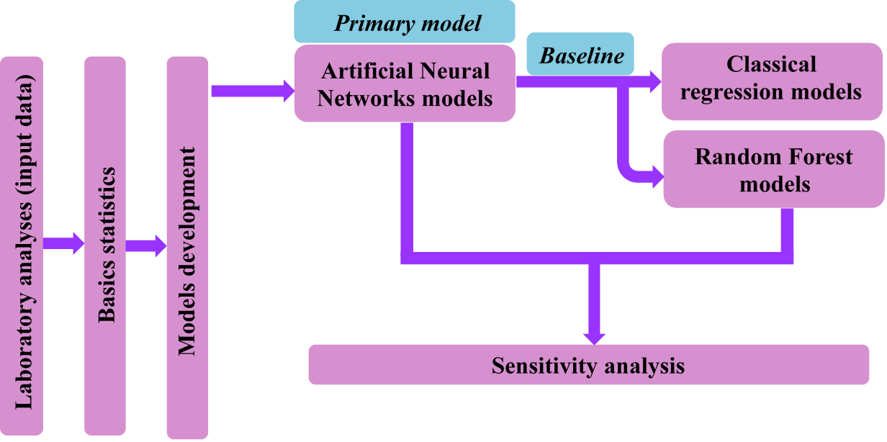
Figure 1. Research plan.
2.5. Statistical analysis and data filtration
Preliminary data management, descriptive statistical analysis, and initial data screening were conducted using Statistica 13 software. Values below the limit of quantification (LOQ) were replaced with the LOQ/2 (Table S2 in Supplementary Materials). To ensure model robustness and eliminate low-signal noise, samples with ∑PAH16 concentrations below the cumulative LOQ/2 threshold (0.253 mg/kg) were excluded.
To establish a rigorous threshold for outlier removal, the distribution parameters were calculated: the first quartile (Q1) was 0.62 mg/kg, and the third quartile (Q3) was 2.48 mg/kg, yielding an Interquartile Range (IQR) of 1.86 mg/kg. Based on these parameters, the formal limit for potential outliers (Q3+1.5×IQR) was 5.27 mg/kg, while the limit for extreme outliers (Q3+3×IQR) reached 8.06 mg/kg. Between these two statistical benchmarks, a conservative empirical threshold of 6 mg/kg was applied. This value was chosen based on preliminary data distribution analysis to ensure the highest model reliability by effectively capturing the continuous urban background distribution while excluding isolated, high-concentration hotspots. The excluded observations appeared as single, disconnected points that lacked the continuity required for effective machine learning training. This approach ensured that the machine learning models (ANN and RF), developed in the Python ecosystem, were trained on a representative and stable dataset.

2.6. Data preparation and encoding
Qualitative data were prepared and encoded for artificial neural network and random forest modeling. To ensure compatibility with machine learning algorithms and preserve the inherent relationships between categories, all categorical variables were encoded as numerical values using ordinal encoding (Géron, 2019). The connections to the municipal district heating network were encoded as Y (yes) = 1 and N (no) = 0, while the building layout was represented as C (closed) = 1 and O (open) = 0. Similarly, the heights of surrounding buildings were ordinally categorized to reflect their increasing physical scale: N (no buildings) = 0, L (low-rise, 1–2 floors) = 1, M (medium-rise, 3–5 floors) = 2, H (high-rise, >5–7 floors) = 3, and V (very high buildings – skyscrapers) = 4. This approach allowed the models to account for the qualitative progression of urban density within a single input dimension for each variable.
The normalization or standardization of data is an essential step in preparing input features for neural networks(Hastie et al., 2001; Kuhn & Johnson, 2013). The purpose of this process is to bring all variables to a comparable scale, preventing those with larger numerical ranges from dominating the learning process.
To ensure numerical stability and uniform weight distribution across the disparate architectures of RF and ANNs, all input features were rescaled using Z-score standardization. While RF is generally robust to monotonic transformations, the convergence of ANN is highly sensitive to the scale of input data.
The transformation was implemented within the Python scientific computing ecosystem according to Equation (1):

$$z= \frac{x-μ}{ σ} \left(1\right)$$
In which z is the standardized value, $x$ is the original feature, and μ and σ are the mean and standard deviation, respectively. This transformation ensures that all input features contribute proportionally during training, improving the model’s convergence and numerical stability. The necessity of data normalization has been discussed in previous studies. Ioffe and Szegedy (2015) introduced batch normalization as a method to accelerate deep network training by reducing the internal covariate shift. Likewise, (Anemangely et al., 2019) emphasized the importance of proper feature scaling to enhance the performance and efficiency of machine learning models. The input data employed in this study are presented in Table S3 in the Supplementary Materials.
2.7. Research software and computational methodology
Preliminary data management, descriptive statistical analysis, and initial data screening were conducted using Statistica 13 software. The core computational framework, including the development of non-linear models and SHapley Additive exPlanations analysis, was implemented in a Python environment. Data management, including cleaning processes and advanced filtering of input datasets, was handled using the Pandas library (McKinney, 2010). Numerical operations and matrix calculations were conducted via NumPy (Harris et al., 2020), which was also utilized to determine model performance through specific error metrics: MAE (Mean Absolute Error), representing the average magnitude of the prediction error, and RMSE (Root Mean Square Error), which was used to evaluate model stability by penalizing larger deviations. Furthermore, Scikit-learn (Pedregosa et al., 2011) served as the primary tool for data standardization via Z-score scaling, the construction of machine learning architectures (specifically RF and ANNs), and the execution of rigorous cross-validation procedures.

2.8. Multilayer perceptron (MLP) Neural Networks, Limited-memory Broyden–Fletcher–Goldfarb–Shanno (L-BFGS) Training, Activation Functions, Second-Order Polynomial Model, and SHapley Additive exPlanations (SHAP)
The multilayer perceptron (MLP) is the most widely used static neural network. In an MLP, the network receives input together with the target output, and the connection weights are updated so that the network learns to approximate the desired output (Fausett, 1994). The details of the MLP, L-BFGS, activation functions, and polynomial model are described in the Supplementary Materials – Chapter S5. Furthermore, to ensure the interpretability of the results and quantify the impact of individual environmental variables on the predictions, the SHapley Additive exPlanations (SHAP) method was employed; its detailed mathematical background and implementation are provided in the Supplementary Materials – Chapter S6.
3. Results and discussion
3.1. Descriptive statistics and principal component analysis (PCA)
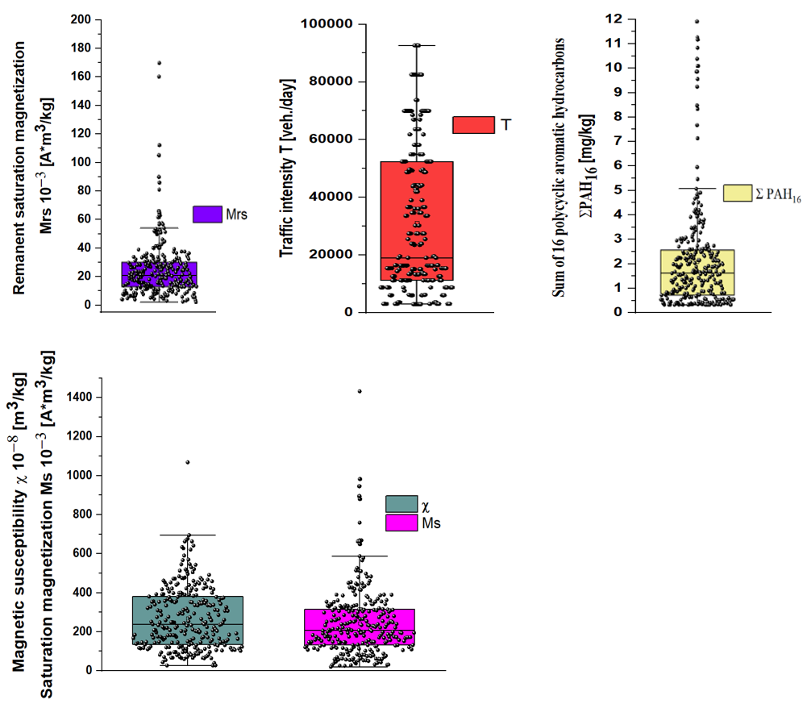

Figure 2. Box-and-whisker plots summarizing the distribution of all numerical parameters investigated in this study. The displayed parameters are: magnetic susceptibility (χ); saturation magnetization (Ms); remanent saturation magnetization (Mrs); daily traffic intensity (T); and total concentration of the 16 priority polycyclic aromatic hydrocarbons (∑PAH₁₆). The central line represents the median, the box extends from the first to the third quartile, and the whiskers show the variability outside the interquartile range. Outliers are plotted as individual points.
In this study, descriptive statistical analysis was conducted on all measured quantitative (numerical) variables to characterize their distributions, central tendencies, and variabilities. The dataset included the magnetic properties of the samples, as well as environmental parameters, such as traffic intensity and PAH concentrations. The magnetic susceptibility (χ) (Figure 2, Table S3 in Supplementary Materials) ranged from 27.11 to 1068.25 10⁻⁸ m³/kg, with a mean value of 269.51 ± 160.59 10⁻⁸ m³/kg. The median value was 238.70 10⁻⁸ m³/kg, suggesting a slightly skewed distribution. The saturation magnetization (Ms, 10⁻³ A·m³/kg) ranged from 20.76 to 1432.08, with a mean of 244.61 ± 174.39 and a median of 207.27, indicating moderate skewness. The remanent saturation magnetization (Mrs, 10⁻³ A·m³/kg) ranged from 1.92 to 171.44, with a mean of 24.77 ± 20.84. The median was 20.84, indicating a slightly right-skewed distribution. These values are generally lower than those reported for road dust in the West Midlands, UK (588.3 × 10⁻⁸ m³ kg⁻¹; Shilton et al., 2005) and Asaluye, Iran (550.9 × 10⁻⁸ m³ kg⁻¹; Abbasi et al., 2020), but higher than those measured in Sofia, Bulgaria (264.6 × 10⁻⁸ m³ kg⁻¹; Jordanova et al., 2014). The mean χ value is also comparable to that reported in Lanzhou city, China (442.4 × 10⁻⁸ m³ kg⁻¹; Wang et al., 2011), and Thessaloniki, Greece (408.7 × 10⁻⁸ m³ kg⁻¹; Bourliva et al., 2018), indicating that the magnetic properties of Warsaw road dust fall within the typical urban range reported worldwide.
The total ∑PAH₁₆ concentrations in the present study ranged from 0.24 to 11.81 mg/kg, with a mean of 2.00 ± 2.06 mg/kg and a median of 1.54 mg/kg, indicating a skewed distribution. These levels are generally lower than those reported for Tokyo, Japan (mean ∑PAH₁₂, 0.3 mg/kg; Khanal et al., 2018), Saudi Arabia (mean ∑PAH₁₅, 0.3 mg/kg; Shabbaj et al., 2018); mean ∑PAH₁₆, 0.43 mg/kg; Alghamdi et al., 2021), Asansol, India (mean ∑PAH₁₆, 0.5 mg/kg; Gope et al., 2018), and several Chinese cities, including Hubei Province (4.43 mg/kg; Zhang et al., 2016), Qingyang (3.0 mg/kg; Wu et al., 2020), Shanghai (3.92 mg/kg; Wang et al., 2021), Huainan (4.1 mg/kg; Xu et al., 2022), Chengdu (4.8 mg/kg) and Tianjin (8 mg/kg; Yu et al., 2014). Conversely, the PAH concentrations measured in Warsaw were higher than those reported for Jalalabad, Afghanistan (∑PAH₁₇, 0.29 mg/kg; (Khpalwak et al., 2019), some locations in Iran (0.3–2.2 mg/kg; (Abbasi & Keshavarzi, 2019; Davoudi et al., 2021; Najmeddin & Keshavarzi, 2019), Myanmar, Japan, Taiwan, and Vietnam (∑PAH₁₉, 1.7 mg/kg; Mon et al., 2020), and Huanggang, China (1.8 mg/kg; Liu et al., 2019).
The traffic intensity (vehicles per day) (Table S3 in Supplementary Materials) ranged from 1,900 to 88,910, with a mean of 29,122 ± 24,039. The median traffic intensity was 17,500, reflecting the influence of extremely high values on the mean. Overall, these descriptive statistics provide a clear quantitative overview of the dataset and form the basis for subsequent correlation, regression, and trend analyses.

 | χ | Ms | Mrs | T | Nap | Acy | Ace | Flu | Phe | Ant | Flt | Pyr | BaA | Chr | BbF | BkF | BaP | DBA | BghiP | IP | ∑PAH 16
χ | 1
Ms | 0.54  ** | 1
Mrs | 0.46  ** | 0.89  ** | 1
T | 0.24  ** | 0.14* | 0.18* | 1
Nap | 0.01 | 0.03 | 0.05 | 0.08 | 1
Acy | 0.25  ** | 0.11 | 0.08 | -0.03 | -0.03 | 1
Ace | 0.33  ** | 0.22  ** | 0.15* | 0.21  ** | 0.35  ** | 0.30  ** | 1
Flu | -0.03 | 0.08 | 0.1 | 0.04 | 0.27  ** | 0.07 | 0.37  ** | 1
Phe | 0.20  ** | 0.1 | 0.04 | 0.03 | 0.32  ** | 0.20  ** | 0.46  ** | 0.6** | 1
Ant | 0.04 | 0.03 | 0.01 | -0.02 | 0.30  ** | 0.09 | 0.31  ** | 0.60  ** | 0.72  ** | 1
Flt | 0.19* | 0.08 | 0.04 | 0.06 | 0.30  ** | 0.26  ** | 0.46  ** | 0.5** | 0.89  ** | 0.66  ** | 1
Pyr | 0.04 | 0.04 | 0.00 | 0.06 | 0.43  ** | 0.15* | 0.41  ** | 0.51  ** | 0.82  ** | 0.64  ** | 0.81  ** | 1
BaA | -0.03 | 0.00 | 0.00 | -0.02 | 0.37  ** | 0.14* | 0.37  ** | 0.58  ** | 0.87  ** | 0.69  ** | 0.85  ** | 0.91  ** | 1
Chr | 0.21  ** | 0.09 | 0.04 | 0.01 | 0.29  ** | 0.29  ** | 0.51  ** | 0.52  ** | 0.90  ** | 0.67  ** | 0.87  ** | 0.85  ** | 0.89  ** | 1
BbF | 0.07 | 0.01 | -0.03 | 0.00 | 0.32  ** | 0.23  ** | 0.44  ** | 0.41  ** | 0.79  ** | 0.60  ** | 0.79  ** | 0.88  ** | 0.90  ** | 0.93  ** | 1
BkF | 0.08 | 0.04 | 0.01 | -0.06 | 0.19  ** | 0.25** | 0.32  ** | 0.37  ** | 0.78  ** | 0.55  ** | 0.80  ** | 0.79  ** | 0.85  ** | 0.88  ** | 0.89  ** | 1
BaP | 0.24  ** | 0.11 | 0.04 | 0.01 | 0.23  ** | 0.30  ** | 0.45  ** | 0.40  ** | 0.82  ** | 0.58  ** | 0.80  ** | 0.80  ** | 0.83  ** | 0.94  ** | 0.93  ** | 0.92  ** | 1
DBA | -0.16* | -0.07 | -0.01 | -0.04 | 0.50  ** | -0.02 | 0.12  ** | 0.25  ** | 0.31  ** | 0.38  ** | 0.26  ** | 0.52  ** | 0.52  ** | 0.36  ** | 0.51  ** | 0.34  ** | 0.33  ** | 1
BghiP | -0.05 | -0.08 | -0.09 | 0.06 | 0.27  ** | 0.07 | 0.27 | 0.12  ** | 0.26  ** | 0.27  ** | 0.31  ** | 0.50  ** | 0.45  ** | 0.38  ** | 0.54  ** | 0.41  ** | 0.40  ** | 0.46  ** | 1
IP | 0.06 | 0.01 | -0.01 | 0.00 | 0.21  ** | 0.17* | 0.38  ** | 0.27  ** | 0.61  ** | 0.48  ** | 0.61  ** | 0.68  ** | 0.70  ** | 0.73  ** | 0.79  ** | 0.72  ** | 0.75  ** | 0.42  ** | 0.62  ** | 1
∑PAH 16 | 0.25** | 0.14 | 0.08 | 0.09 | 0.40  ** | 0.45  ** | 0.75  ** | 0.54  ** | 0.85  ** | 0.64  ** | 0.86  ** | 0.84  ** | 0.83  ** | 0.90  ** | 0.86  ** | 0.78  ** | 0.86  ** | 0.38  ** | 0.48  ** | 0.71  ** | 1
Note: Statistical significance is indicated by asterisks: * p < 0.05, ** p < 0.001.
Table 1. Pearson’s correlation matrix (r) between magnetic parameters, traffic intensity, and individual PAH concentrations.
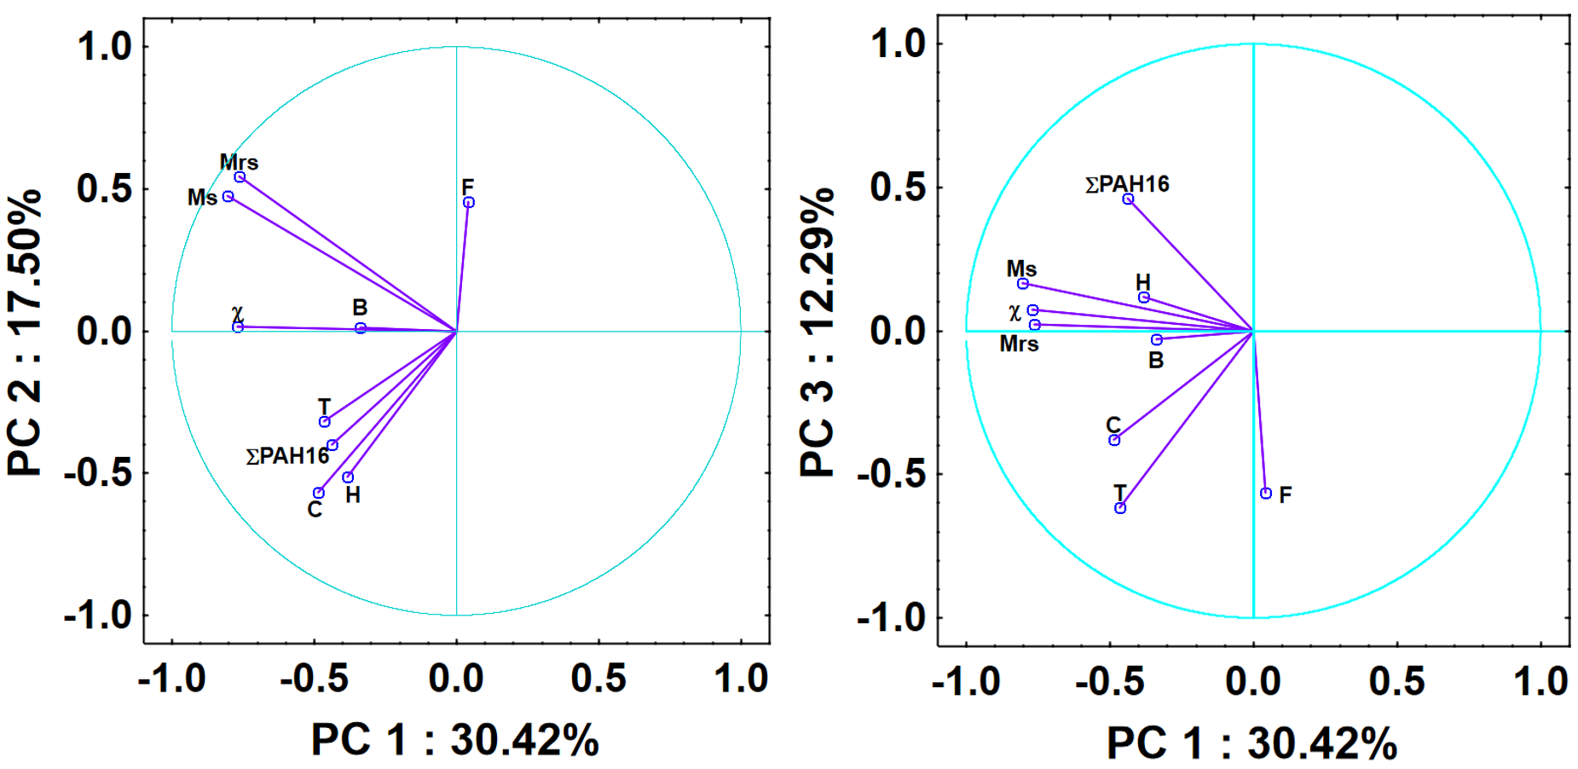
The statistical analysis of the Pearson (Table 1) correlation matrix reveals a high internal consistency between saturation magnetization (Ms​) and saturation remanence (Mrs​), with a coefficient of r = 0.89 (p<0.01). Magnetic susceptibility (χ) displays weak but statistically significant positive correlations with the concentration of total ∑PAH₁₆ (r = 0.25, p<0.01) and Benzo[a]pyrene (r = 0.24, p<0.01). In contrast, traffic intensity shows a correlation of r = 0.24 with χ, while its association with total ∑PAH₁₆ remains weak and statistically non-significant (r = 0.09). Among the individual PAH compounds, high-molecular-weight fractions exhibit the strongest intercorrelations, particularly between Benzo[a]pyrene and Chrysene (r = 0.94). Additionally, Dibenzo[a,h]anthracene shows a negative weak correlation with magnetic susceptibility (r = −0.16, p<0.05), representing a distinct statistical outlier within the analyzed dataset.

Figure 3. PCA for road dust. Variables: χ - Magnetic susceptibility, Ms - Saturation magnetization, Mrs - Remanent of saturation magnetization, T - Traffic intensity, F - Fraction/Grainsize, C – Connection to the municipal central heating network, H - Height of buildings, ∑PAH₁₆ - Total PAH16, B – building layout. The percentage values provided for each principal component (PC1, PC2, and PC3) represent their respective contributions to the total explained variance.

Principal Component Analysis was performed on the expanded dataset of 284 records to elucidate the multivariate relationships between magnetic parameters, urban structural variables, and PAH concentrations (Figure 3). The first three principal components (PC1–PC3) collectively account for 60.21% of the total variance (PC1 = 30.42%, PC2 = 17.50%, and PC3 = 12.29%). The first principal component (PC1) is predominantly defined by magnetic parameters, showing strong negative loadings for magnetic susceptibility (χ), saturation magnetization (Ms​), and remanent saturation magnetization (Mrs​). This component represents the fundamental magnetic signal of the road dust. Notably, PC1 also shows a meaningful alignment with traffic intensity (T) and connection to the municipal heating grid (C), confirming that the magnetic mineralogy in the study area is intrinsically linked to anthropogenic emission sources. The second principal component (PC2) reveals a strong correlation between total PAH concentrations (∑PAH₁₆) and urban morphological features. Specifically, ∑PAH₁₆ clusters closely with traffic intensity (T), building height (H), and the heating grid status (C). This grouping underscores the combined impact of vehicular emissions and residential heating on PAH accumulation. The grain size fraction (F) remains distinct on this axis, indicating that while PAHs are associated with specific urban environments, their distribution is also modulated by physical particle characteristics. The third principal component (PC3) highlights the interplay between building layout (B), traffic (T), and particle size (F) in relation to ∑PAH16. This component captures the secondary variance associated with the spatial configuration of the urban canopy and its influence on the deposition patterns of different dust fractions. The clear separation of the grain size fraction (F) on the PC3 axis further suggests that the accumulation of PAHs is a complex process driven by both the source intensity (captured in PC1/PC2) and the physical transport/deposition dynamics of the dust particles.
3.2. Multistage analysis framework for PAH assessment
3.2.1. Development of the consolidated model of ANNs
The overall research plan for PAH assessment via a multistage ANN framework is illustrated in Figure 1. The first stage of the study involved developing a consolidated machine learning model using artificial neural networks to predict polycyclic aromatic hydrocarbon concentrations in urban road dust based on a set of independent variables. Ten following input variables were used for modeling: magnetic susceptibility (χ), saturation magnetization (Ms), remanent saturation magnetization (Mrs), traffic intensity (T), grain size/fraction (F), connection to the municipal central heating network (C), building height (H), building layout (B) and and geospatial coordinates (GPS) (LO, LA).
To this end, various multilayer perceptron network architectures were evaluated using a 5-fold cross-validation procedure, differing in the activation functions applied in the hidden and output layers. The independent variables were standardized using Z-score standardization according to Equation (1). To prevent data leakage, the scaling parameters (mean and standard deviation) were calculated solely on the training set and subsequently applied to the validation set. The characteristics of the trained neural networks are summarized in Table S4 (Supplementary Materials), which presents the architecture of each model, including the number of neurons in the input, hidden, and output layers. The table presents the results of neural network models obtained using ReLU and tanh activation functions. For the remaining analyzed functions, including the logistic function, the results were comparable or lower. Additionally, the L-BFGS optimization algorithm was evaluated, and its results are provided in Table S5 (Supplementary Materials).
The presented data clearly indicate that modeling the accumulation of PAHs in the urban environment is a challenging task. Despite having a relatively rich dataset, the existing relationships are difficult for the applied learning algorithm to capture. None of the analyzed neural network architectures yielded satisfactory results. In many cases, the coefficient of determination was negative, indicating that the models developed for the entire dataset produced higher prediction errors than a baseline model based on the mean value. The lowest RMSE values were obtained for simple architectures with three neurons (for both ReLU and tanh activation functions), which is most likely related to the limited number of observations available for training. However, even in these cases, cross-validation revealed considerable model instability, manifested by negative R² values in some folds and relatively high standard deviation (STD).
In parallel, a detailed analysis of correlations among the independent variables was conducted (Table S6 in Supplementary Materials). Based on the correlation matrix, strong multicollinearity was identified between the variables Mrs and Ms, as well as their significant correlation with the variable χ. To improve numerical stability and reduce data redundancy, the effect of removing these variables on the predictive performance of the neural network model was evaluated. Additionally, descriptive statistics of the dependent variable were analyzed. The dataset consisted of 284 observations, with a mean value of 1.98 and a standard deviation of 2.06. The minimum value was 0.24, corresponding to the limit of detection, while the maximum reached 11.81. The distribution of the dependent variable exhibited right skewness, which justified considering a logarithmic transformation. Therefore, additional analyses were performed using the logarithmic form of the variable (logPAHs) to assess whether this transformation could improve model performance. The most suitable network architecture obtained after applying the logarithmic transformation of the dependent variable was an MLP 8–3–1 model with a ReLU activation function and the Adam optimization solver. Compared to previous configurations, a clear improvement in model stability was observed, withR² remaining positive across all cross-validation folds.
The standard deviation of RMSE was 0.03, while the mean RMSE reached 0.37 with a corresponding Mean Absolute Error (MAE) of 0.76. Considering the logarithmic transformation of the dependent variable, this corresponds to an average prediction error of approximately 37%. Despite the improved stability, the model explains only about 16% of the variance in the dependent variable (mean R² = 0.16), indicating limited predictive capability of the applied architecture. Additionally, the distribution of the dependent variable was analyzed using a whisker plot (Figure 2, Table S3 in Supplementary Materials). The quartile distribution was as follows: Q1 = 0.62, median (Q2) = 1.55, and Q3 = 2.48, confirming the asymmetric nature of the data.
In accordance with the statistical criteria established in Section 2.5, the original dataset of 284 samples (Table S3 in the Supplementary Materials) was refined to ensure model reliability. First, 17 samples with concentrations below the cumulative LOQ/2 threshold (6.0% of the total) were excluded to eliminate low-signal noise. Subsequently, the applicability range was limited to values not exceeding 6 mg/kg, which led to the removal of 13 extreme observations (4.6% of the total) identified as localized hotspots.
This preprocessing resulted in a final optimized dataset of 254 samples (89.4% of the original data), covering a continuous concentration range up to 5.86 mg/kg. This step significantly improved model consistency by reducing the influence of extreme values, which are difficult to model reliably using global approaches such as ANNs. Based on these findings, the final ANN model was developed using an MLP architecture with 10–3–1 layers and a ReLU activation function, with the Adam optimizer. The cross-validation results of the final model, reflecting its performance across all five folds, are presented in Figure 4.
The ANN model demonstrated moderate and relatively consistent predictive performance across the 5-fold cross-validation. The R² values ranged from 0.10 to 0.31, with the highest values observed in Folds 1, 3, and 4 (R² = 0.31) and the lowest in Fold 2 (R² = 0.10). The mean R² reached 0.26, indicating a moderate ability to explain data variability. The RMSE was 1.01, and the standard deviation was 0.09, confirming stable prediction errors across all folds.

Figure 4. Validation of the developed network.
The developed neural network does not constitute a fully satisfactory predictive model due to relatively low values of R², which remained limited despite attempts to optimize the architecture, activation functions, and training algorithms. Nevertheless, the presented configuration represents the most suitable and relatively stable solution among the tested variants. These results may indicate a limited amount of information contained in the independent variables used for model construction. Despite the low R², an attempt was made to preliminarily assess the influence of individual variables on the PAHs value. The developed model can also serve as a baseline for further research, particularly if a larger dataset and additional independent variables become available, which may improve predictive performance.
To evaluate the importance of the analyzed independent variables, SHAP (SHapley Additive exPlanations) analysis was performed. This approach enabled the identification of key variables and the determination of the direction and magnitude of their influence on the dependent variable (Figure 5a).
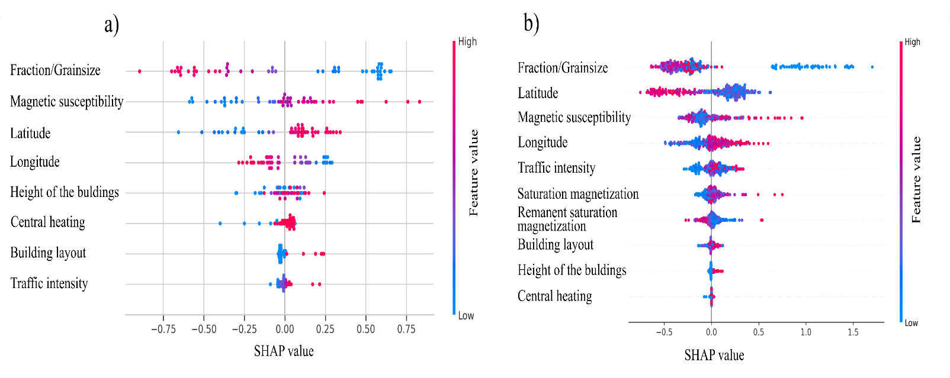
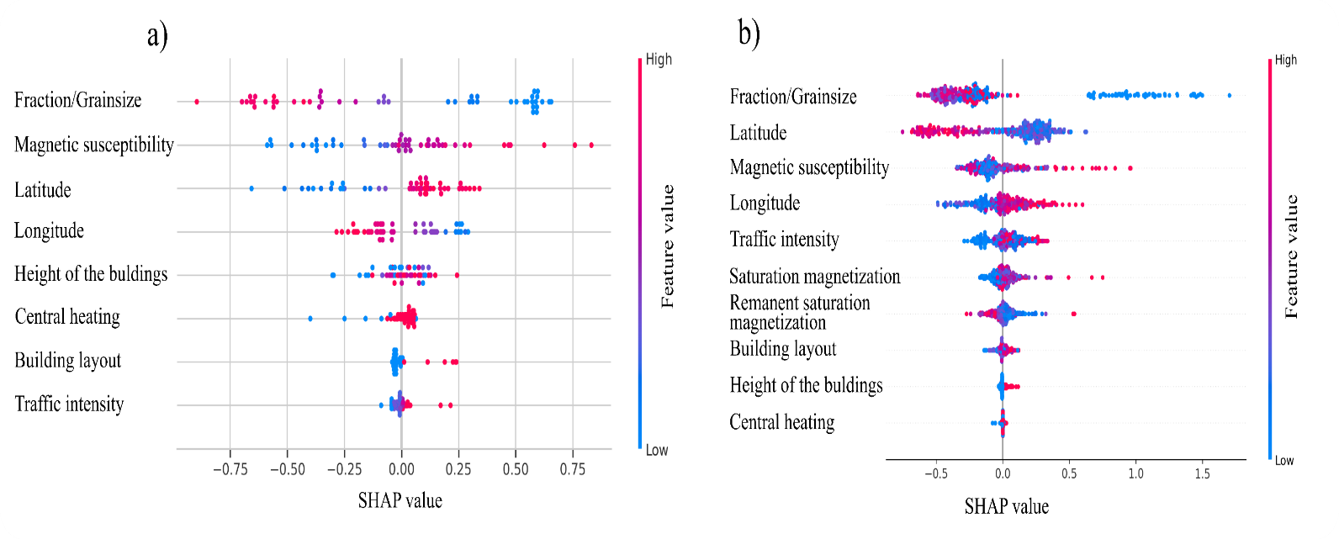
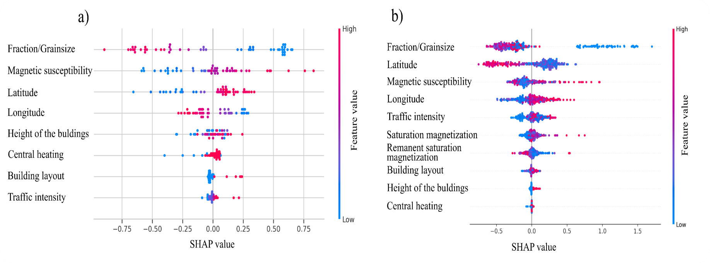

Figure 5. SHAP (SHapley Additive exPlanations) summary plot illustrating the relative importance and impact of input variables for the ANN model predictions (a) and Random Forest model predictions (b).
3.2.2. Regression Model
The predictive capacity of the ANN model exhibited an average coefficient of determination established a high benchmark with a mean R² ≈ 0.26, as indicated by the linear regression fit of its results in Figure 4. To determine if traditional statistical methods could offer a comparable or more stable representation, a dedicated regression model was independently developed. It was demonstrated that ANNs model exhibits higher predictive performance compared to the classical linear regression model. In the case of linear regression, despite achieving an average coefficient of determination of approximately R² ≈ 0.26, the model lacked stability – negative R² values were observed in several cross-validation folds, indicating poor fit to the underlying data structure. To improve the mathematical representation of the system, the linear model was extended by incorporating interactions between independent variables (Table S4 in Supplementary Materials). Following a variable selection procedure and the elimination of statistically insignificant terms (at a significance level of p > 0.05), a final regression model with interactions was obtained (Equation 2), consisting of seven key predictors.

$$ΣPAHs=1.62-141.88⋅H-0.08⋅x⋅F+0.11⋅T⋅LO-0.16⋅F^{2}+0.28⋅C⋅LO+142.06⋅H⋅LA (2)$$

Where: magnetic susceptibility (χ), traffic intensity (T), grain size/fraction (F), connection to the municipal central heating network (C), building height (H), building layout (B), and geospatial coordinates (LO: longitude, LA: latitude).
The transition to a more complex interaction-based model provided a deeper mathematical framework, yet the cross-validation outcomes underscored the persistent challenges of linear modeling for this dataset. The overall predictive power was characterized by a mean R² = 0.18, a value that falls notably short of the benchmarks set by the nonlinear ANN. The instability of the regression approach was particularly evident in the high variance between validation stages. While Fold 4 reached a peak performance of 0.32, these gains were not sustained; Fold 5 showed a critical drop to 0.05, indicating a near-total failure to capture the local data structure in that subset. The remaining folds maintained a low but more stable range: 0.20 (Fold 1), 0.17 (Fold 2), and 0.15 (Fold 3). With an RMSE of 1.07, these results demonstrate that even after optimizing the model with synergistic terms, the linear approach can only partially represent the underlying dynamics. This confirms that the relationships governing PAH accumulation are predominantly nonlinear, leaving the regression model as a significantly less effective tool than the neural network architectures discussed earlier.
The obtained results indicate that the ANN model provides more information than both simple and extended linear regression models. Analysis of the regression equation revealed that the PAHs accumulation process is governed by a complex system of interactions between independent variables. Key contributions arise from synergistic effects between parameter pairs such as T–LO, C–LO, and the dominant interaction of H–LA. The presence of interaction terms confirms that the influence of individual process parameters is not constant but depends on the values of other variables, highlighting the strongly interdependent nature of the analyzed system. Additionally, the negative coefficient for the quadratic flow term (F²) indicates nonlinear system dynamics, suggesting saturation or threshold effects. These findings confirm the presence of both nonlinear and interaction-driven relationships, which can only be partially captured by regression-based approaches, but are more effectively represented by nonlinear models such as artificial neural networks.
3.2.3. Random Forest
As an alternative to global approximation methods, an ensemble-based approach using the Random Forest (RF) algorithm was implemented. This model was specifically configured to capture complex, nonlinear dependencies through a forest of 100 decision trees. To ensure maximum use of the available data structure, the trees were grown without depth restrictions, with at least one sample per leaf and all input features considered at every split. The splitting process was optimized using the mean squared error (MSE) criterion.
The robustness of the tree-based architecture was confirmed via 5-fold cross-validation, in which the RF model achieved the highest predictive accuracy among all evaluated methods. The calculated coefficients of determination reached 0.47 (Fold 1), 0.41 (Fold 2), 0.40 (Fold 3), and 0.39 (Fold 4), with a performance drop to 0.30 observed in Fold 5. This resulted in an overall mean R² of 0.40 (approximately 0.394), indicating a moderate yet superior ability to explain the dataset’s variance compared to the ANN and regression models.
The prediction error metrics further supported the model’s reliability, with a Root Mean Square Error (RMSE) of 0.92 and a Mean Absolute Error (MAE) of 0.71. These values represent the typical deviation between the ensemble’s predictions and the observed PAH concentrations. Although the predictive performance remains within a moderate range, the results suggest that the hierarchical, threshold-based structure of the Random Forest model is particularly effective at capturing the underlying patterns and local variations present in urban road dust data.
Based on the developed Random Forest model, SHAP analysis was performed to interpret the model predictions (Figure 5b). This approach enabled the assessment of the relative importance of individual input variables and their contributions to the model output, providing insights into the underlying relationships within the data.
In the case of the Random Forest model, removing the Mrs and Ms variables did not significantly affect model performance, yielding a comparable coefficient of determination (R² ≈ 0.39). A comparative analysis of both approaches indicated that variable F was the key predictor, showing the highest importance in both models and exhibiting a consistent direction of influence on PAHs. Similarly, variables χ, LO, and LA were identified as among the most influential features. In contrast, the remaining variables differed in their relative importance between the Random Forest and ANN models. Considering that slightly better model performance was achieved with the Random Forest approach, this suggests that the threshold-based structure of RF may better capture the underlying process behavior, whereas ANN reflects a more generalized representation of the relationships. Furthermore, the SHAP distributions showed that the ANN model produced more compact, smoothly distributed feature contributions, with most SHAP values concentrated around zero, indicating a more continuous, global approximation of the input–output relationships. In contrast, the Random Forest model exhibited a wider spread of SHAP values and more pronounced asymmetry, reflecting stronger sensitivity to local variations and potential interaction effects between variables. This difference suggests that while ANN emphasizes overall trend generalization, RF is more effective in capturing localized, nonlinear dependencies present in the data.
While several studies exist in this field, none have integrated urban, magnetic, and particle-size data using ANN to identify the key drivers and their relative influence on PAH accumulation. Li et al. (2026) analyzed 79 urban runoff samples, detecting 16 PAHs (2924–6072 ng/L) and 9 Cl‑PAHs (384–1315 ng/L), quantified six PAH and three Cl‑PAH sources using PMF, and demonstrated that Random Forest combined with Shapley Additive exPlanation (SHAP) method (RF-SHAP) reliably identified the impact of environmental driving factors on pollutant concentrations. Salazar-Rojas et al. (2022) applied machine learning models, including multiple linear regression (MLR) and support vector machine (SVM), to predict HMs in road dust and leaves, showing that SVM accurately predicted Fe, Cu, Cr, V, and Zn (adjusted R² ≥ 0.7), while Pb and Ni were poorly predicted. Similarly, studies applying ANN to predict pollutant levels in stormwater sediments (e.g., heavy metals and PAHs) demonstrated good predictive performance (r = 0.85–0.98, mean relative error below 20% for most metals, and r = 0.85 for PAHs), yet highlighted that pollutant concentrations driven by variable atmospheric and land-use conditions - particularly those influenced by heating-related emissions-pose additional challenges for reliable modeling (Bąk et al., 2019). Similarly, predictive models for atmospheric heavy metals using PM2.5 and meteorological data from five locations in Seoul over two years applied multiple machine learning techniques, with random forest regression performing best for most metals and achieving an R² =0.59 for zinc, while seasonal and spatial variations affected accuracy for other metals (Xu et al., 2023).
3.3. Limitations and future research
This study represents a significant step toward predictive modeling of PAH accumulation in road dust using magnetic properties and urban environmental features, yet it also highlights the need to integrate more dynamic atmospheric parameters in future research. A primary limitation is that the sampling campaign was conducted within a single seasonal window from September to November. To refine the predictive accuracy and robustness of the ANN framework, a crucial next step is to repeat the road dust sampling at the same locations during different seasons, specifically during the peak of the winter heating period and the height of summer. This longitudinal approach, based on paired seasonal sampling, will enable the neural networks to precisely disentangle the permanent influence of urban morphology from the variable chemical signals of residential combustion and seasonal traffic fluctuations.
Furthermore, future models should account for the influence of regional wind speed and direction in the days preceding sampling. Atmospheric pollution transported from major sources, especially from off-grid residential heating areas, and subsequently deposited on road surfaces, may contribute substantially to PAH concentrations, potentially outweighing local structural factors. Utilizing existing meteorological station networks, such as those in Warsaw or during our upcoming research in Vienna, will provide sufficient data to evaluate these transport dynamics and the representative wind vectors affecting the sampling sites. By transitioning to a framework that accounts for regional atmospheric transport patterns and seasonal regimes, we aim to provide a more reliable tool for forecasting pollution hotspots in the road-dust matrix without the need for additional local micro-measurements.

- Conclusions
The comparative analysis of linear regression, ANN, and Random Forest models enabled the assessment of relationships between variables and the identification of key factors influencing PAH concentrations in road dust. The application of methods with different capacities to capture nonlinearity and interactions provided a more comprehensive interpretation of the studied system.
- The consistency of results obtained from RF and ANN models indicates that the main patterns in the data were reliably identified, and that the key variables governing PAH concentrations are robust across modeling approaches.
- The Random Forest model, as a locally adaptive method, achieved a better fit than the ANN model, suggesting a higher capability to capture complex relationships present in the data.
- The same variables were identified as important in both models; however, their effects are not uniform across the entire data range, which may indicate the presence of nonlinearities and context-dependent behavior.
- The comparison of ANN and RF results suggests that the relationships governing PAH concentrations are nonlinear and may involve interactions between independent variables. Moreover, these relationships appear to be partially local, i.e., varying depending on specific conditions.
- Model comparison showed an increase in predictive performance with greater ability to capture nonlinear relationships (R² ≈ 0.18 for linear regression, ≈ 0.26 for ANN, and ≈ 0.40 for Random Forest). It should be noted that this trend is empirical and specific to the dataset analyzed.
- Despite agreement in identifying key variables, the difference in R² between ANN (R² ≈ 0.26) and RF (R² ≈ 0.40) suggests that the relationships between variables are nonlinear and partly local. The ANN model, as a global approach, may not fully capture this complexity, whereas the Random Forest better accounts for local variability.
- The variable C does not appear in the linear model as an independent predictor, but only as part of an interaction term with LO (C-LO), suggesting a context-dependent effect. At the same time, SHAP analysis indicates its importance in the ANN model, whereas its contribution in the RF model is limited. This discrepancy may suggest that C participates in more complex relationships (e.g., interactions), rather than acting as a strong independent predictor.

Funding
This research was funded in whole by the National Science Centre, Poland, under grant number 2021/43/D/ST10/00996.

Acknowledgment
This research was funded in whole by the National Science Centre (Poland), grant number 2021/43/D/ST10/00996. For the purpose of open access, the author has applied a CC-BY public copyright license to any Author Accepted Manuscript (AAM) version arising from this submission. This work was supported by a subsidy from the Polish Ministry of Education and Science for the Institute of Geophysics, Polish Academy of Sciences. The authors would like to thank Dominika Kwiecień, a student who participated in the field and laboratory work but did not contribute to the content of the publication. We thank Klaudia Tetfejer and Andrzej Gawor for contributing their technical expertise, and Julio Cesar Torres-Elguera for his methodological expertise. We acknowledge the support provided by the EPOS-PL project (No. POIR.04.02.00-14-A003/16), co-financed by the European Union through the European Regional Development Fund (ERDF), which facilitated the use of laboratory facilities at the Institute of Geophysics, Polish Academy of Sciences.
References
Abbasi, S., & Keshavarzi, B. (2019). Source identification of total petroleum hydrocarbons and polycyclic aromatic hydrocarbons in PM10 and street dust of a hot spot for petrochemical production: Asaluyeh County, Iran. Sustainable Cities and Society, 45, 214–230. https://doi.org/10.1016/j.scs.2018.11.015
Abbasi, S., Keshavarzi, B., Moore, F., Hopke, P. K., Kelly, F. J., & Dominguez, A. O. (2020). Elemental and magnetic analyses, source identification, and oxidative potential of airborne, passive, and street dust particles in Asaluyeh County, Iran. Science of The Total Environment, 707, 136132. https://doi.org/10.1016/j.scitotenv.2019.136132
Alghamdi, M. A., Hassan, S. K., Al Sharif, M. Y., Khoder, M. I., & Harrison, R. M. (2021). On the nature of polycyclic aromatic hydrocarbons associated with sporting walkways dust: Concentrations, sources and relative health risk. Science of The Total Environment, 781, 146540. https://doi.org/10.1016/j.scitotenv.2021.146540
Anemangely, M., Ramezanzadeh, A., Amiri, H., & Hoseinpour, S.-A. (2019). Machine learning technique for the prediction of shear wave velocity using petrophysical logs. Journal of Petroleum Science and Engineering, 174, 306–327. https://doi.org/10.1016/j.petrol.2018.11.032
Ayoubi, S., Samadi, M. J., Khademi, H., Shirvani, M., & Gyasi-Agyei, Y. (2020). Using magnetic susceptibility for predicting hydrocarbon pollution levels in a petroleum refinery compound in Isfahan Province, Iran. Journal of Applied Geophysics, 172, 103906. https://doi.org/10.1016/j.jappgeo.2019.103906
Bąk, Ł., Szeląg, B., Sałata, A., & Studziński, J. (2019). Modeling of Heavy Metal (Ni, Mn, Co, Zn, Cu, Pb, and Fe) and PAH Content in Stormwater Sediments Based on Weather and Physico-Geographical Characteristics of the Catchment-Data-Mining Approach. Water, 11(3), 626. https://doi.org/10.3390/w11030626
Bondar, K. M., Bakhmutov, V., Poliachenko, I., Hlavatskyi, D., & Menshov, O. (2025). Magnetic and chemical signals of post-blast residue in soil: A case study from northern Ukraine. Science of The Total Environment, 977, 179342. https://doi.org/10.1016/j.scitotenv.2025.179342
Bourliva, A., Kantiranis, N., Papadopoulou, L., Aidona, E., Christophoridis, C., Kollias, P., Evgenakis, M., & Fytianos, K. (2018). Seasonal and spatial variations of magnetic susceptibility and potentially toxic elements (PTEs) in road dusts of Thessaloniki city, Greece: A one-year monitoring period. Science of The Total Environment, 639, 417–427. https://doi.org/10.1016/j.scitotenv.2018.05.170
Cabaneros, S. M., Calautit, J. K., & Hughes, B. R. (2019). A review of artificial neural network models for ambient air pollution prediction. Environmental Modelling & Software, 119, 285–304. https://doi.org/10.1016/j.envsoft.2019.06.014
Cao, L., Appel, E., Hu, S., Yin, G., Lin, H., & Rösler, W. (2015). Magnetic response to air pollution recorded by soil and dust-loaded leaves in a changing industrial environment. Atmospheric Environment, 119, 304–313. https://doi.org/10.1016/j.atmosenv.2015.06.017
Cao, Z., Zhao, L., Shi, Y., Feng, J., Wang, S., Zhang, Y., Yan, G., Zhang, X., Wang, X., Shen, M., & Wang, Y. (2017). PAH contamination in road dust from a moderate city in North China: The significant role of traffic emission. Human and Ecological Risk Assessment: An International Journal, 23(5), 1072–1085. https://doi.org/10.1080/10807039.2017.1300768
CEEB. (2023). CEEB. General Office of Building Control. Central Emissions Building Register, ZONE Portalhttps://zone.gunb.gov.pl/pl
Chanel, O., Perez, L., Künzli, N., & Medina, S. (2016). The hidden economic burden of air pollution-related morbidity: evidence from the Aphekom project. The European Journal of Health Economics, 17(9), 1101–1115. https://doi.org/10.1007/s10198-015-0748-z
Choubin, B., Abdolshahnejad, M., Moradi, E., Querol, X., Mosavi, A., Shamshirband, S., & Ghamisi, P. (2020). Spatial hazard assessment of the PM10 using machine learning models in Barcelona, Spain. Science of The Total Environment, 701, 134474. https://doi.org/10.1016/j.scitotenv.2019.134474
Christoforidis, A., & Stamatis, N. (2009). Heavy metal contamination in street dust and roadside soil along the major national road in Kavala’s region, Greece. Geoderma, 151(3–4), 257–263. https://doi.org/10.1016/j.geoderma.2009.04.016
Chudaničová, M., Hutchinson, S. M., Hradecký, J., & Sedláček, J. (2016). Environmental magnetism as a dating proxy for recent overbank sediments of (peri-)industrial regions in the Czech Republic and UK. CATENA, 142, 21–35. https://doi.org/10.1016/j.catena.2016.02.008
City of Warsaw. (2023). Warszawskie badanie Ruchu. . https://zdm-warszawa.maps.arcgis.com/apps/dashboards/9482f44e811f472a8e9a68405eb86517
Davoudi, M., Esmaili-Sari, A., Bahramifar, N., & Moeinaddini, M. (2021). Spatio-temporal variation and risk assessment of polycyclic aromatic hydrocarbons (PAHs) in surface dust of Qom metropolis, Iran. Environmental Science and Pollution Research, 28(8), 9276–9289. https://doi.org/10.1007/s11356-020-08863-5
Debbarma, S., Rajeev, P., Gupta, T., & Phuleria, H. C. (2025). Characteristics, emission factors, and health risks of vehicular polycyclic aromatic hydrocarbons. Npj Clean Air, 1(1), 6. https://doi.org/10.1038/s44407-025-00005-w
dos Santos, P. R. S., Moreira, L. F. F., Moraes, E. P., de Farias, M. F., & Domingos, Y. S. (2021). Traffic-related polycyclic aromatic hydrocarbons (PAHs) occurrence in a tropical environment. Environmental Geochemistry and Health, 43(11), 4577–4587. https://doi.org/10.1007/s10653-021-00947-6
Dytłow, S., & Górka-Kostrubiec, B. (2019). Effective and universal tool for evaluating heavy metals—passive dust samplers. Environmental Pollution, 247. https://doi.org/10.1016/j.envpol.2019.01.030
Dytłow, S., Karasiński, J., & Torres-Elguera, J. C. (2025). Baseline concentrations and quantitative health risk assessment of polycyclic aromatic hydrocarbons (PAHs) in relation to particle grain size in street dust of Warsaw Poland. Environmental Geochemistry and Health, 47(1), 23. https://doi.org/10.1007/s10653-024-02344-1
Fausett, L. V. (1994). Fundamentals of neural networks. Prentice-Hall Upper Saddle River.
Franco, C. F. J., de Resende, M. F., de Almeida Furtado, L., Brasil, T. F., Eberlin, M. N., & Netto, A. D. P. (2017). Polycyclic aromatic hydrocarbons (PAHs) in street dust of Rio de Janeiro and Niterói, Brazil: Particle size distribution, sources and cancer risk assessment. Science of The Total Environment, 599–600, 305–313. https://doi.org/10.1016/j.scitotenv.2017.04.060
Galatioto, F., Masey, N., Murrells, T., Hamilton, S., & Pommier, M. (2022). Review of Road Dust Resuspension Modelling Approaches and Comparisons Analysis for a UK Case Study. Atmosphere, 13(9), 1403. https://doi.org/10.3390/atmos13091403
Géron, A. (2019). Hands-On Machine Learning with Scikit-Learn, Keras, and TensorFlow: Concepts, Tools, and Techniques to Build Intelligent Systems; . O’Reilly Media, Inc.
Gope, M., Masto, R. E., George, J., & Balachandran, S. (2018). Exposure and cancer risk assessment of polycyclic aromatic hydrocarbons (PAHs) in the street dust of Asansol city, India. Sustainable Cities and Society, 38, 616–626. https://doi.org/10.1016/j.scs.2018.01.006
Gunawardana, C., Goonetilleke, A., Egodawatta, P., Dawes, L., & Kokot, S. (2012). Source characterisation of road dust based on chemical and mineralogical composition. Chemosphere, 87(2), 163–170. https://doi.org/10.1016/j.chemosphere.2011.12.012
Guo, C., & Berkhahn, F. (2016). Entity embeddings of categorical variables. . ArXiv Preprint ArXiv:1604.06737 Https://Doi.Org/10.48550/ArXiv.1604.06737.
Hamdan, A. M., Kirana, K. H., Hakim, F., Iksan, M., Bijaksana, S., Mariyanto, M., Ashari, T. M., Ngkoimani, L. O., Kurniawan, H., Pratama, A., & Wahid, M. A. (2022). Magnetic susceptibilities of surface sediments from estuary rivers in volcanic regions. Environmental Monitoring and Assessment, 194(4), 239. https://doi.org/10.1007/s10661-022-09891-z
Harris, C. R., Millman, K. J., van der Walt, S. J., Gommers, R., Virtanen, P., Cournapeau, D., Wieser, E., Taylor, J., Berg, S., Smith, N. J., Kern, R., Picus, M., Hoyer, S., van Kerkwijk, M. H., Brett, M., Haldane, A., del Río, J. F., Wiebe, M., Peterson, P., … Oliphant, T. E. (2020). Array programming with NumPy. Nature, 585(7825), 357–362. https://doi.org/10.1038/s41586-020-2649-2
Hastie, T., Friedman, J., & Tibshirani, R. (2001). The Elements of Statistical Learning. Springer New York. https://doi.org/10.1007/978-0-387-21606-5
Haynes, H. M., Taylor, K. G., Rothwell, J., & Byrne, P. (2020). Characterisation of road-dust sediment in urban systems: a review of a global challenge. Journal of Soils and Sediments, 20(12), 4194–4217. https://doi.org/10.1007/s11368-020-02804-y
Hu, X.-F., Su, Y., Ye, R., Li, X.-Q., & Zhang, G.-L. (2007). Magnetic properties of the urban soils in Shanghai and their environmental implications. CATENA, 70(3), 428–436. https://doi.org/10.1016/j.catena.2006.11.010
IARC, I. A. for R. on C. (2010). Some nonheterocyclic polycyclic aromatic hydrocarbons and some related exposures (IARC Monographs on the Evaluation of Carcinogenic Risks to Humans, Vol. 92). .
IARC, I. A. for R. on C. (2016). Outdoor air pollution (IARC Monographs on the Evaluation of Carcinogenic Risks to Humans, Vol. 109). .
Ioffe, S., & Szegedy, C. (2015). Batch normalization: Accelerating deep network training by reducing internal covariate shift. . In Proceedings of the 32nd International Conference on Machine Learning (ICML’ 15) JMLR.Org., 37, 448–456.
Jaffar, S. T. A., Chen, L., Younas, H., & Ahmad, N. (2017). Heavy metals pollution assessment in correlation with magnetic susceptibility in topsoils of Shanghai. Environmental Earth Sciences, 76(7), 277. https://doi.org/10.1007/s12665-017-6598-5
Jordanova, D., Jordanova, N., & Petrov, P. (2014). Magnetic susceptibility of road deposited sediments at a national scale – Relation to population size and urban pollution. Environmental Pollution, 189, 239–251. https://doi.org/10.1016/j.envpol.2014.02.030
Karakaş, D., Berberler, E., Demir, T., Bayramoğlu Karşı, M. B., & Yenisoy, S. (2025). Source identification and quantification of real-world PAH contributions from traffic-related exhaust and non-exhaust emission sources using the EFECT method. Chemosphere, 374, 144237. https://doi.org/10.1016/j.chemosphere.2025.144237
Karimian, F., Ayoubi, S., Khalili, B., & Mireei, S. A. (2023). Magnetic susceptibility as a proxy for detection of total petroleum hydrocarbons in contaminated wetlands. Environmental Monitoring and Assessment, 195(1), 244. https://doi.org/10.1007/s10661-022-10826-x
Kassandros, T., Bagkis, E., Johansson, L., Kontos, Y., Katsifarakis, K. L., Karppinen, A., & Karatzas, K. (2023). Machine learning-assisted dispersion modelling based on genetic algorithm-driven ensembles: An application for road dust in Helsinki. Atmospheric Environment, 307, 119818. https://doi.org/10.1016/j.atmosenv.2023.119818
Khanal, R., Furumai, H., Nakajima, F., & Yoshimura, C. (2018). Carcinogenic profile, toxicity and source apportionment of polycyclic aromatic hydrocarbons accumulated from urban road dust in Tokyo, Japan. Ecotoxicology and Environmental Safety, 165, 440–449. https://doi.org/10.1016/j.ecoenv.2018.08.095
Khpalwak, W., Jadoon, W. A., Abdel-dayem, S. M., & Sakugawa, H. (2019). Polycyclic aromatic hydrocarbons in urban road dust, Afghanistan: Implications for human health. Chemosphere, 218, 517–526. https://doi.org/10.1016/j.chemosphere.2018.11.087
Kida, M., Musiał, M., Pochwat, K., Ziembowicz, S., Koszelnik, P., Strojny, W., Pizzo, H., & Bodog, M. (2024). Modeling of microplastics degradation in aquatic environments using an experimental plan. Journal of Hazardous Materials, 471, 134396. https://doi.org/10.1016/j.jhazmat.2024.134396
Kida, M., Pochwat, K., & Ziembowicz, S. (2024). Assessment of machine learning-based methods predictive suitability for migration pollutants from microplastics degradation. Journal of Hazardous Materials, 461, 132565. https://doi.org/10.1016/j.jhazmat.2023.132565
Kreider, M. L., Panko, J. M., McAtee, B. L., Sweet, L. I., & Finley, B. L. (2010). Physical and chemical characterization of tire-related particles: Comparison of particles generated using different methodologies. Science of The Total Environment, 408(3), 652–659. https://doi.org/10.1016/j.scitotenv.2009.10.016
Kuhn, Max., & Johnson, Kjell. (2013). Applied predictive modeling. Springer.
Lanzerstorfer, C. (2021). Toward more intercomparable road dust studies. Critical Reviews in Environmental Science and Technology, 51(8), 826–855. https://doi.org/10.1080/10643389.2020.1737472
Li, L., Huang, H., Hua, P., Chen, T., Zhang, J., Deng, P., Zhao, Z., & Yan, B. (2026). Machine learning combined with the PMF model reveals the sources and driving factors of PAHs and Cl-PAHs in urban runoff. Journal of Environmental Sciences, 160, 174–184. https://doi.org/10.1016/j.jes.2025.07.011
Lim, H., Silvergren, S., Spinicci, S., Mashayekhy Rad, F., Nilsson, U., Westerholm, R., & Johansson, C. (2022). Contribution of wood burning to exposures of PAHs and oxy-PAHs in Eastern Sweden. Atmospheric Chemistry and Physics, 22(17), 11359–11379. https://doi.org/10.5194/acp-22-11359-2022
Liu, J., Zhang, J., Zhan, C., Liu, H., Zhang, L., Hu, T., Xing, X., & Qu, C. (2019). Polycyclic Aromatic Hydrocarbons (PAHs) in Urban Street Dust of Huanggang, Central China: Status, Sources and Human Health Risk Assessment. Aerosol and Air Quality Research, 19(2), 221–233. https://doi.org/10.4209/aaqr.2018.02.0048
Li, Z., Feng, X., Li, G., Bi, X., Zhu, J., Qin, H., Dai, Z., Liu, J., Li, Q., & Sun, G. (2013). Distributions, sources and pollution status of 17 trace metal/metalloids in the street dust of a heavily industrialized city of central China. Environmental Pollution, 182, 408–416. https://doi.org/10.1016/j.envpol.2013.07.041
Loganathan, P., Vigneswaran, S., & Kandasamy, J. (2013). Road-Deposited Sediment Pollutants: A Critical Review of their Characteristics, Source Apportionment, and Management. Critical Reviews in Environmental Science and Technology, 43(13), 1315–1348. https://doi.org/10.1080/10643389.2011.644222
Logiewa, A., Miazgowicz, A., Krennhuber, K., & Lanzerstorfer, C. (2020). Variation in the Concentration of Metals in Road Dust Size Fractions Between 2 µm and 2 mm: Results from Three Metallurgical Centres in Poland. Archives of Environmental Contamination and Toxicology, 78(1), 46–59. https://doi.org/10.1007/s00244-019-00686-x
Lorenzi, D., Entwistle, J. A., Cave, M., & Dean, J. R. (2011). Determination of polycyclic aromatic hydrocarbons in urban street dust: Implications for human health. Chemosphere, 83(7), 970–977. https://doi.org/10.1016/j.chemosphere.2011.02.020
Majumdar, D., Rajaram, B., Meshram, S., Suryawanshi, P., & Chalapati Rao, C. V. (2017). Worldwide distribution of polyclyclic aromatic hydrocarbons in urban road dust. International Journal of Environmental Science and Technology, 14(2), 397–420. https://doi.org/10.1007/s13762-016-1084-2
McKinney, W. (2010). Data Structures for Statistical Computing in Python. 56–61. https://doi.org/10.25080/Majora-92bf1922-00a
Mon, E. E., Phay, N., Agusa, T., Bach, L. T., Yeh, H.-M., Huang, C.-H., & Nakata, H. (2020). Polycyclic Aromatic Hydrocarbons (PAHs) in Road Dust Collected from Myanmar, Japan, Taiwan, and Vietnam. Archives of Environmental Contamination and Toxicology, 78(1), 34–45. https://doi.org/10.1007/s00244-019-00693-y
Morris, W. A., Versteeg, J. K., Bryant, D. W., Legzdins, A. E., McCarry, B. E., & Marvin, C. H. (1995). Preliminary comparisons between mutagenicity and magnetic susceptibility of respirable airborne particulate. Atmospheric Environment, 29(23), 3441–3450. https://doi.org/10.1016/1352-2310(95)00203-B
Najmeddin, A., & Keshavarzi, B. (2019). Health risk assessment and source apportionment of polycyclic aromatic hydrocarbons associated with PM10 and road deposited dust in Ahvaz metropolis of Iran. Environmental Geochemistry and Health, 41(3), 1267–1290. https://doi.org/10.1007/s10653-018-0209-6
Olawoyin, R. (2016). Application of backpropagation artificial neural network prediction model for the PAH bioremediation of polluted soil. Chemosphere, 161, 145–150. https://doi.org/10.1016/j.chemosphere.2016.07.003
Padoan, E., Romè, C., & Ajmone-Marsan, F. (2017). Bioaccessibility and size distribution of metals in road dust and roadside soils along a peri-urban transect. Science of The Total Environment, 601–602, 89–98. https://doi.org/10.1016/j.scitotenv.2017.05.180
Patel, K., Bhandari, S., Gani, S., Kumar, P., Baig, N., Habib, G., Apte, J., & Hildebrandt Ruiz, L. (2023). Factors influencing ambient particulate matter in Delhi, India: Insights from machine learning. Aerosol Science and Technology, 57(6), 546–561. https://doi.org/10.1080/02786826.2023.2193237
Pathak, A. K., Yadav, S., Kumar, P., & Kumar, R. (2013). Source apportionment and spatial–temporal variations in the metal content of surface dust collected from an industrial area adjoining Delhi, India. Science of The Total Environment, 443, 662–672. https://doi.org/10.1016/j.scitotenv.2012.11.030
Pedregosa, F., Varoquaux, G., Gramfort, A., Michel, V., Thirion, B., Grisel, O., Blondel, M., Prettenhofer, P., & Weiss, R. , D. V. , V. J. , P. A. , C. D. , B. M. , P. M. , D. É. : (2011). Scikit-learn: machine learning in python. Scikit-Learn: Machine Learning in Python, 12, 2825–2830.
Peng, Z., Zhang, B., Wang, D., Niu, X., Sun, J., Xu, H., Cao, J., & Shen, Z. (2024). Application of machine learning in atmospheric pollution research: A state-of-art review. Science of The Total Environment, 910, 168588. https://doi.org/10.1016/j.scitotenv.2023.168588
Power, A. L., Tennant, R. K., Stewart, A. G., Gosden, C., Worsley, A. T., Jones, R., & Love, J. (2023). The evolution of atmospheric particulate matter in an urban landscape since the Industrial Revolution. Scientific Reports, 13(1), 8964. https://doi.org/10.1038/s41598-023-35679-3
Puy-Alquiza, M. J., Reyes, V., Wrobel, K., Wrobel, K., Torres Elguera, J. C., & Miranda-Aviles, R. (2016). Polycyclic aromatic hydrocarbons in urban tunnels of Guanajuato city (Mexico) measured in deposited dust particles and in transplanted lichen Xanthoparmelia mexicana (Gyeln.) Hale. Environmental Science and Pollution Research, 23(12), 11947–11956. https://doi.org/10.1007/s11356-016-6256-6
Qiao, Q., Zhang, C., Huang, B., & Piper, J. D. A. (2011). Evaluating the environmental quality impact of the 2008 Beijing Olympic Games: magnetic monitoring of street dust in Beijing Olympic Park. Geophysical Journal International, 187(3), 1222–1236. https://doi.org/10.1111/j.1365-246X.2011.05195.x
Salazar-Rojas, T., Cejudo-Ruiz, F. R., & Calvo-Brenes, G. (2022). Comparison between machine linear regression (MLR) and support vector machine (SVM) as model generators for heavy metal assessment captured in biomonitors and road dust. Environmental Pollution, 314, 120227. https://doi.org/10.1016/j.envpol.2022.120227
Salazar-Rojas, T., Cejudo-Ruiz, F. R., & Calvo-Brenes, G. (2023). Assessing magnetic properties of biomonitors and road dust as a screening method for air pollution monitoring. Chemosphere, 310, 136795. https://doi.org/10.1016/j.chemosphere.2022.136795
Shabbaj, I. I., Alghamdi, M. A., & Khoder, M. I. (2018). Street Dust—Bound Polycyclic Aromatic Hydrocarbons in a Saudi Coastal City: Status, Profile, Sources, and Human Health Risk Assessment. International Journal of Environmental Research and Public Health, 15(11), 2397. https://doi.org/10.3390/ijerph15112397
Shi, G., Chen, Z., Bi, C., Wang, L., Teng, J., Li, Y., & Xu, S. (2011). A comparative study of health risk of potentially toxic metals in urban and suburban road dust in the most populated city of China. Atmospheric Environment, 45(3), 764–771. https://doi.org/10.1016/j.atmosenv.2010.08.039
Shilton, V. F., Booth, C. A., Smith, J. P., Giess, P., Mitchell, D. J., & Williams, C. D. (2005). Magnetic properties of urban street dust and their relationship with organic matter content in the West Midlands, UK. Atmospheric Environment, 39(20), 3651–3659. https://doi.org/10.1016/j.atmosenv.2005.03.005
Tanner, P. A., Ma, H.-L., & Yu, P. K. N. (2008). Fingerprinting Metals in Urban Street Dust of Beijing, Shanghai, and Hong Kong. Environmental Science & Technology, 42(19), 7111–7117. https://doi.org/10.1021/es8007613
Tobiszewski, M., & Namieśnik, J. (2012). PAH diagnostic ratios for the identification of pollution emission sources. Environmental Pollution, 162, 110–119. https://doi.org/10.1016/j.envpol.2011.10.025
UN. (2019). World urbanization prospects the 2018 revision. . Https://Population.Un.Org/Wup/Assets/WUP2018-Report.Pdf.
Venkatachalapathy, R., Veerasingam, S., Basavaiah, N., & Ramkumar, T. (2010). Comparison between petroleum hydrocarbon concentrations and magnetic properties in Chennai coastal sediments, Bay of Bengal, INDIA. Marine and Petroleum Geology, 27(9), 1927–1935. https://doi.org/10.1016/j.marpetgeo.2010.07.004
Wang, G., Chen, J., Zhang, W., Chen, Y., Ren, F., Fang, A., & Ma, L. (2019). Relationship between magnetic properties and heavy metal contamination of street dust samples from Shanghai, China. Environmental Science and Pollution Research, 26(9), 8958–8970. https://doi.org/10.1007/s11356-019-04338-4
Wang, G., Liu, Y., Chen, J., Ren, F., Chen, Y., Ye, F., & Zhang, W. (2018). Magnetic evidence for heavy metal pollution of topsoil in Shanghai, China. Frontiers of Earth Science, 12(1), 125–133. https://doi.org/10.1007/s11707-017-0624-5
Wang, G., Oldfield, F., Xia, D., Chen, F., Liu, X., & Zhang, W. (2011). Magnetic properties and correlation with heavy metals in urban street dust: A case study from the city of Lanzhou, China. Atmospheric Environment. https://doi.org/10.1016/j.atmosenv.2011.09.059
Wang, X.-T., Fu, R., Zhou, Y., Wang, C.-L., Ren, G.-F., Wang, X.-L., & Li, H. (2021). Occurrence, source apportionment, and carcinogenic risk assessment of polycyclic aromatic hydrocarbons in urban road dusts in Shanghai. Environmental Science and Pollution Research, 28(46), 65621–65632. https://doi.org/10.1007/s11356-021-15532-8
WHO. (2016). Ambient Air Pollution: A Global Assessment of Exposure and Burden of Disease.
Wu, Y., Zhang, N., Wang, Y., Ren, Y., Yuan, Z., & Li, N. (2020). Concentrations of polycyclic aromatic hydrocarbons in street dust from bus stops in Qingyang city: Estimates of lifetime cancer risk and sources of exposure for daily commuters in Northwest China. Environmental Pollution, 266, 115222. https://doi.org/10.1016/j.envpol.2020.115222
Xu, B., Liu, F., Alfaro, D., Jin, Z., Liu, Y., Liu, Y., Zhou, Z., & Zhang, J. (2022). Polycyclic aromatic hydrocarbons in fine road dust from a coal-utilization city: Spatial distribution, source diagnosis and risk assessment. Chemosphere, 286, 131555. https://doi.org/10.1016/j.chemosphere.2021.131555
Xu, X., Liu, W., Jia, T., Shi, Z., He, Y., Mao, T., Deng, J., Yin, F., Chen, Q., Liu, J., & Su, L. (2023). Investigation of relationship between polycyclic aromatic hydrocarbons and human activities in urban soils of China using machine learning methods. Journal of Cleaner Production, 404, 136839. https://doi.org/10.1016/j.jclepro.2023.136839
Yıldırım, G., & Tokalıoğlu, Ş. (2016). Heavy metal speciation in various grain sizes of industrially contaminated street dust using multivariate statistical analysis. Ecotoxicology and Environmental Safety, 124, 369–376. https://doi.org/10.1016/j.ecoenv.2015.11.006
Yu, B., Xie, X., Ma, L. Q., Kan, H., & Zhou, Q. (2014). Source, distribution, and health risk assessment of polycyclic aromatic hydrocarbons in urban street dust from Tianjin, China. Environmental Science and Pollution Research, 21(4), 2817–2825. https://doi.org/10.1007/s11356-013-2190-z
Zhang, J., Zhan, C., Liu, H., Liu, T., Yao, R., Hu, T., Xiao, W., Xing, X., Xu, H., & Cao, J. (2016). Characterization of Polycyclic Aromatic Hydrocarbons (PAHs), Iron and Black Carbon within Street Dust from a Steel Industrial City, Central China. Aerosol and Air Quality Research, 16(10), 2452–2461. https://doi.org/10.4209/aaqr.2016.02.0085
Zhang, Y. (2021). Seasonal Disparity in the Effect of Meteorological Conditions on Air Quality in China Based on Artificial Intelligence. Atmosphere, 12(12), 1670. https://doi.org/10.3390/atmos12121670
Zhang, Y., Shen, Z., Sun, J., Zhang, L., Zhang, B., Zou, H., Zhang, T., Hang Ho, S. S., Chang, X., Xu, H., Wang, T., & Cao, J. (2021). Parent, alkylated, oxygenated and nitrated polycyclic aromatic hydrocarbons in PM2.5 emitted from residential biomass burning and coal combustion: A novel database of 14 heating scenarios. Environmental Pollution, 268, 115881. https://doi.org/10.1016/j.envpol.2020.115881
Zhang, Y.-S., Hu, X.-F., Wang, X.-D., Mei, L.-S., & Jia, Y.-T. (2024). Magnetic enhancement of road dusts in Shanghai and its implications for the urban environment. Journal of Soils and Sediments, 24(5), 1969–1987. https://doi.org/10.1007/s11368-024-03759-0
ZOM. (2025). Kalendarz sprzątania ulic. Https://Zom.Waw.Pl/Ulice/Kalendarz-Sprzatania .

